Is Smoking Compatible with Colorectal Enhanced Recovery after Surgery: 1 Year Review

El Jichi, T; Okocha, M; Browning N; Shafiq, W and Sumrien, H

Abstract

Our aim was to demonstrate the relation between smoking and length of hospital stay in Enhanced Recovery after Surgery (ERAS) patients, who underwent elective major colorectal surgery in a tertiary referral center - North Bristol NHS Trust.

The NBT ERAS program is well established and all patients who undergo colorectal resection are included. Smoking increases risk of poor postoperative outcomes, general morbidity and wound complications. NBT is a smoke-free trust, and it became noticeable that smokers mobilize earlier after surgery to get to smoking zones. Previous studies showed that less than 7.5% of smokers stop smoking in the perioperative period.

Prospective review of data collected from ERAS patients who had elective colorectal resection between 01/2017 and 01/2018. Outcomes collected included, type of surgery, open or laparoscopic +/- conversion, and length of hospital stay. Smoker and non-smoker groups were compared in terms of post-operative length of stay.

Between January 2017 and January 2018, we performed 200 major colorectal resections, of these 40% were on Female patients (82) (males 118). Procedures included 51 right hemicolectomies, 70 anterior resections/TME, 10 APER, 14 Hartmann’s reversals and 55 Left Hemicolectomies, Transverse colectomies, subtotal colectomies and segmental colectomies. 140 (69%) cases were laparoscopic, 41 (20%) open and 21 (14%) were laparoscopic converted to open. Mean hospital stay 8 days, median 5 days, re-admission rate was 15.3% and SSI was 8.1%.

Mean age of smokers was 62, range 30-86. Mean age of non-smokers was 66, range (19 -93).Of the 200 patients 49 were smokers, 151 non-smokers. Of the smokers 4% (2) ceased smoking with advice. Mean length of hospital stay for smokers was 6.81 and non-smokers was 7.13 days.

Smokers remain a challenging group in terms of compliance. Although smokers seemed to mobilize early postoperatively, that did not translate into a reduction of hospital stay.
Image 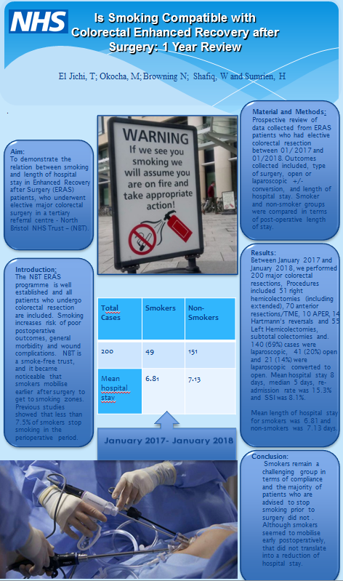

Email: dr.jichi.619@icloud.com

