The mesenteric panniculitis: an understood disease
Buragina Giuseppe, University of Milan
Introduction
The mesenteric panniculitis is a rare and chronic inflammatory disease which involves primarly the mesentery and rarely other sites like omentum and mesocolon. The disease is often asymptomatic but it may produce symptoms like abdominal pain, constipation or diarrhoea, and dyspepsia. Sometimes it may produce bowel obstruction or ischemia, requiring urgent surgery. The two main form of mesenteric panniculitis are: the classical type with inflammation, necrosis and degeneration of fat, and the retractile panniculitis with a prominent fibrosis of mesentery with rectraction of the surrounding structures and a major risk of bowel occlusion. The diagnosis is mainly radiological, and the computed tomography (CT) and magnetic resonance imaging (MRI) are the most useful methods to detect the disease (1-2-3).
Main Concept
This disease is actually considered idiopathic but various evidence in literature and the experience of the author suggest a clear secondary nature of the disease in some cases. The mesenteric panniculitis discovered in patients previous treated for abdominal lymphomas with radio-chemotherapy (4), the mesenteric panniculitis discovered at the same time of inflammatory disease of abdomen like pancreatitis, appendicitis, colitis or diverticulitis or which evolves from an inflammatory oedema of the mesentery (5), the mesenteric panniculitis secondary to surgery (6) or autoimmune disease like IgG4 related disease or lupus (7-8) may be considered as a chronic inflammation of the mesenteric fat secondary to these conditions (image 1-2).
Conclusion
This observation may clarify the etiology of the disease and may be useful in the clinical practice because the identification of the mesenteric panniculitis as a secondary lesion may be explain abdominal symptoms following other abdominal conditions such as abdominal pain or discomfort after the resolution of a pancreatitis or also a late acute abdomen after abdominal surgery. Therefore, the mesenteric panniculitis in some case may appear as a late manifestation or complication of previous abdominal diseases.

References
1. Emory TS, Monihan JM, Carr NJ, Sobin LH. Sclerosing mesenteritis, mesenteric panniculitis and mesenteric lipodystrophy: a single entity? Am J Surg Pathol 1997;21(4):392-8.
2. Issa I. Baydoun H. Mesenteric panniculitis: various presentations and treatment regimens. World J Gastroenterol 2009 Aug 14;15(30):3827-30.

3. Coulier B. Mesenteric panniculitis. Mesenteric panniculitis. Part 2: prevalence and natural course: MDCT prospective study. JBR-BTR 2011 94(5):241-6.

4. L. Fatahi Bandpey, G. Martinez Sanz, C. Roig Salgado, E. Santa Eulalia Mainegra, F. O. Lenghel, J. Torres Nuez, E. Y. V. Bonacasa, N. González Gómez. Lymphomas and mesenteric panniculitis: causative relationship depending on histological type and treatment. Poster ECR 2013 / C-1418.
5. Giuseppe BURAGINA *, Gaia SPADARELLA, Francesca RIGIROLI, Luca A. CARBONARO, Pierpaolo BIONDETTI, Gianpaolo CARRAFIELLO, Alberto MAGENTA BIASINA. Aspetti clinico-radiologici della panniculite mesenterica. Il Giornale Italiano di Radiologia Medica 2018 Gennaio-Febbraio;5(1):41-7
6.Nasta AM, Patel D, Shrivastav O, Goel M, Shrimal A, Gupte A, Goel R. Mesenteric Panniculitis-First Case Series After Bariatric Surgery.Obes Surg. 2018 Mar;28(3):881-885.
7. Kerdsirichairat T, Mesa H, Abraham J, et al. Sclerosing mesenteritis and IgG4-related mesenteritis: case series and a systematic review of natural history and response to treatments. Immunogastroenterology.2013;2:119–28.
8. Bourgeois S, Van den Eeckhaut A, De Geeter F. Mesenteric Panniculitis With Lupus Demonstrated on 18F-FDG PET/CT. Clin Nucl Med. 2018 Dec;43(12):e479-e481.
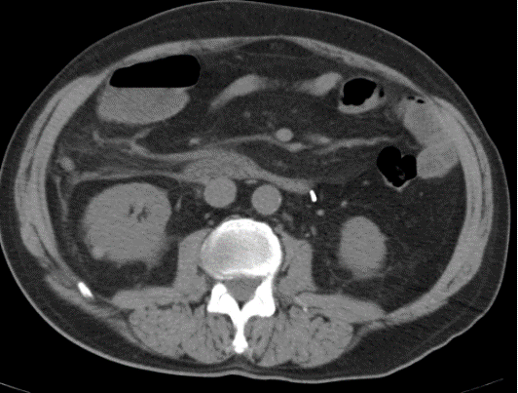
Image 1: In this CT axial image we observed a inflammatory edema of mesentery in a patient with acute appendicitis.

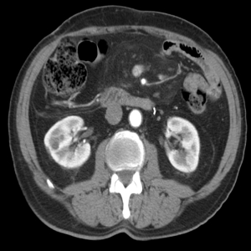

Image 2: In the same patient of the figure 1, 13 months later, we observed the presence of a mass in the mesentery with the features of mesenteric panniculitis. This case may be considered a secondary form of the disease.

Personal Information
Giuseppe Buragina graduated in medicine and surgery at Bologna University in july 2013 and he is currently fellow in diagnostic radiology at the University of Milan.

