7 Years’ Experience in Migraine Surgery with Minimally Invasive and Endoscopic Techinique

Raposio E.¹, Lago G.¹, Bertozzi N.¹, Fante C.¹, Sanese G.²
- Plastic Surgery Unit, Department of Medicine and Surgery, University of Parma , Italy
- Plastic Surgery Unit, Tor Vergata University, Rome, Italy

Abstract
Introduction/Statement of the Problem: Migraine Headache (MH) is a very common disorder affecting 1.7–4% of the world’s adult population. The first line therapy for these patients is usually a combination of conservative treatments. Despite this large variety of options available, some patients remain refractory. For such group, migraine surgery might offer a definitive solution for their medical condition. In these patients, migraine is usually caused by extracranial nerve compression due vascular, fascial or muscular structures nearby. The aim of migraine surgery is to relieve such compression at specific trigger points located in the occipital, temporal and frontal regions.
Methodology & Theoretical Orientation: From 2011, in our Plastic Surgery Unit at the University of Parma, Italy, we performed 235 surgical procedures for Migraine in patients suffering from either frontal, occipital or temporal headache. In patients with occipital and temporal migraine, nerve decompression was achieved by occipital and superficial temporal artery ligation, respectively. Vessels were previously localized by mean of portable Doppler device. In patients suffering from frontal headache we performed nerve decompression with single-entry endoscopic myotomies of procerus, corrugator and depressor supercilii muscles.
Findings: Among patient suffering from occipital migraine, 95% of them observed significant improvement of their condition, with 86% reporting complete relief. In temporal migraine, positive outcome was achieved in 83% of the patients (50% complete elimination and 33% partial improvement). In patient treated with endoscopic frontal myotomies, positive results were observed in 94% of the patients (32% complete elimination, 62% partial improvement).
Conclusion & Significance: Migraine is a common and debilitating condition that can be treated successfully with minimally invasive surgical procedures. Our results suggest that vascular compression is the main causative agent in occipital and temporal migraine.

Biography

Prof. Edoardo Raposio, MD, PhD, graduated at the University of Genoa, is specialized in Plastic and Reconstructive Surgery and in Hand Surgery. He has obtained a PhD at the University of Tromso, Norway, and is currently the Director of the Chair and Residency Program in Plastic Surgery at the University of Parma, Italy. During his academic career, he gained international experience as visiting professor in several Plastic Surgery Departments, both in Europe and USA. His clinical activities are mainly focused on the surgical treatment of migraine headache and primary hyperhidrosis with minimally invasive techniques.

Email: edoardo.raposio@unipr.it

Recent Publications:

- Raposio E, Caruana G. Tips for the surgical treatment of occipital nerve-triggered headaches. Eur J Plast Surg. 2017:40;3:177-182.
- Raposio E, Bertozzi N, Bordin C, Simonacci F. Surgical therapy of migraine and tension-type headache. In: Current Perspectives on Less-Known Aspects of Headache. (Turker H. ed.). InTech, London, UK. pp.: 93-114.
- Polotto S, Simonacci F, Grignaffini E, Grieco MP, Raposio E. Surgical Treatment of Frontal and Occipital Migraines: A Comparison of Results. Plast Reconstr Surg Glob Open. 2016;18;4(3):e653.
- Raposio E, Caruana G. Minimally Invasive Endoscopic Surgical Treatment of Headache. In: Atlas of Endoscopic Plastic Surgery. (Raposio E., ed.). Springer, New York, USA, 2015; pp.: 17-23.
- Raposio E, Caruana G. Frontal endoscopic myotomies for chronic headache. J Craniofac Surg. 2015;26;3:E201-203.
- Caruana G, Grignaffini E, Raposio E. Endoscopic forehead muscle resection for nerve decompression: A modified procedure. Plast Reconstr Surg Glob Open. 2015;7;3:e342.
- Caruana G, Bertozzi N, Boschi E, Pio Grieco M, Grignaffini E, Raposio E. Endoscopic forehead surgery for migraine therapy Personal technique. Ann Ital Chir. 2014;85:583-586
- Raposio E, Bertozzi N, Bordin C, Simonacci F. Surgical Therapy of Headaches: Minimally Invasive Approaches. In: “Clinical Advances in Head & Neck Surgery”. Openaccess eBooks, Las Vegas, USA. 1-23, 2018.
- Gfrerer L, Raposio E, Ortiz R, Austen WG Jr. Surgical Treatment of Migraine Headache: Back to the Future. Plast Reconstr Surg. 2018 Oct;142(4):1036-1045.
Image:
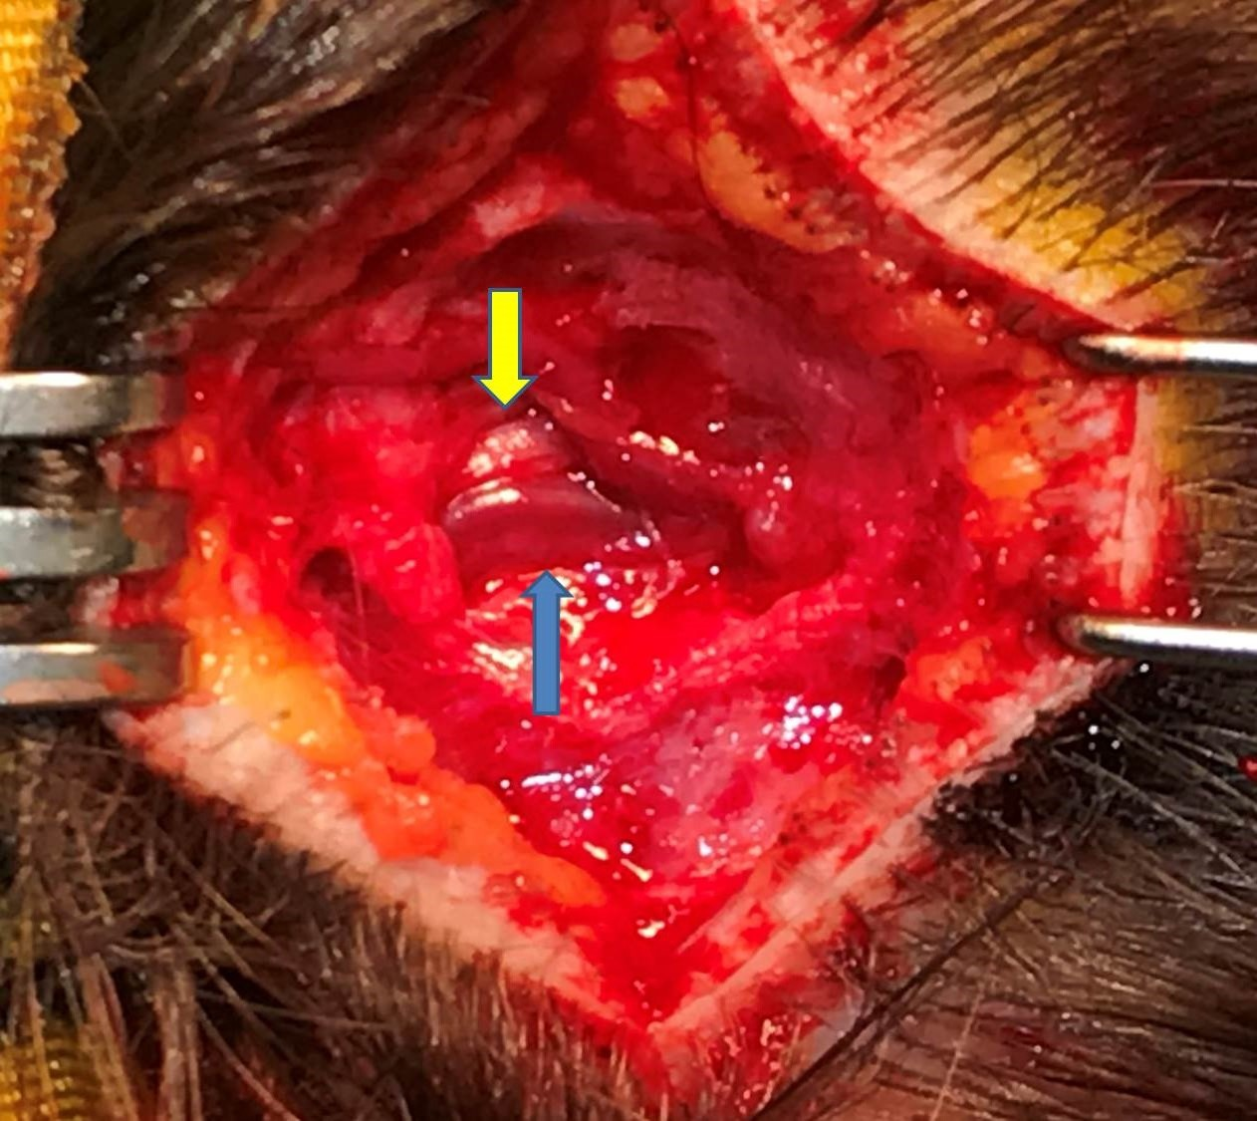

Figure legend: Dilated right occipital artery (blue arrow) running in close proximity to the right Great Occipital nerve (yellow arrow).

