Thoracoscopic Video-Assisted Sympathicotomy for the Treatment of Hyperhidrosis: 20 Years’ Experience with Minimally Invasive Technique
Lago G.¹, Bertozzi N.¹, Sanese G.², Fante C.¹, Raposio E.¹
- Plastic Surgery Unit, Department of Medicine and Surgery, University of Parma - Italy
- Plastic Surgery Unit, Tor Vergata University (Rome) - Italy

Abstract
Introduction/Statement of the Problem: Hyperhidrosis is a frequent disorder with an estimated prevalence of 3% in the general population. This condition carries relevant impairments in social relationships for the patients. Hyperhidrosis can affect different anatomical areas with palmar region being the most disturbing for everyday activities and social relevance. Several conservative and topical treatments are available for the patients but their efficacy is often limited and temporary. Video-assisted thoracoscopic sympathicotomy of T2 and T3 ganglia with a minimally invasive technique might represent a definitive treatment for palmar and axillary hyperhidrosis. Methodology & Theoretical Orientation: This minimally invasive approach for thoracoscopic sympathicotomy was first described by Raposio et. al. two decades ago. This single-entry thoracoscopic procedure is carried out with a specifically modified endoscope equipped with optic fiber and a wire loop for electrocautery at its distal end. Since 1995, 760 patients have been treated in our department with this surgical technique.
Findings: Out of 1520 thoracoscopic video-assisted sympathicotomies performed in the last 20 years, 1428 resulted in complete resolution of palmar hyperhidrosis. In 46 subjects, the procedure could not be completed due to the presence of vascular structures overlying sympathetic ganglia. In 6 patients symptoms relapsed after the procedure, most likely due to accessory sympathetic pathways. Only 2 patients complained of generalized compensatory hyperhidrosis.
Conclusion & Significance: Video-assisted thoracoscopic sympathicotomy represents a definitive treatment for palmar and axillary hyperhidrosis and it should be considered when conservative options failed to relieve the symptoms. This minimally invasive approach provides effective resolution for this disorder with minimal post-operative complication rate.

Biography

Gianluigi Lago, MD, graduated from University of Padova (Italy). During medical school he developed interest in Plastic Surgery and before graduation he participated in several research projects, especially in the field of tissue bioengineering. After his graduation he moved to the USA, where he worked as research fellow at Brigham and Women’s Hospital in Boston. Later he returned to his home country and started his residency program in Plastic and Reconstructive Surgery at the University of Parma, Italy.

Email: gianluigi.lago@gmail.com

References:

- Raposio E, Caruana G. Video-assisted Thoracic Sympathicotomy for the Treatment of Palmar and Axillary Hyperhidrosis: A 17-Year Experience. Surg Laparosc Endosc Percutan Tech. 2015 Oct;25(5):417-9.
- Raposio E, Filippi F, Nordström RE, Santi P. Endoscopic transthoracic dorsal sympathectomy for the treatment of upper extremity hyperhidrosis: a new minimally invasive approach. Plast Reconstr Surg. 1998 Oct;102(5):1629-32.
- Raposio E. “Atlas of Endoscopic Plastic Surgery”. Springer, New York, USA, 2015.
- Raposio E, Cella A, Filippi F, Panarese P, Schenardi F, Santi PL. A minimally-invasive thoracic-sympathectomy technique for the treatment of upper extremity ischaemia and palmar/axillary hyperhidrosis. J Hand Surg. 1997; 22(1): 52.
- Raposio E, Filippi F, Renzi M, Caregnato P, Capello C, Santi PL. Minimally-invasive endoscopic transthoracic sympathectomy of the upper limbs. A new method. Minerva Chir. 2001 Apr;56(2):193-7.
- Raposio E, Puricelli O, Canini E, Iacoviello P, Menoni S, Santi PL. Psychologic evaluation of patients undergoing dorsal sympathicotomy for the treatment of bilateral palmar and axillary hyperhidrosis. Min Psich. 2007; 48 (4): 379-86.
- Raposio E, Bellini E, Grieco MP. Minimally-invasive dorsal sympathicotomies for the treatment of hyperhidrosis: Palmar microcirculatory assessment as an intraoperative-aid. Eur J Plast Surg. 2018.41(4):447-50.

Image:
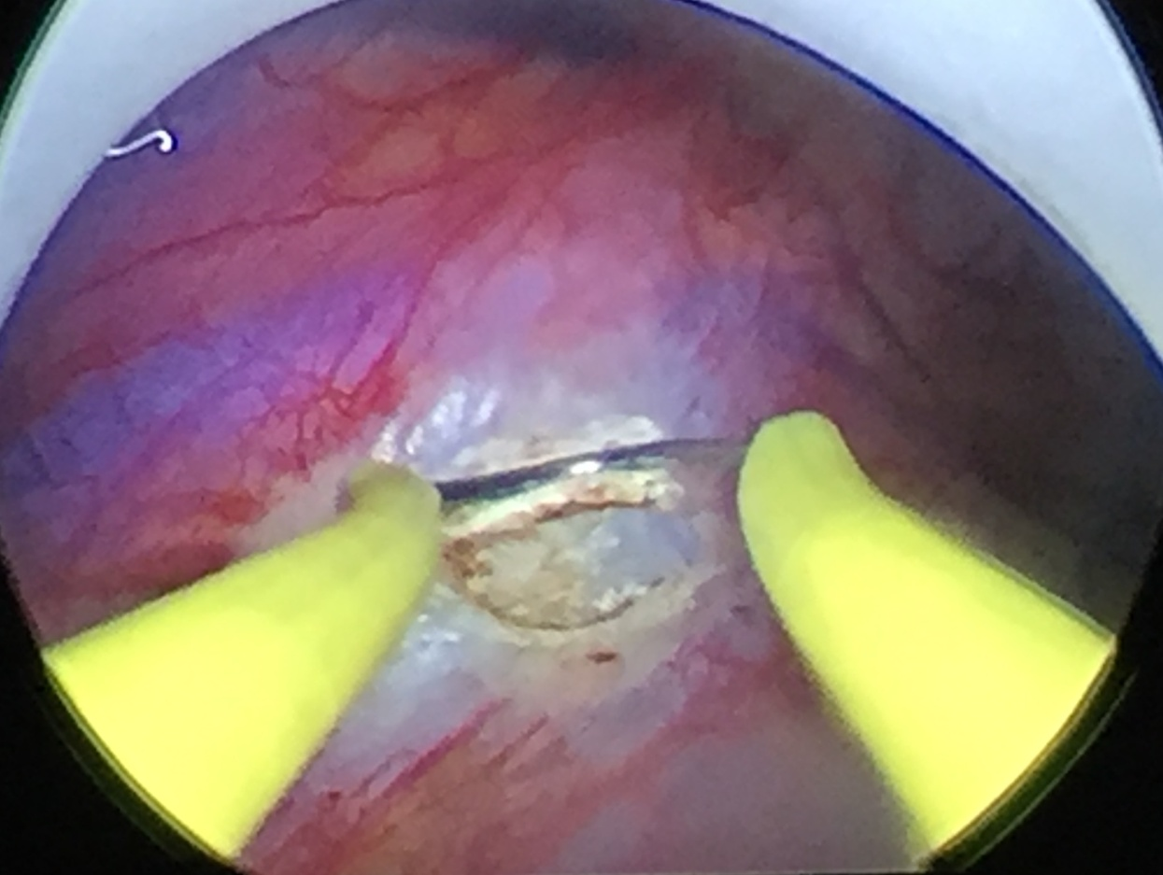

Figure legend: Sympathicotomy of the third left thoracic ganglia.

