Our Experiences in 7 years sealing veins -
A follow - up study conducted on 2250 truncal saphenous veins in 1250 cases

Dr. U. Th. Zierau, SAPHENION® Berlin, Rostock

Summary:
We report about 7 - years results of a prospective comparative study of VenaSeal® - Closure in the treatment of 2250 saphenous veins in 1250 patients.
The present research paper sheds light on the advantages and disadvantages and presents the 84 - month results of a single- center ambulatory clinical study with prospective design.
In the base, all varicose veins should be treated actively. This we can find in nearly all guidelines worldwide.
Since 20 years by now, varicosis has been increasingly treated endovenously. Before this, the varicose veins were treated radically with the "stripping" - method, a 110 years old radical surgery method.
At the start, the rather inconvenient VNUS® Closure Plus procedure and the more convenient linear laser procedure were used, and these were followed in 2006/2007 by the bipolar RFITT® catheter, the VNUS® ClosureFast system and the radial
laser. Thus, in the course of the last few years, plenty of experience has been gathered with endoluminal therapy, quality criteria have been defined and standards for the different techniques have been developed.
In addition, 16 years ago, far from the beaten tracks of radio wave and laser, the development of a fascinatingly simple, yet nevertheless highly effective method of sealing veins - the VenaSeal® closure technique - was initiated.
After CE approval had been granted in the autumn of 2011, a number of vein centers in Germany and Europe started using the VenaSeal® - system.
Today there is an approval in all countries, also in USA since 2 / 2015. The author has applied Venaseal for the first time in a great saphenous vein on 1st. August 2012.

1. Lawson J, S Gauw, C van Vlijmen, P Pronk, M Gaastra, M Mooij, C Wittens: Sapheon: the solution? Phlebology 2013;0:1-8
2. Min RJ, Almeida JI, McLean DJ, Madsen M, Raabe R.: Novel vein closure procedere using a proprietary cyanoacrylate adhesive: 30-day swine model results. Phlebology 2012; epub jan. 2012
3. Morrison, Nick and Kathleen Gibson: Veclose Study: Preliminary Month 1 Data; 2nd Annual Cyanoacrylate Embolization Symposium, Mainz, Jan. 18, 2014
4. Almeida, JI, Julian J. Javier, Ed Mackay, Claudia Bautista, Thomas M. Proebstle: One - Year follow up of first human use of cyanoacrylate adhesive for treatment of saphenous vein incompetence: epub 20. dec. 2012
5. Proebstle TM, Vago B, Alm J, Göckeritz O, Lebard C, Pichot, O.: Treatment of the incompetent great saphenous vein by endovenous radiofrequency powered segmental thermal ablation: first clinical experience.
J Vasc Surg 2008; 47:151–155
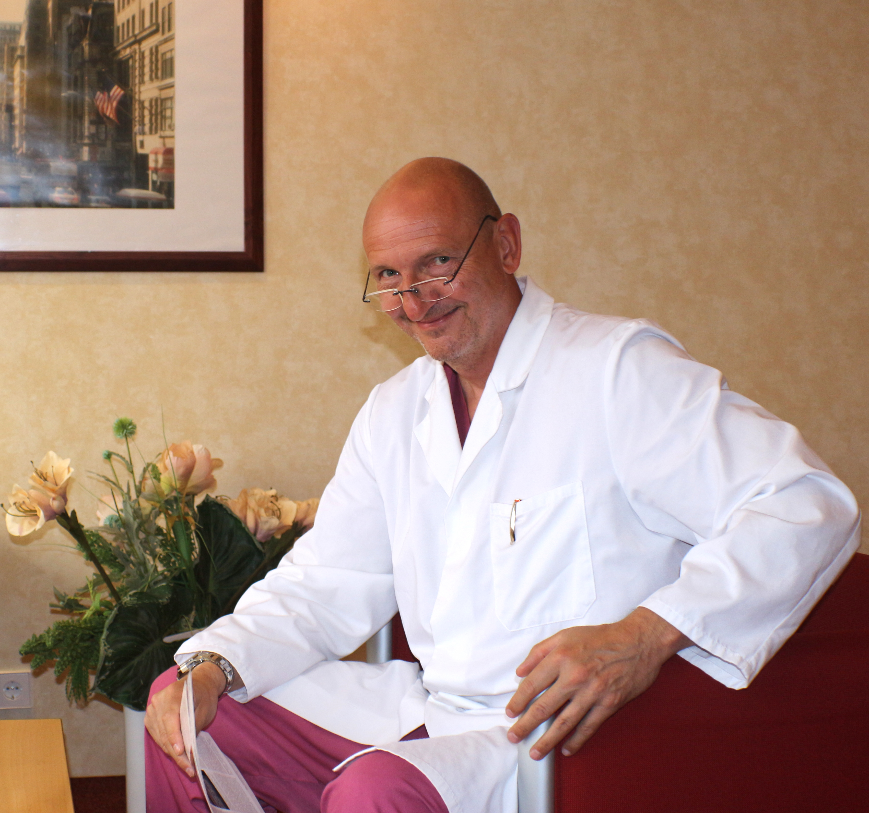

Curriculum Vitae

Ulf Thorsten Zierau

Founder and CEO of SAPHENION® - Surgeon, Vascular Surgeon, Phlebologist,

Endovascular specialist artery, endovenous specialist

Berlin / Rostock, Deutschland

Personal Information

Born: 08.06.1960, Magdeburg,
Nationality: german
Marital Status: divorced, 3 children

Professional Experiences:

Study of medicine at Humboldt University of Berlin / Charitè 1982-1988
Master Thesis 1986 (Prof. Klaus Bürger) - The Leriche - Syndrom
Promotion Thesis 1988 (Prof. Klaus Bürger) - Guidelines of Thrombosis Prophylaxis at the Charitè Hospital

Specialist training surgery 1988-1994 (Prof. Helmut Wolff)

Specialist training vascular surgery and Phlebology 1994 - 1996 at Mühlenberg Klinik Malente (Dr. Künkel) and 2. University Hospital Köln (Prof. Troidl)

Workshop endovascular catheter therapy at Stanford - University 1995
Hospitations at department of interventional radiology in Hospital Berlin - Buch

Head of vascular surgery at City Hospital Gransee / Brandenburg

Founder and CEO of SAPHENION - Vascular Surgery and Vein Care Center Berlin 1997

Founder and CEO of SAPHENION - Vein Care Center Rostock since 2012

Experiences in endovascular therapy of arteries

Catheter therapy in arteries since 1995 - 2010 - endovascular treatments in pelvic and femoral and popliteal arteries, imlantation of stents.

Experiences phlebology, endovenous theapy

Catheter therapy in veins since 2002

Conventional surgery of stripping and phlebectomy in over 10.000 cases (until 2012)

Laser ablation (2002 - 2008) of 2.200 veins

Radio wave catheter of 2.600 truncal veins (2008-2018),

VenaSeal - Closure sealing varicose veins in 1984 truncal veins and 1076 patients (since 1st. August 2012)

Scientific work

papers and presentations about history of vascular surgery from 1994-1997

papers and presentations about lasertherapy from 2002 - 2006

papers and presentations about radio wave therapy from 2008 - 2018

papers and presentations about VenaSeal - sealing veins from 2012 - 2018

First description and development of endocystic radio wave ablation of baker`s cyst in 2010

Chairman of the "1st. Northern European Endovenous Forum"
5. - 6st. October 2018 in Congress Center Hohe Düne;
Rostock - Warnemünde; Germany

Blogger at the own plebology blog: http://www.saphenion.de/news/

Some publications in newspapers, magazines and TV

