A case of pneumoscrotum following spontaneous colonic perforation and mimicking strangulated inguinal hernia
Rahele Monzavi Sany(Mehraeen), MD¹; Soheil Osia, MD²
- Assistant professor, Departement of Radiology, Amirkola Hospital, Babol University of Medical Sciences, Babol, Iran. swt_f@yahoo.com
- Assistant professor, Departement of Surgery, Amirkola Hospital, Babol University of Medical Sciences, Babol, Iran. swt_sb88@yahoo.com

Corresponding Author: Rahele Monzavi Sany (Mehraeen)
Department of Radiology, Amirkola hospital,
Babol University of Medical Sciences,
Babol , Iran
Tel: 0098-111-3242151
Fax: 0098- 111- 3253061
Email: swt_f@yahoo.com

sany_monzavi@yahoo.com

Abstract
We reported a fourty two days old, previously healthy boy following spontaneous perforation of the descending and sigmoid colon. The patient presented with progressive abdominal distention and a swollen scrotum that lead to the suspicion of strangulated inguinal hernia. Next plain abdominal radiographs showed free intraperitoneal gas and final diagnosis was made by exploratory laparatomy, that revealed perforation in the descending and sigmoid colon.
Keywords: pneumoscrotum – spontaneous perforation – strangulated inguinal hernia – sigmoid colon – pneumoperitoneum

Introduction

Idiopathic, or spontaneous, perforation of the bowels occurs without any demonstrable cause. It was first described in newborns as early in 1825.
It is extremely rare in neonates, but early diagnosis and prompt surgical treatment are life-saving [1- 3].Pneumoscrotum is also uncommon and has rarely been reported as a complication of colonic perforation [4].
Herein, we reported, an idiopathic sigmoid colon perforation revealed with a rare manifestation of pneumoscrotum.

Case Presentation
A fourty two days old boy was referred to us because of agitation, tachycardia, tachypnea, progressive abdominal distention and swollen scrotum (Fig 1). There were not any symptoms of other gastrointestinal tract such as nausea, vomiting, diarrhea, fever and the change of the stool color.
He was the first born baby of his parents and was born at full term by normal vaginal delivery.
The post natal period was uneventful until he developed progressive abdominal distention and swollen scrotum. There was not any history of related disease in his family.
On physical examination, the infant had tachycardia and tachypnea. His abdomen had distention but was soft and lax, and his scrotum had swelling with red skin that led us into a consideration of strangulated inguinal hernia.

The laboratory investigations were within normal limits, including complete blood cell counts and biochemical analysis.
Portable CXR was normal but plain abdominal x-ray revealed bowel distention, specially in the distal colon, with free intra-peritoneal gas (Rigler's sign). A small bubble of gas was seen in the left scrotal region (Figs 2).
According to the Rigler's sign, we made a tentative diagnosis of bowel perforation resulting from left sided inguinal hernia.
An urgent ultrasound of the scrotum revealed only reverberation artefact,consistent with gas. Both testes were normal.
The next plain abdominal x-ray and cross-table lateral view revealed severe progression of disease with an increased volume of free intraperitoneal gas (Figs 3).
An exploratory laparotomy was done through midline incision. The peritoneum was grossly contaminated and there was perforation of the descending and sigmoid colon on the antimesenteric side (Fig 4). Rest of the large and small bowel was normal and there were not any vesiculation or ulceration and the mucosal surfaces were intact.
Biopsies were taken from the edge of the perforation folowing which the wounds were closed. A colostomy was performed for the patient.
The mucosal biopsy specimen from the edge of perforation had a normal appearance under light microscopy, and there were not any characteristic CMV inclusions or HSV cytopathic changes. However, we had not immunohistochemistry, FISH, and PCR in our center to detect latent infection.
Also multiple distal biopsies revealed normal ganglion cells and Hirschprung's disease was excluded.
In addition, Gram stain and culture of the peritoneal fluid revealed mixed bacteria in which the most common agents included Escherichia coli and Bacteroides fragilis.
The patient recovered completely and was discharged from the hospital one week later.

Discussion

Many different factors such as trauma, ARDS, prematurity, sepsis, anaemia, and diarrhea may play a role in developing colon perforation in neonates. The hypothesis of mechanical injury, the presence of muscular defects in the wall of the colon, infection to a Schwartzman phenomenon, necrosis and perforation by meconium plugs, and perforation of colon by necrotizing bacterial enterocolitis were reported as aetiology [5].

Although spontaneous intestinal perforation (SIP) is most commonly found in VLBW premature infants [6,7], isolated colonic perforation in neonates is mostly secondary to necrotizing enterocolitis (NEC), Hirschsprung's disease, meconium ileus and small left colon syndrome [8], and colon is the predominant site of perforations caused by NEC in term neonates [9].
However, none of these seem to be the cause of perforation in our case.

The incidence of spontaneous colonic perforation is extremely rare. As in one study, it was reported only ten cases, seven of ten in very-low-birth-weight (VLBW) infants and three of ten in term or near-term neonates (one with Hirschsprung disease and the two cases without clear etiology during 10 years (2000-2009) [10].

Prompt diagnosis and early vigorous management are mandatory for neonatal colonic perforation, because of the highest mortality rate of it among neonatal gastrointestinal perforations which was reported in some studies [9].
Chen Jeng-Chang et al that performed clinicopathologic analysis of fifteen patients with spontaneous bowel perforation, revealed that perforations had a predilection for three areas: the transverse colon near the splenic flexure, the lower sigmoid, and the ileocecal region [11].
This finding was consistent with our case in which the perforation sites were in descending and sigmoid colon.

On the other hand, our patient was the first case which reported spontaneous colonic perforation with unknown etiology, which presented with pneumoscrotum during the last decades.
Intraabdominal gas may have reached the scrotum by any of the three following routes; subcoutaneously to the subcoutaneous spaces of the scrotum and remain there, or dissect or diffuse interstitially through the dartos muscle to deeper layers, retroperitoneally through the inguinal canal but superficial to the facial coverings of the spermatic cord, intraperitoneally through a processus vaginalis that is patent in 80- 95% of newborn males or by moving across the peritoneum (by diffusion or through small peritoneal tears) [12].
The first case of pneumoscrotum was described in 1912 [13], and 60 cases have been reported in the last century. In 57% of these cases, pneumoscrotum was a complication related directly to a procedure (table 1), with tube thoracostomy the most common mitigating procedure [14]. Endoscopic (upper and lower) and laparoscopic procedures were the second and third most common causes, respectively [15].
However, pneumoscrotum has been reported secondary to perforation of Meckel’s diverticulum perforation of ileum secondary to atresia, after aggressive resuscitation, and gastric perforation.[16]
Therefore, as mentioned above, the finding of gas in the scrotal sac may be an early sign of a life-threatening condition like visceral perforation or may represent an incidental finding associated with more benign conditions like laparoscopic procedures [17,18].

In our case, however, pneumoscrotum occurred following spontaneous perforation of the sigmoid and descending colon that was a life-threatening condition.
In conclusion, although a combination of free abdominal gas and distended abdomen usually make the diagnosis evident and surgical intervention should be the rule[9], this case presentation reminds us that eventhough pneumoscrotum is a benign, rare condition, its mere presence should signal the possibility of a severe, life-threatening disease process within the peritoneum like bowel perforation or retroperitoneum like pancreatic or renal abscess.

Acknowledgement
The authors would like to thank Farzan Institute for Research and Technology for technical assistance and Amirkola pediatric research centre.
Conflict of Interest: None
References
1. Bystrom J, Dencker H, Hallgren T, et al. Idiopathic Perforation of the colon in infancy. Acta chirurgica scandinavica. 1968; 134: 314-315.
2. Cacloppo PL, Gau FC. Idiopathic perforation of the colon in a newborn. American Journal of Surgery. 1976; 132: 392-393.
3. Goodman P, Domingues R. Idiopathic colonic perforation in the neonates. Pediatric Emergency Care. 1991; 7: 18-20
4. Fu KI, Sano Y, Kato S, et al. Pneumoscrotum: A rare manifestation of perforation associated with therapeutic colonoscopy. World Journal of Gastroenterology. 2005; 11: 5061-5063.
5. H. Öztürk, A. Onen, S. Otçu, A. I. Dokucu & S. Gedik : Idiopathic Perforation Of The Colon In Neonates: A Clinical Review Of Seven Cases . The Internet Journal of Gastroenterology. 2003;2: Volume 2 Number 1

6. Kawase Y, Ishii T, Aria H, et al. Gastrointestinal perforation in very low-birth weight infants. Pediatrics International. 2006; 48: 599.

7. Meyer CL, Payne NR, Roback SA. Spontaneous, isolated intestinal perforation in neonates with birth weight less than 1000 g not associated with necrotizing enterocolitis. Journal of Pediatric Surgery. 1991; 26: 714.

8. Yadav SK, Helmi S, Al-Ramadan S. Idiopathic perforation of caecum in a neonate: Kuwait Medical Journal. 2005; 37: 47-49.

9. Ahmed Elham Fares, Hesham Mohamed El-Saket. Neonatal Colonic Perforation: A Case Series. Arabic Journal of Gastroenterolgy. 2008; 9: 75-79.

10. Bartoli F, Vasseur Maurer S, Giannoni E, et al. Focal spontaneous colic perforation in term or near-term neonates: Rare and potentially insidious: Archives of Pediatrics and Adolescent Medicine. 2011; 18: 408-412.

11. Chen JC, Chen CC, Liang JT, et al. Spontaneous bowel perforation in infants and young children: A clinicopathologic analysis of pathogenesis. Journal of Pediatric Gastroenterology and Nutrition. 2000; 30: 432-435.
12. Millmound SH, Goldman SM. Pneumoscrotum after spontaneous pneumothorax with air leak. Journal of Urology. 1991; 145: 1271-1272.
13. Keyes EL. two cases of pneumoscrotum following nephrectomy. American Journal of Urology. 1912; 8:68.
14. Futter NG. Scortal Emphysema. Urology. 1980; 15: 360-361.
15. Klimach OE, Defriend Dj, foster DN. Pneumoscrotum following endoscopic sphincterotomy. Surgical Endoscopy. 1990; 4: 230-231.
16. Yousuf AK, Jamshed A. Pneumoscrotum: A rare presentation of Gastric Perforation in a Neonate. Association of Pediatrics Surgeons of Pakistan Journal of Case Reports. 2010; 1: 15
17.Casey RG, Al-Dousari S, Murphy D, et al. Chest drain insertion may result in the acute scrotum. Scandinavian Journal of Urology and Nephrology. 2006; 40: 78-79.
18. Keyes EI. Two cases of pneumoscrotum following open gastrostomy. Contemporary Surgery. 2004; 60: 219-221.

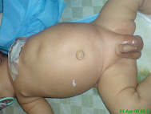
Fig 1: A 42 day old boy with agitation, progressive abdominal distention and an erythematous swollen scrotum

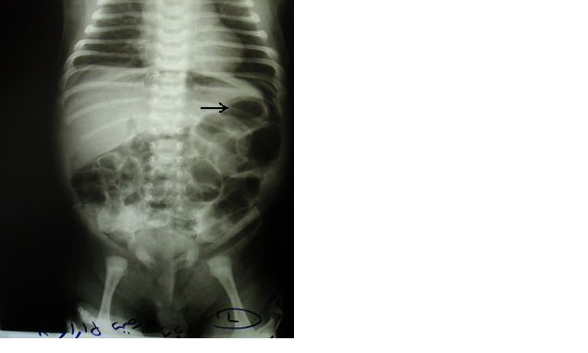

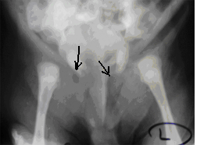
Fig 2: A- Abdominal x-ray reveals bowel loop distention and free intraperitoneal gas(arrow). B- Pelvic x-ray shows air in left scrotal and inguinal region (arrow).

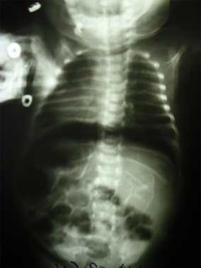

Fig 3: Plain abdominal x-ray 3 hours later showed free intraperitoneal gas.

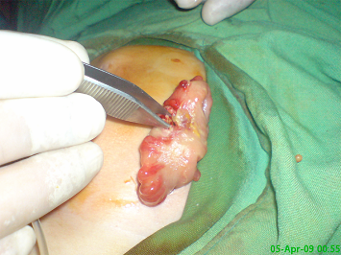

Fig 4- Perforation of the descending and sigmoid colon on the antimesenteric side revealed during exploratomy laparotomy.

TABLE-1 Etiology of Pneumoscrotum in 60 Reported Cases

Procedure (n=34) Number of cases
Chest tube | 8
Endoscopy | 5
Laparoscopy | 5
Artificial pneumoperitoneum | 4
Open intraabdominal procedures | 3
Mechanical ventilation | 2
Cardiopulmonary resuscitation | 2
Retroperitoneal procedures | 2
Arthroscopy | 1
Pacemaker insertion | 1
Hemorrhoidectomy | 1
Disease Process (n=26)
Perforated viscus | 10
Urogenital infection/trauma | 8
Pneumothorax | 5
Spontaneous | 2
Rapid decompression after diving | 1

