Abstract Template
Abstract Title: A Successful Weight Loss Strategy
Dr. Ghazi Daradkeh¹, Ph.D, Dr.Nahla Bayari 2, Ph.D, Asmaa AL Muhannadi 3 , Hussien Awadat 4

¹ Dr. Ghazi Daradkeh, Ph.D ⁽Hamad Medical Corporation , Qatar )
² Dr. Nahla Bayari, Ph.D (Balqa University, Joprdan)
³ Asmaa AL Muhannadi (Hamad Medical Corporation , Qatar )
4 Hussien Awadat (Hamad Medical Corporation , Qatar )

Abstract

Background: Obesity occurred because of imbalance between energy intake and energy expenditure. It became a global epidemic in all age groups in both developed and developing countries. In addition to health complications of obesity, costs and social difficulties has been reported. Weight loss goal should be gradual, easy to achieve and maintainable. Developing skills required to successfully change problematic eating and activity patterns is an important factor in weight reduction. A combination of calorie reduction increased physical activity and behavior therapy are the basic principles for better outcomes.
Method: Calorie restriction (-500 Cal/day) diet, increase physical activity (45 minutes of moderate intensity for at least five days/week) and behavioral therapy (food selection, slow eating, well chewing, calorie counting, etc.) were followed.
Results: Weight and body mass index were reduced by 23.5%, while waist circumference and% of body fat were reduced by 21.3% and 30% respectively. Total cholesterol, triglycerides, LDL-c and uric acid were significantly reduced post intervention; HDL-c and vitamin D were significantly improved.
Conclusion: Weight reduction goal is achievable through a combination
Keywords: Behavioral, Obesity, Strategy, Weight Reduction

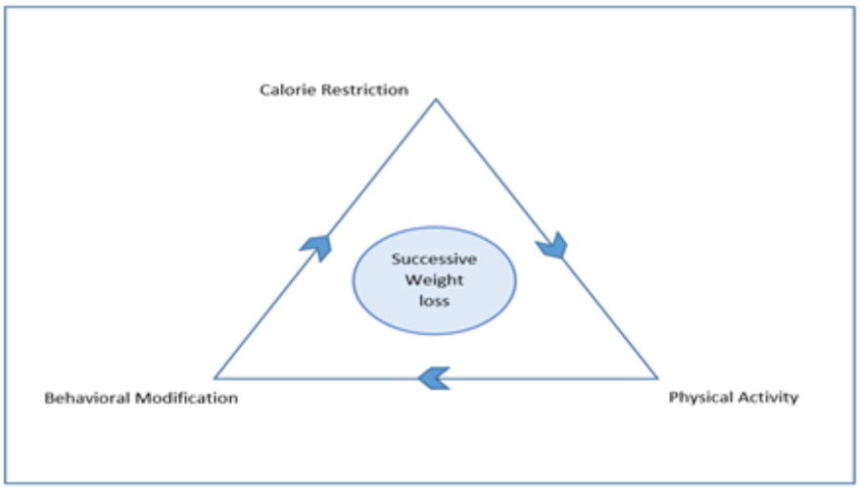

Figure 1: Components of a successful weight loss strategies

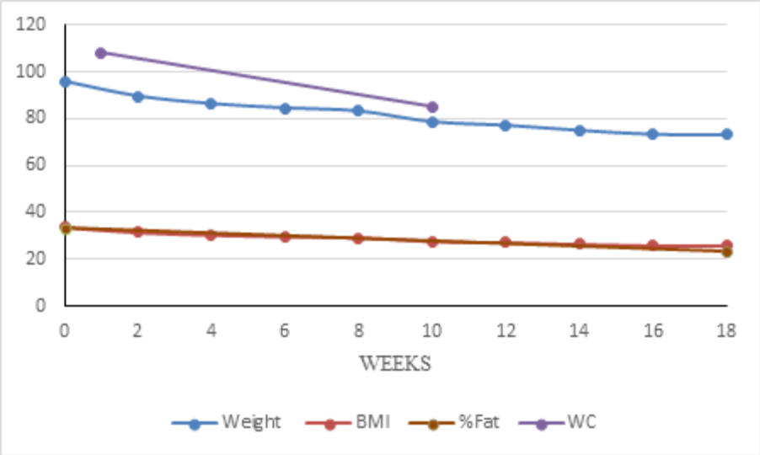

Figure 2. Progression of Anthropometric Measurements Post Intervention.

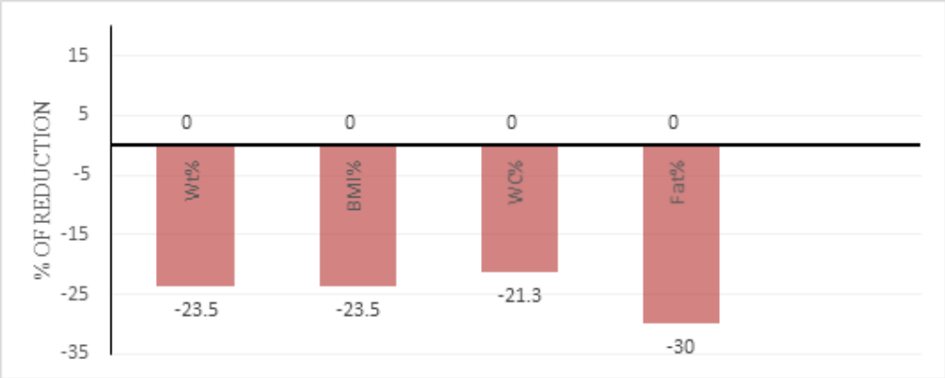

Figure 3. Percentage of Anthropometric and % Body Fat Reduction.

These instructions give you guidelines for preparing papers for conference. Use this document as a template if you are using Microsoft Word. Otherwise, use this document as an instruction set. Define all symbols used in the abstract. Do not cite references in the abstract. Insert images/graphs if any.

Keywords—Four key words or phrases in alphabetical order, separated by commas

Professional Biography (100-150 words)

Dr.Ghazi Daradkeh has completed his PhD at the age of 35 years from Sultan Qaboos University. He is the clinical dietitian supervisor at Hamad Medical Corporation – State of Qatar... He has published more than 25 papers in reputed journals and has been serving as an editorial board member of repute. He has 30 years of experience in clinical nutrition and dietetics field.
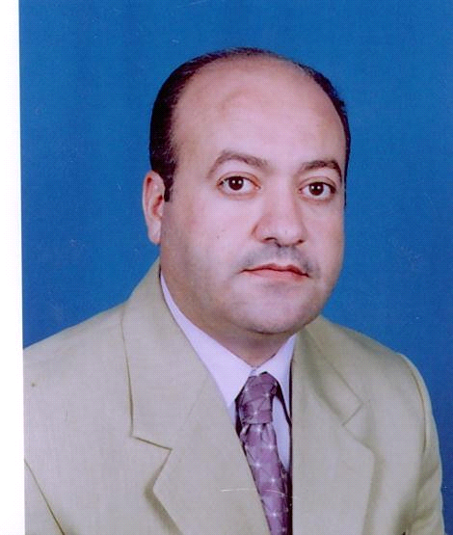

Paste your Photograph here

Email Id: ghaziffff@gmail.com

Any Comments:

