Abstract Template
Omega-3 Fatty Acids Insufficiency in Post Traumatic Brain Injury Patient (TBI) Attending Neurosurgery Clinics at Khola Hospital in Muscat- Sultanate of Oman
Research Article Open Access
Dr. Ghazi Daradkeh1,Ph.D, Dr. Musthafa Mohamed Essa2, Dr. Ali AL- Maashani3, Dr. Samir Al-Adawi4

¹ Dr. Ghazi Daradkeh (Hamad Medical Corporation , Qatar )
²Dr. Mustafa Essa (Sultan Qaboos University, , Oman )
³Dr. Ali Mashaani (khola hospital , Ministry of Health, Oman )
4 DR. Samir Al-Adawi4 (Sultan Qaboos University, , Oman)

Abstract
Background: Traumatic brain injury (TBI) is an acquired brain trauma that occurs when any sudden trauma/injury causes damage to the brain. TBI is characterized by tissue damage and imbalance in the cerebral blood flow and metabolism. It has been established through laboratory experiments that the dietary supplementation of omega-3 fatty acids (FAs) could reduce the oxidative stress developed in the brain due to TBI. The inclusion of omega-3 FAs in diet could normalize the levels of brain-derived neurotrophic factor (BDNF), and thus, it could restore the survival of neuronal cells that improves the synaptic transmission.

Method: A total of 71 Posttraumatic brain injury Patients (PTBIP) aged 18-65 years, males and females participated in a cross-sectional study in Khola hospital (trauma center) Sultanate of Oman. The intake of omega -3 FAs were calculated from a dietary intake assessment using 24 hour-recall diet history.

Results: The Average intake of omega – 3 in both males (1.1 gm/d) and females (0.65gm/d) was significantly inadequate compared with the RDA (1.6 gm/d and 1.1 gm/d) among males and females respectively P < 0.05. There was a positive association between the dietary intake of omega-3 FAs and BMI. The severity of Traumatic brain injury as measured by GCS has been inversely correlated with the intake of omega-3-FAs.

Conclusions: Inadequate dietary intake of omega-3 FAs is common in post-traumatic brain injury patients. Thus, omega-3 FAs supplements could be considered as a therapeutic option to reduce the secondary neuronal damages initiated by TBI.

Keywords: Fatty acids, Omega-3, Ssupplements, Traumatic brain injury

Professional Biography (100-150 words)

Dr.Ghazi Daradkeh has completed his PhD at the age of 35 years from Sultan Qaboos University. He is the clinical dietitian supervisor at Hamad Medical Corporation – State of Qatar... He has published more than 25 papers in reputed journals and has been serving as an editorial board member of repute. He has 30 years of experience in clinical nutrition and dietetics field.
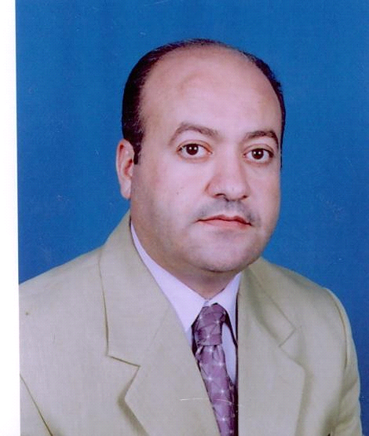

Paste your Photograph here

Email Id: ghaziffff@gmail.com

