Title: Microbial and nutritional analysis of packed ice cream sold in Lahore
Aiman Shafique ¹

¹ Department of Home Economics, The Lahore College for Women University, Lahore, Pakistan
Abstract

Ice cream is a dairy product that is produced by freezing the mixture containing sugar, cream, stabilizers, emulsifiers and aroma materials, and it is the most famous frozen food in the world. This research was conducted to investigate the microbiological and nutritional quality of the famous ice cream brands sold in Lahore. Qualitative microbiological analysis of different ice cream samples of various famous local brands was carried out for the identification of microbes by the standard biochemical tests. Proximate analysis has been done in order to evaluate the nutritional quality of the ice cream. Results obtained from the quantitative analysis of biochemical tests showed that the specimens carried a number of microbes and 6 isolates were identified from them. Cultural and biochemical evaluations disclosed the existence of Klebsiella sp., Staphylococcus sp., Shigella sp., Bacillus sp., Escherichia coli and Salmonella sp. Although, no ice cream sample has the total viable count within the acceptable range standardized by the International Standards for Food. But, the highest microbial quantity was detected in Doce vanilla ice cream, and least microbial count was obtained from Gourmet vanilla ice cream. Proximate analysis of all the ice cream samples revealed that none of the ice cream sample has the nutritional quality in compliance with the standard values. The results indicated that packed ice creams sold in Lahore are contaminated with pathogens and would be a potential hazard for public health. Therefore, strict action has to be taken by the government to imply quality standards in these famous ice cream manufacturing companies.
Keywords— Ice cream, microbiological quality, nutritional quality, public health

Professional Biography

Aiman Shafique has completed her BSc in Food & Nutrition at the age of 22 years from Lahore College for Women University Lahore Pakistan. She secured 3.73/4.0 cgpa and ranked second in her session. She is looking for scholarships for her masters from abroad. At the same time, she is making her research profile.

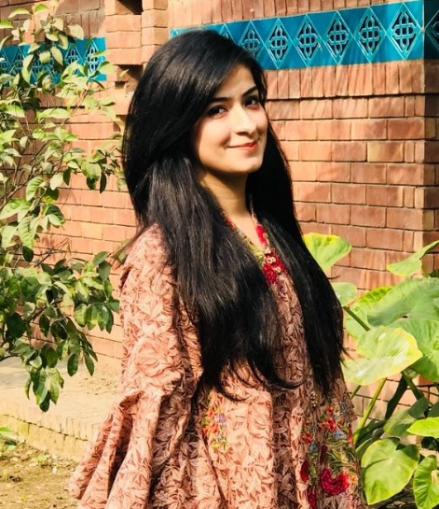

Email Id: aimanshafique57@gmail.com

