The efficacy of hepamerze in the treatment of acute viral hepatitis
Jawad F. H. Al-Musawi*, Alaa J. Hasin** , Riyadh A. Jaed***
Abstract;.
This study was done in Al- Hussein Teaching Hospital in An-Nasiriyah City, on 97 patients through one year from august 2011 to July 2012,those patients were complaining from fever, jaundice, pain in right hypochondrial area, dark color urine, loss of appetite, nausea and vomiting ,after complete history and clinical examination with specific investigation for viral hepatitis, we selected the cases that improved " the complaining from viral hepatitis B or C, that, we exclude all the patients who suffered from other causes. We can investigate 97 of those patients complaining from viral hepatitis B. or C. Their age ranging from 23-68 years.
We divided those patients to many groups according to the level of liver enzymes as serum A.S.T., serum A.L.T., Alkaline Phosphates, and Alanin Transaminase. Hepamerze was the treatment which was given to those patients for 14 days, other group for 21 days and other 28 days. All patients were followed-up regularly to evaluate the effect of Hepamerze on the liver .
We found that, the peak effect of Hepamerze on day 16th and day 21th where 42% of the cases, that, there were completely reduction in the liver enzymes.
Key word; Hepamerze ,liver enzymes (A.L.T., A.S.T.), hepatitis
Introduction;
Hepamerze is composed from active substance: L-ornithine L-aspartate 3,00 g; with the additional substances are anhydrous citric acid, lemon flavor, orange flavor, sodium saccharin, sodium cyclamate, orange-yellow S (Е 110), povidone К 25, laevulose. Hepamerze is Hepaprotector-detoxicant. Lowers high ammonia level in the organism, and, particularly, in the encephalon(1).
under disorder of desintoxication liver function. It has an apparent effect upon toxic hepatic encephalopathy(2). The action of the preparation is connected with participation thereof in the urea cycle (formation of urea from ammonia, increase in glutamine synthesis). Contributes to production of insulin and somatotropic hormone STH. Improves protein metabolism in diseases requiring parenteral nutrition(3).
Hepamerze has adverse effect as Cutaneous reactions are rarely observed. In specific cases – nausea, vomiting. It has some contraindications as Apparent hepatic dysfunction (with creatinine level exceeding 3 mg/100 ml of blood plasma)(4). It
Interacted with other medicinal products: As no compatibility studies have been performed, the medicinal product must not be mixed with other medicinal products. It has 5 year shelf life and store in room temperature.
Hepa-Merz is a hepatoprotective medications that lowers high ammonia levels in the organism. Hepa-Merz possesses the expressed therapeutic effect against toxic liver encephalopathy, contributes to production of insulin and somatotropic hormone STH, improves protein metabolism in diseases required parenteral nutrition(5).
Hepamerze is indicated:
in acute and chronic liver diseases, manifested in hyperammoniemia
in liver encephalopathy
Talk with your doctor before the treatment with Hepa-Merz if you are pregnant or breastfeeding(6).

Hepatitis B
Hepatitis B is an infectious inflammatory illness of the liver caused by the hepatitis B virus (HBV) that affects hominoidea, including humans. Originally known as "serum hepatitis"(7) the disease has caused epidemics in parts of Asia and Africa, and it is endemic in China(8). About a third of the world population has been infected at one point in their lives(9), including 350 million who are chronic carriers(10).
The virus is transmitted by exposure to infectious blood or body fluids such as semen and vaginal fluids, while viral DNA has been detected in the saliva, tears, and urine of chronic carriers. Perinatal infection is a major route of infection in endemic (mainly developing) countries. Other risk factors for developing HBV infection include working in a healthcare setting, transfusions, dialysis, acupuncture, tattooing, sharing razors or toothbrushes with an infected person, travel in countries where it is endemic, and residence in an institution.(3, 6, 7, 8). However, hepatitis B viruses cannot be spread by holding hands, sharing eating utensils or drinking glasses, kissing, hugging, coughing, sneezing, or breastfeeding(9).
The acute illness causes liver inflammation, vomiting, jaundice, and, rarely, death. Chronic hepatitis B may eventually cause cirrhosis and liver cancer—a disease with poor response to all but a few current therapies(10). The infection is preventable by vaccination(11).
Hepatitis B virus is a hepadnavirus—hepa from hepatotropic (attracted to the liver) and dna because it is a virus and it has a circular genome of partially double-stranded DNA. The viruses replicate through an RNA intermediate form by reverse transcription, which in practice relates them to retroviruses(12, 13). Although replication takes place in the liver, the virus spreads to the blood where viral proteins and antibodies against them are found in infected people(14). The hepatitis B virus is 50 to 100 times more infectious than HIV(15).

Signs and symptoms
Acute infection with hepatitis B virus is associated with acute viral hepatitis – an illness that begins with general ill-health, loss of appetite, nausea, vomiting, body aches, mild fever, and dark urine, and then progresses to development of jaundice. It has been noted that itchy skin has been an indication as a possible symptom of all hepatitis virus types. The illness lasts for a few weeks and then gradually improves in most affected people. A few people may have more severe liver disease (fulminant hepatic failure), and may die as a result. The infection may be entirely asymptomatic and may go unrecognized(16).

Virology:
Main article: Hepatitis B virus

Structure:
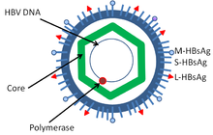
The structure of hepatitis B virus
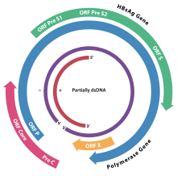
The genome organization of HBV. The genes overlap.

Genome
The genome of HBV is made of circular DNA, but it is unusual because the DNA is not fully double-stranded. One end of the full length strand is linked to the viral DNA polymerase. The genome is 3020–3320 nucleotides long (for the full-length strand) and 1700–2800 nucleotides long (for the short length-strand)(17).
The negative-sense (non-coding) is complementary to the viral mRNA. The viral DNA is found in the nucleus soon after infection of the cell. The partially double-stranded DNA is rendered fully double-stranded by completion of the (+) sense strand and removal of a protein molecule from the (-) sense strand and a short sequence of RNA from the (+) sense strand. Non-coding bases are removed from the ends of the (-) sense strand and the ends are rejoined. There are four known genes encoded by the genome, called C, X, P, and S. The core protein is coded for by gene C (HBcAg), and its start codon is preceded by an upstream in-frame AUG start codon from which the pre-core protein is produced. HBeAg is produced by proteolytic processing of the pre-core protein(18).

Serotypes and genotypes
The virus is divided into four major serotypes (adr, adw, ayr, ayw) based on antigenic epitopes presented on its envelope proteins, and into eight genotypes (A-H) according to overall nucleotide sequence variation of the genome. The genotypes have a distinct geographical distribution and are used in tracing the evolution and transmission of the virus. Differences between genotypes affect the disease severity, course and likelihood of complications, and response to treatment and possibly vaccination(18, 19).
Genotypes differ by at least 8% of their sequence and were first reported in 1988 when six were initially described (A-F)(20). Two further types have since been described (G and H)(21). Most genotypes are now divided into subgenotypes with distinct properties(22).
Genotype A is most commonly found in the Americas, Africa, India and Western Europe. Genotype B is most commonly found in Asia and the United States. Genotype B1 dominates in Japan, B2 in China and Vietnam while B3 confined to Indonesia. B4 is confined to Vietnam. All these strains specify the serotype ayw1. B5 is most common in the Philippines. Genotype C is most common in Asia and the United States. Subgenotype C1 is common in Japan, Korea and China. C2 is common in China, South-East Asia and Bangladesh and C3 in Oceania. All these strains specify the serotype adrq. C4 specifying ayw3 is found in Aborigines from Australia.(23).
Genotype D is most commonly found in Southern Europe, India and the United States and has been divided into 8 subtypes (D1–D8). In Turkey genotype D is also the most common type(22).

Pathogenesis:
Hepatitis B virus primarily interferes with the functions of the liver by replicating in liver cells, known as hepatocytes. A functional receptor is NTCP(24). There is evidence that the receptor in the closely related duck hepatitis B viruscarboxypeptidase D(25). The virions bind to the host cell via the preS domain of the viral surface antigen and are subsequently internalized by endocytosis. HBV-preS-specific receptors are expressed primarily on hepatocytes; however, viral DNA and proteins have also been detected in extrahepatic sites, suggesting that cellular receptors for HBV may also exist on extrahepatic cells(26).
During HBV infection, the host immune response causes both hepatocellular damage and viral clearance. Although the innate immune response does not play a significant role in these processes, the adaptive immune response, in particular virus-specific cytotoxic T lymphocytes(CTLs), contributes to most of the liver injury associated with HBV infection. CTLs eliminate HBV infection by killing infected cells and producing antiviral cytokines, which are then used to purge HBV from viable hepatocytes(28). Although liver damage is initiated and mediated by the CTLs, antigen-nonspecific inflammatory cells can worsen CTL-induced immunopathology, and platelets activated at the site of infection may facilitate the accumulation of CTLs in the liver(29).

Transmission:
Transmission of hepatitis B virus results from exposure to infectious blood or body fluids containing blood. Possible forms of transmission include sexual contact, blood transfusions and transfusion with other human blood products . re-use of contaminated needles and syringes(27), and vertical transmission from mother to child (MTCT) during childbirth. Without intervention, a mother who is positive for HBsAg confers a 20% risk of passing the infection to her offspring at the time of birth. This risk is as high as 90% if the mother is also positive for HBeAg. HBV can be transmitted between family members within households, possibly by contact of nonintact skin or mucous membrane with secretions or saliva containing HBV. ^{[28]} However, at least 30% of reported hepatitis B among adults cannot be associated with an identifiable risk factor. And Shi et al. showed that breastfeeding after proper immunoprophylaxis did not contribute to MTCT of HBV(29).

Diagnosis
Hepatitis B viral antigens and antibodies detectable in the blood following acute infection.

Hepatitis B viral antigens and antibodies detectable in the blood of a chronically infected person.
The tests, called assays, for detection of hepatitis B virus infection involve serum or blood tests that detect either viral antigens (proteins produced by the virus) or antibodies produced by the host. Interpretation of these assays is complex(30).
The hepatitis B surface antigen (HBsAg) is most frequently used to screen for the presence of this infection. It is the first detectable viral antigen to appear during infection. However, early in an infection, this antigen may not be present and it may be undetectable later in the infection as it is being cleared by the host. The infectious virion contains an inner "core particle" enclosing viral genome. The icosahedral core particle is made of 180 or 240 copies of core protein, alternatively known as hepatitis B core antigen, or HBcAg. During this 'window' in which the host remains infected but is successfully clearing the virus, IgM antibodies to the hepatitis B core antigen (anti-HBc IgM) may be the only serological evidence of disease. Therefore most hepatitis B diagnostic panels contain HBsAg and total anti-HBc (both IgM and IgG)(31).
Shortly after the appearance of the HBsAg, another antigen called hepatitis B e antigen (HBeAg) will appear. Traditionally, the presence of HBeAg in a host's serum is associated with much higher rates of viral replication and enhanced infectivity; however, variants of the hepatitis B virus do not produce the 'e' antigen, so this rule does not always hold true. During the natural course of an infection, the HBeAg may be cleared, and antibodies to the 'e' antigen (anti-HBe) will arise immediately afterwards. This conversion is usually associated with a dramatic decline in viral replication(32).
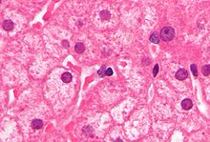
Ground glass hepatocytes as seen in a chronic hepatitis B. Liver biopsy. H& E stains.
If the host is able to clear the infection, eventually the HBsAg will become undetectable and will be followed by IgG antibodies to the hepatitis B surface antigen and core antigen, (anti-HBs and anti HBc IgG)(33). The time between the removal of the HBsAg and the appearance of anti-HBs is called the window period. A person negative for HBsAg but positive for anti-HBs either has cleared an infection or has been vaccinated previously.
Individuals who remain HBsAg positive for at least six months are considered to be hepatitis B carriers(34). Carriers of the virus may have chronic hepatitis B, which would be reflected by elevated serum alanine aminotransferase (ALT) levels and inflammation of the liver, as revealed by biopsy. Carriers who have seroconverted to HBeAg negative status, in particular those who acquired the infection as adults, have very little viral multiplication and hence may be at little risk of long-term complications or of transmitting infection to others(35).
PCR tests have been developed to detect and measure the amount of HBV DNA, called the viral load, in clinical specimens. These tests are used to assess a person's infection status and to monitor treatment. Individuals with high viral loads, characteristically have ground glass hepatocytes(34).
The earliest record of an epidemic caused by hepatitis B virus was made by Lurman in 1885(36). An outbreak of smallpox occurred in Bremen in 1883 and 1,289 shipyard employees were vaccinated with lymph from other people. After several weeks, and up to eight months later, 191 of the vaccinated workers became ill with jaundice and were diagnosed as suffering from serum hepatitis. Other employees who had been inoculated with different batches of lymph remained healthy. Lurman's paper, now regarded as a classical example of an epidemiological study, proved that contaminated lymph was the source of the outbreak. Later, numerous similar outbreaks were reported following the introduction, in 1909, of hypodermic needles that were used, and, more importantly, reused, for administering Salvarsan for the treatment of syphilis. The virus was not discovered until 1965 when Baruch Blumberg , then working at the National Institutes of Health (NIH), discovered the Australia antigen (later known to be hepatitis B surface antigen, or HBsAg) in the blood of Australian aboriginal people(34). Although a virus had been suspected since the research published by MacCallum in 1947, D.S. Dane and others discovered the virus particle in 1970 by electron microscopy. By the early 1980s the genome of the virus had been sequenced, and the first vaccines were being tested(37).

Hepatitis C :
Hepatitis C is an infectious disease affecting primarily the liver, caused by the hepatitis C virus (HCV)(38). The infection is often asymptomatic, but chronic infection can lead to scarring of the liver and ultimately to cirrhosis, which is generally apparent after many years. In some cases, those with cirrhosis will go on to develop liver failure, liver cancer or life-threatening esophageal and gastric varices(39).
HCV is spread primarily by blood-to-blood contact associated with intravenous drug use, poorly sterilized medical equipment and transfusions. An estimated 130–200 million people worldwide are infected with hepatitis C. The existence of hepatitis C (originally "non-A non-B hepatitis") was postulated in the 1970s and proven in 1989(30). Hepatitis C only infects humans and chimpanzees(40).
The virus persists in the liver in about 85% of those infected. This persistent infection can be treated with medication: the standard therapy is a combination of peginterferon and ribavirin, with either boceprevir or telaprevir added in some cases. Overall, 50–80% of people treated are cured. Those who develop cirrhosis or liver cancer may require a liver transplant. Hepatitis C is the leading cause of liver transplantation, though the virus usually recurs after transplantation. No vaccine against hepatitis C is available(41).

Signs and symptoms :

Acute infection :
Hepatitis C infection causes acute symptoms in 15% of cases. Symptoms are generally mild and vague, including a decreased appetite, fatigue, nausea, muscle or joint pains, and weight loss and rarely does acute liver failure result. Most cases of acute infection are not associated with jaundice. The infection resolves spontaneously in 10-50% of cases, which occurs more frequently in individuals who are young and female(42).

Virology:
The hepatitis C virus (HCV) is a small, enveloped, single-stranded, positive-sense RNA virus. It is a member of the hepacivirus genus in the family Flaviviridae.^{[43]} There are seven major genotypes of HCV, which are indicated numerically from one to seven(43). In the United States, about 70% of cases are caused by genotype 1, 20% by genotype 2, and about 1% by each of the other genotypes. Genotype 1 is also the most common in South America and Europe(44).

Transmission:
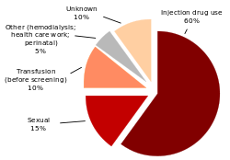
"Hepatitis C infection in the United States by source"
The primary route of transmission in the developed world is intravenous drug use (IDU), while in the developing world the main methods are blood transfusions and unsafe medical procedures. The cause of transmission remains unknown in 20% of cases; however, many of these are believed to be accounted for by IDU(45).

Intravenous drug use:
IDU is a major risk factor for hepatitis C in many parts of the world(46)

Healthcare exposure:
Blood transfusion, transfusion of blood products, or organ transplantation without HCV screening carry significant risks of infection(47). Those who have experienced a needle stick injury from someone who was HCV positive have about a 1.8% chance of subsequently contracting the disease themselves. The risk is greater if the needle in question is hollow and the puncture wound is deep. There is a risk from mucosal exposures to blood; but this risk is low, and there is no risk if blood exposure occurs on intact skin(48).
Hospital equipment has also been documented as a method of transmission of hepatitis C including: reuse of needles and syringes, multiple-use medication vials, infusion bags, and improperly sterilized surgical equipment, among others(49). Limitations in the implementation and enforcement of stringent standard precautions in public and private medical and dental facilities are known to be the primary cause of the spread of HCV in Egypt, the country with highest rate of infection in the world(50).

Sexual intercourse:
Whether hepatitis C can be transmitted through sexual activity is controversial(51). While there is an association between high-risk sexual activity and hepatitis C, it is not known whether transmission of the disease is due to drug use that has not been admitted to or sex as a risk factor. The majority of evidence supports there being no risk for monogamous heterosexual couples. Sexual practices that involve higher levels of trauma to the anogenital mucosa, such as anal penetrative sex(52).

Body modification:
Tattooing is associated with two to threefold increased risk of hepatitis C(53).

Shared personal items:
Personal-care items such as razors, toothbrushes, and manicuring or pedicuring equipment can be contaminated with blood. Sharing such items can potentially lead to exposure to HCV(54).

Vertical transmission:
Vertical transmission of hepatitis C from an infected mother to her child occurs in less than 10% of pregnancies(55)..

Diagnosis:
Serologic profile of Hepatitis C infection
There are a number of diagnostic tests for hepatitis C including: HCV antibody enzyme immunoassay or ELISA, recombinant immunoblot assay, and quantitative HCV RNA polymerase chain reaction (PCR). HCV RNA can be detected by PCR typically one to two weeks after infection, while antibodies can take substantially longer to form and thus be detected(56).

Biopsy:
Liver biopsies are used to determine the degree of liver damage present; however, there are risks from the procedure. The typical changes seen are lymphocytes within the parenchyma, lymphoid follicles in portal triad, and changes to the bile ducts. There are a number of blood tests available that try to determine the degree of hepatic fibrosis and alleviate the need for biopsy(57).

Treatment:
HCV induces chronic infection in 50–80% of infected persons. Approximately 40-80% of these clear with treatment. In rare cases, infection can clear without treatment. Those with chronic hepatitis C are advised to avoid alcohol and medications toxic to the liver and to be vaccinated for hepatitis A and hepatitis B. Ultrasound surveillance for hepatocellular carcinoma is recommended in those with accompanying cirrhosis(58).

Prognosis:
Responses to treatment vary by HCV C genotype, and is measured by sustained viral response. Sustained response is about 40-50% in people with HCV genotype 1 given 48 weeks of treatment(59). Sustained response is seen in 70-80% of people with HCV genotypes 2 and 3 with 24 weeks of treatment. Sustained response is about 65% in those with genotype 4 given 48 weeks of treatment. The evidence for treatment in genotype 6 disease is sparse, and the evidence that exists is for 48 weeks of treatment at the same doses as are used for genotype 1 disease. Successful treatment decreases the future risk of hepatocellular carcinoma by three quarters(60).

Epidemiology:
Prevalence of hepatitis C worldwide in 1999
It is estimated that 130–200 million people, or ~3% of the world's population, are living with chronic hepatitis C. About 3–4 million people are infected per year, and more than 350,000 people die yearly from hepatitis C-related diseases. Rates have increased substantially in the 20th century due to a combination of IDU and intravenous medication or poorly sterilized medical equipment(61).
Among those chronically infected, the risk of cirrhosis after 20 years varies between studies but has been estimated at ~10%-15% for men and ~1-5% for women. The reason for this difference is not known. Once cirrhosis is established, the rate of developing hepatocellular carcinoma is ~1%-4% per year(62).
In the United States, about 2% of people have hepatitis C. with about 35,000 to 185,000 new cases a year. Rates have decreased in the Western world since the 1990s due to improved screening of blood before transfusion. Annual deaths from HCV in the United States range from 8,000 to 10,000; expectations are that this mortality rate will increase, as those infected by transfusion before HCV testing become apparent(63).
Prevalence is higher in some countries in Africa and Asia. Countries with particularly high rates of infection include Egypt (22%), Pakistan (4.8%) and China (3.2%). It is believed that the high prevalence in Egypt is linked to a now-discontinued mass-treatment campaign for schistosomiasis, using improperly sterilized glass syringes(64).
PATIENTS AND METHODS:
This study was done in Al-Hussein Teaching Hospital on 97 patients, who were complaining from acute viral hepatitis types B or C. through one year from August 2011 to July 2012, 344 patients coming to outpatient to AL-Hussein Teaching Hospital, complaining from fever, nausea, vomiting, right hypochondrial pain and tenderness with dark yellow urine ,specific test for viral hepatitis B and C through eliza technique to isolate the patients who complaining from acute viral hepatitis B, or C and exclude other patients who complaining from other causes .The 97 patients were improved who were viral hepatitis. Liver function tests were also done for them mainly liver enzymes "alanin transamenase"(ALT), "aspertate-trans-amenase"(AST), and total serum billirobin(T.S.B)) ,autrasonographic findings, were also done to visualize the architecture finding of the liver. We classified those patients to 3 groups mild cases were (33 patients) that, the levels of ALT& AST enzymes range between 55-65 U/L and total serum billirobin between 1.4-2.5 mg/dl, moderate cases were (35 patients) that, the levels of their enzymes were within a range of "68-80" U/L. The T.S.B. were within a range of "2.7-4.0" mg/dl and severely affected patients, which were (29 patients), their liver enzymes were within the level above "80"U/L. and T.S.B. above "4.0" gm/dl. Other subdivision of those patients, were divided into: 2 groups according to the abnormality in their liver architecture, in which (70 patients) were within normal architecture and 27 patients were within abnormal architecture (hypo echoic lesions).We started with the treatment by "Hepamerze" in dose 5g (as sachets, 1-2 sachets 3 times/day), for 3 periods in each groups, we treated those patients for 14 ,21 and 28 days frequently, then evaluated the results for each group by laboratory investigation and autrasonographic finding.

RESULTS;
We get (97) patients (28%) out of (344) patients complaining from sign and symptoms of acute hepatitis and this represent a high percentage of viral infection in our city. after treatment with hepamerze to those 3 groups for 14, 21and 28 days. We found that these results as following; in mild cases: there's 7 patients(21.2%) of cases returned to normal level of serum A.L.T. & serum A.S.T.. within 14 days of treatment, and 11 patients ( 33.3%) were improved after 21 days of treatment and 13 patients (39.3%) were improved within 28 days, while 2 patients(6%) reflected on any improvements as described in (paragraph 1). While those which were moderately affected patients 6 cases (17.1%) improved after 14 days ,11 patients (31.4%) improved after 21 days , 13 patients (37.1%) improved after 28 days and 5 cases (14.2%) shown as; no any improvements as described in (paragraph 2), while in severely affected cases 3 patients (10.3%) return to normal liver functions within 14 days, 8 patients ( 27.5%) return within 21 days, and 12 patients( 41.3%) improved within 28 days while 6 cases (20.6%) had no benefit from treatment as described in (paragraph 3). About disappearance of jaundice and return of t.s.b. to normal level in severely affected patients 2 cases (6.8%) returned to normal T.S.B. after 14 days of treatment with hepamerze, 7 cases (24.1%) returned to normal sclera after 21 days, 14 cases (48.2%) returned to normal level of T.S.B. after 28 days, and only 6 patients (20.6%) had no benefit. While in mild affected cases 7 cases (21.2%) returned to normal level after 14 days, 11 cases (33.3%) within 21 days ,14 cases (42.4%) within 28 days; and only one case had no benefit. But in moderate cases we found that 9 cases (25.7%) returned after 14 days , 12 cases (34.2%) returned within 21 days,13 cases (37.1%) within 28 days, and only one patient had no benefit as described in (paragraph 5). And by the way of autrasonographic findings there were 27 patients only (27.8%) of cases who were abnormal texture of liver "hypo echoic lesion" due to the viral effect on the liver , by using hepamerze 5 patients (18.5%) returned to normal texture after 14 days , and 9(33.3%) patients after 21 days returned to normal texture, and 11 patients (40.7%) after 28 days the texture of liver returned to its normal while only 2 patients had not responded as described in( paragraph 4).

DISCUSSION;
Hepa-Merz (L-ornithine, L-aspartate), is a unique hepatoprotector-detoxicant, hypoazotemic action of which is based on direct influence upon the basic mechanism of ammonia neutralization in hepatocytes. Hepa-Merz regulates metabolism of hepatic cells, reduces the level of hepatic enzymes in blood, promotes the recession of portocaval shunt under cirrhosis(1).
From our study we found it’s the drug of choice for treatment of acute viral hepatits [viral B or C],its return the normal level of enzyme with a reasonable period especially in mild to moderate cases ,restoration of normal enzyme, that We get (97) patients (28%) out of (344) patients complaining from sign and symptoms of acute hepatitis and this represent a high percentage of viral infection in our city. after treatment with hepamerze to those 3 groups for 14, 21and 28 days, we found that these results as following; in mild cases: there's 7 patients(21.2%) of cases returned to normal level of serum A.L.T. & serum A.S.T.. within 14 days of treatment, and 11 patients ( 33.3%) were improved after 21 days of treatment and 13 patients (39.3%) were improved within 28 days, while 2 patients(6%) reflected on any improvements, this study was in agreement with Kircheis G, Nilius R, Held C, et al, that the efficacy of L-ornithine, and L-aspartate on mild, moderate and severe liver injuries(2).
Rees CJ, Oppong K, Al Mardini H, et al, found that there were some affects of hepamerze components on different stages of liver impairments, this study was accepted that, we found in this study; that those patients which were moderately affected patients 6 cases (17.1%) improved after 14 days ,11 patients (31.4%) improved after 21 days ,13 patients(37.1%) improved after 28 days and 5 cases (14.2%)(6).
Also this study reflected that, in severely affected cases 3 patients (10.3%) return to normal liver functions within 14 days, 8 patients ( 27.5%) return within 21 days, and 12 patients( 41.3%) improved within 28 days while 6 cases (20.6%) had no benefit from treatment, this was accepted by Poo JL, Góngora J, Sánchez-Avila F, et al, which they improve the effectiveness of Hepamerze on severely diseased liver, for example cirrhosis, liver enlargement etc.(4).
While this drug lead to decrease total serum billirobin level which lead to disappearance of jaundice although it delay some time more than restoration of normal enzyme level, there was some percentage of cases in our study, that there was no any benefit from these treatment for unknown causes as in mild cases 2 patients (6.8%), in moderate cases 5 patients (14.2%), and in severely affected patients, 6 patients (17.1%) so we need more study for these cases which carry no any beneficial effect from hepamerze, this is may be accepted with Poo JL, Góngora J, Sánchez-Avila F, et al., which they found in their study of hepamerze, that although the L-asspartate, and L-orthinate had high efficacious treatment of some hepatic injuries, but it may be of low grad efficacy mainly for some disease, like malignant, or a diseases of unknown etiology(4).
Also these results is agreement with Stauch S, Kircheis G, Adler G, et al, that although, oral L-ornithine-L-aspartate was the therapy of chronic hepatic encephalopathy, but it may play a role in reliving of jaundice deposition in brain, and by this way the total serum bilirubine will reduce(3)
CONCLUSION;
From the results of our study we found that the incidence of viral hepatitis with B& C in our city were high so we need centers for early detection of acute viral hepatitis mainly B&C because hepamerze had high efficacy on mild and moderate cases we found from our study that in mild cases 31 patients with viral hepatitis (B&C) from 33 total number with mild infection (93.9%) were improved within 28 days and in moderate cases 30(85.7%) patients from 35 cases were improve within 28 days but in severely affected patients there were high percentage of not responses to this treatments about 6 patients (20.6%).
So early detection of cases means a good prognosis for returning of normal liver enzyme although in severely affected cases hepamerze also effective but less than in mild and moderate cases.
Hepa-Merz is safe - ornithine-aspartate is a natural chain in tricarboxylic acid cycle.

Paragraphs;

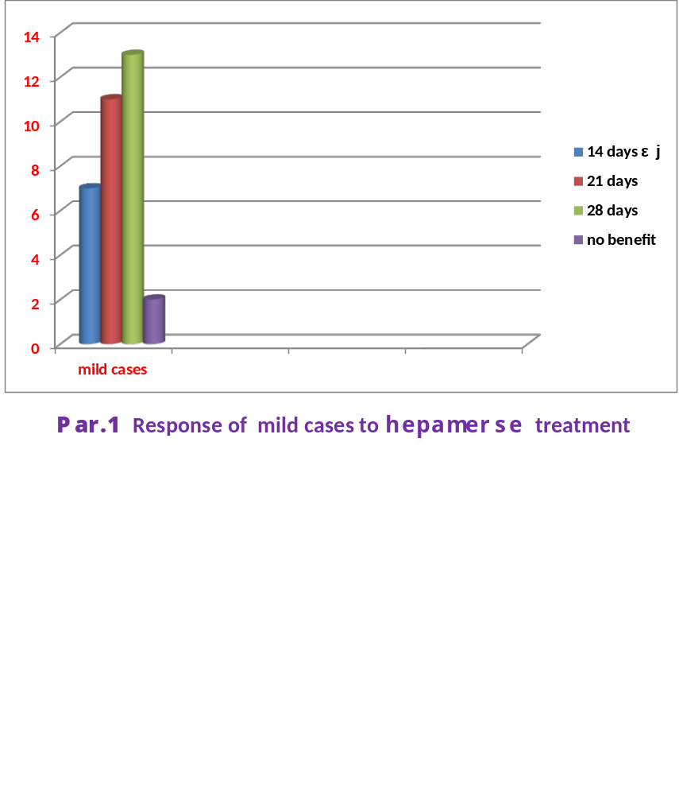

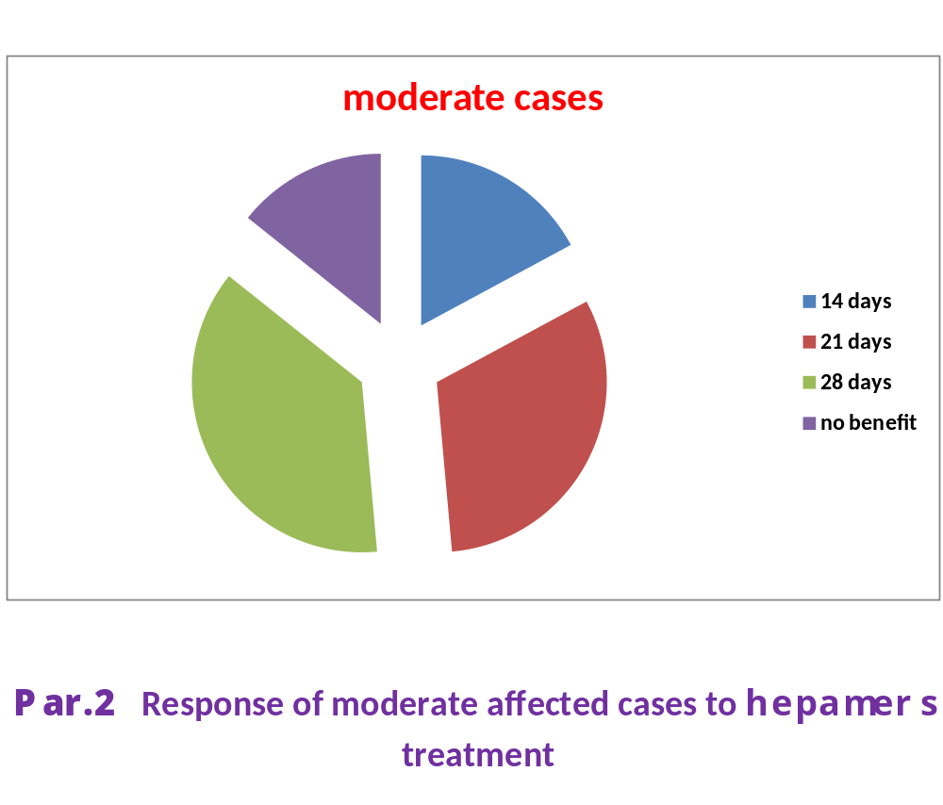

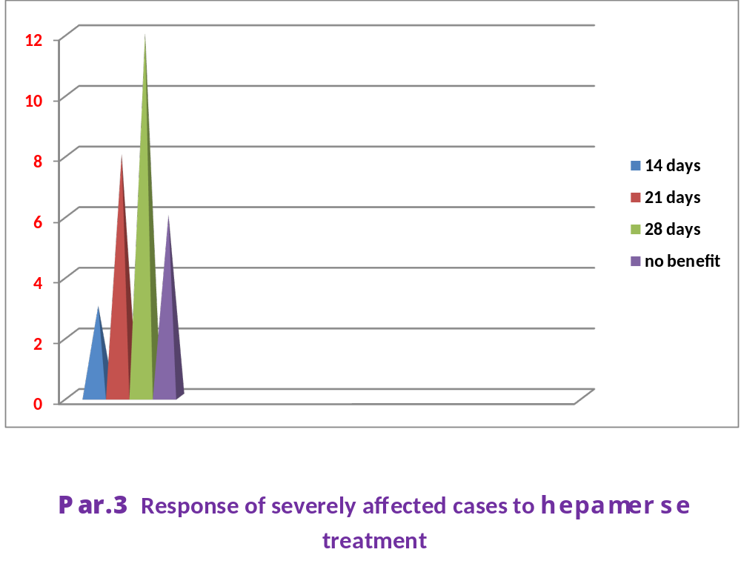
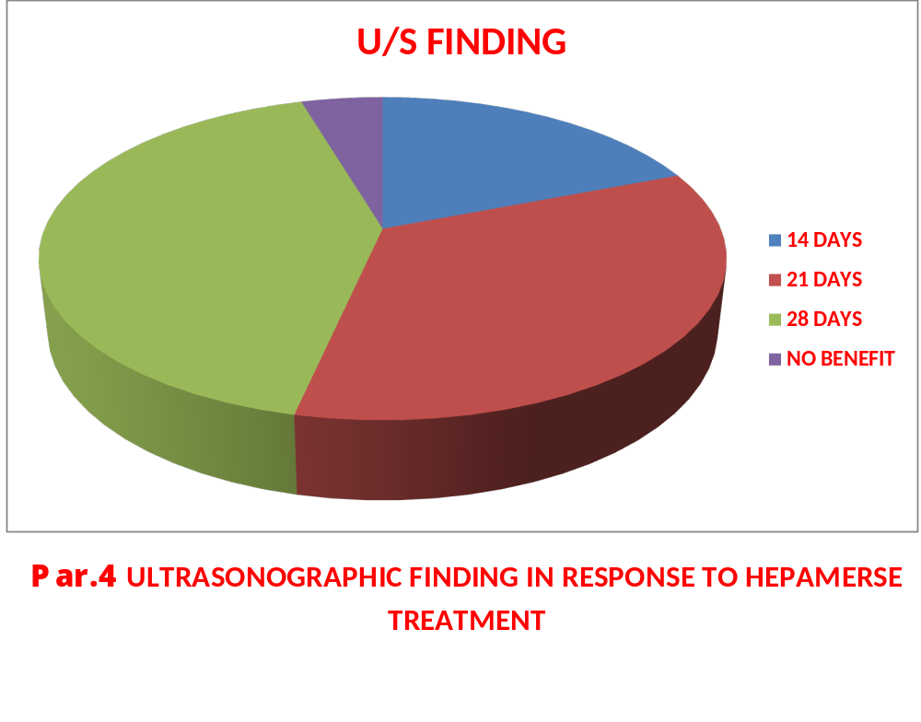

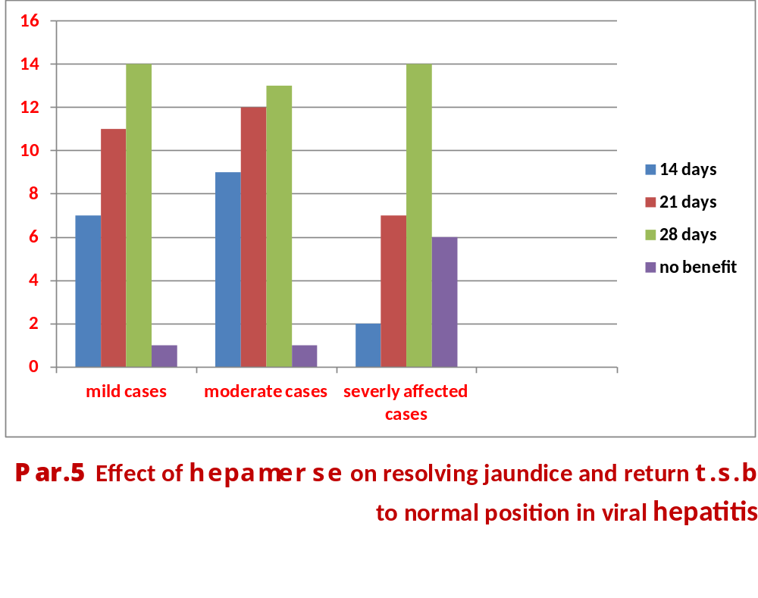

REFRENCES;
1-Staedt U, Leweling H, Gladisch R, et al. Effects of ornithine aspartate on plasma ammonia and plasma amino acids in patients with cirrhosis (A double-blind, randomized study using a four-fold crossover design). J Hepatol. 1993;19:424–430

2-Kircheis G, Nilius R, Held C, et al. Therapeutic efficacy of L-ornithine-L-aspartate infusions in patients with cirrhosis and hepatic encephalopathy: results of a placebo-controlled, double-blind study. Hepatology. 1997;25:1351–1
3-Stauch S, Kircheis G, Adler G, et al. Oral L-ornithine-L-aspartate therapy of chronic hepatic encephalopathy: results of a placebo-controlled double-blind study. J Hepatol. 1998;28:856–864
4-Poo JL, Góngora J, Sánchez-Avila F, et al. Efficacy of oral L-ornithine-L-aspartate in cirrhotic patients with hyperammonemic hepatic encephalopathy (Results of a randomized, lactulose-controlled study). Ann Hepatol. 2006;5:281–288
5-Clemmesen JO, Kondrup J, Ott P. Splanchnic and leg exchange of amino acids and ammonia in acute liver failure. Gastroenterology. 2000;118:1131–1139
6-Rees CJ, Oppong K, Al Mardini H, et al. Effect of L-ornithine-L-aspartate on patients with and without TIPS undergoing glutamine challenge: a double blind, placebo controlled trial. Gut. 2000;47:571–574
7- Barker LF, Shulman NR, Murray R, Hirschman RJ, Ratner F, Diefenbach WC, Geller HM . "Transmission of serum hepatitis. 1970". Journal of the American Medical Association; (1996); 276 (10): 841–844.
8- Williams R. "Global challenges in liver disease". Hepatology (Baltimore, Md.);2006); 44 (3): 521–526.
9- "Hepatitis B". World Health Organization (WHO). Retrieved 2009-09-19.
10-^ "FAQ about Hepatitis B". Stanford School of Medicine. 2008-07-10. Retrieved (2009), 9-19.
11- Coopstead, Lee-Ellen C. Pathophysiology. Missouri: Saunders, "Vaccination for liver diseases". (2010), 886–887.
12- Sleisenger, MH; Feldman M, Friedman LS Fordtran's gastrointestinal and liver disease: pathophysiology, diagnosis, management (8th ed.). Philadelphia: Saunders(2006), 303-23.
13- Kidd-Ljunggren K, Holmberg A, Bläckberg J, Lindqvist B (December 2006). "High levels of hepatitis B virus DNA in body fluids from chronic carriers". The Journal of Hospital Infection 64 (4): 352–7.
14- "Hepatitis B FAQs for the Public — Transmission". U.S. Centers for Disease Control and Prevention (CDC). Retrieved 2011-11-29.
15-"Hepatitis B". National Institute of Health. Retrieved 2010-11-23.
16- Chang MH (June 2007). "Hepatitis B virus infection". Semin Fetal Neonatal Med 12 (3): 160–167.
17- Pungpapong S, Kim WR, Poterucha JJ (2007). "Natural History of Hepatitis B Virus Infection: an Update for Clinicians". Mayo Clinic Proceedings 82 (8): 967–975.
18 Zuckerman AJ (1996). "Hepatitis Viruses". In Baron S, et al.. Baron's Medical Microbiology (4th ed.). University of Texas Medical Branch. ISBN 0-9631172-1-1.
19- Locarnini S . "Molecular virology of hepatitis B virus". Semin. Liver Dis.(2004) 24 Suppl 1: 3–10.
20-Hepatitis B Foundation: Blood Test FAQ,2011.
21-http://www.who.int/mediacentre/factsheets/fs204/en/
22 Terrault N, Roche B, Samuel D (July 2005). "Management of the hepatitis B virus in the liver transplantation setting: a European and an American perspective". Liver Transpl. 11 (7): 716–32.
23-Kay A, Zoulim F (2007). "Hepatitis B virus genetic variability and evolution". Virus research 127 (2): 164–176.
24-Beck J, Nassal M (January 2007). "Hepatitis B virus replication". World J. Gastroenterol. 13 (1): 48–64.
25-Li W, Miao X, Qi Z, Zeng W, Liang J, Liang Z (2010). "Hepatitis B virus X protein upregulates HSP90alpha expression via activation of c-Myc in human hepatocarcinoma cell line, HepG2". Virol. J. (2005) 7(3) 201-212.
26_Yan, H.; Zhong, G.; Xu, G.; He, W.; Jing, Z.; Gao, Z.; Huang, Y.; Qi, Y. et al. (2012). "Sodium taurocholate cotransporting polypeptide is a functional receptor for human hepatitis B and D virus". ELife 1: e00049. doi:10.7554/eLife.00049. PMC 3485615. PMID 23150796. edit
27-Bruss V . "Hepatitis B virus morphogenesis". World J. Gastroenterol.(2007); 13 (1): 65–73.
28-Kramvis A, Kew M, François G . "Hepatitis B virus genotypes". Vaccine ;2005; 23 (19): 2409–23.
29- Magnius LO, Norder H . "Subtypes, genotypes and molecular epidemiology of the hepatitis B virus as reflected by sequence variability of the S-gene". Intervirology;1995; 38 (1-2): 24–34.
30- Norder H, Courouce AM, Magnius LO"Complete genomes, phylogenic relatedness and structural proteins of six strains of the hepatitis B virus, four of which represent two new genotypes". Virology ; 2011; 198 (2): 489–503.
31-Shibayama T, Masuda G, Ajisawa A, Hiruma K, Tsuda F, Nishizawa T, Takahashi M, Okamoto H ."Characterization of seven genotypes (A to E, G and H) of hepatitis B virus recovered from Japanese patients infected with human immunodeficiency virus type 1". Journal of Medical Virology ;2005;76 (1): 24–32.
32-Schaefer S . "Hepatitis B virus taxonomy and hepatitis B virus genotypes". World Journal of Gastroenterology WJG; (2008); 13 (1): 14–21.
33- Kurbanov F, Tanaka Y, Mizokami M."Geographical and genetic diversity of the human hepatitis B virus". Hepatology Research : the Official Journal of the Japan Society of Hepatology , (2010) 40 (1): 14–30.
34-ebe D, Urban S "Viral and cellular determinants involved in hepadnaviral entry". World J. Gastroenterol 2007;. 13 (1): 22–38.
35-Coffin CS, Mulrooney-Cousins PM, van Marle G, Roberts JP, Michalak TI, Terrault NA "Hepatitis B virus (HBV) quasispecies in hepatic and extrahepatic viral reservoirs in liver transplant recipients on prophylactic therapy". Liver Transpl ; 2010; 17 (8): 955–62.
36- Iannacone M, Sitia G, Ruggeri ZM, Guidotti LG "HBV pathogenesis in animal models: recent advances on the role of platelets". J. Hepatol.'Aprill 2011; 46 (4): 719–26.
37- Iannacone M, Sitia G, Isogawa M, Marchese P, Castro MG, Lowenstein PR, Chisari FV, Ruggeri ZM, Guidotti LG (November 2005). "Platelets mediate cytotoxic T lymphocyte-induced liver damage". Nat. Med. (February 2012). 11 (11): 1167–9.
38- Fairley CK, Read TR "Vaccination against sexually transmitted infections". Current Opinion in Infectious Diseases(February 2012), 25 (1): 66–72..
39-Buddeberg F, Schimmer BB, Spahn DR. (September 2008). "Transfusion-transmissible infections and transfusion-related immunomodulation". Best Practice & Research. Clinical Anesthesiology, (1976), 22 (3): 503–17..
40- Hughes RA et al; "Drug injectors and the cleaning of needles and syringes". European Addiction Research(February 2012), 6 (1): 20–30.
41- Petersen, N.; Barrett; Bond; Berquist; Favero; Bender; Maynard "Hepatitis B surface antigen in saliva, impetiginous lesions, and the environment in two remote Alaskan villages". Applied and environmental microbiology 32 (4): 572–574. 43- Shapiro CN (May 1993). "Epidemiology of hepatitis B". Pediatr. Infect. Dis. J. (1976),12,(5): 433–437.
44-Encyclopedia of Human and Medical Virology. Boston: Academic Press.2011, p. 110.
45-Lok AS, McMahon BJ (February 2007). "Chronic hepatitis B". Hepatology 45 (2): 507–39.
46-Chu CM, Liaw YF (November 2007). "Predictive factors for reactivation of hepatitis B following hepatitis B e antigen seroconversion in chronic hepatitis B". Gastroenterology 133 (5): 1458–65.
47- Zoulim F (November 2006). "New nucleic acid diagnostic tests in viral hepatitis". Semin. Liver Dis. 26 (4): 309–317.
48-"Hepatitis B Vaccine". Doylestown, Pennsylvania: Hepatitis B Foundation. 2009-01-31. Retrieved 2010-03-13.
49-"Hepatitis B virus: a comprehensive strategy for eliminating transmission in the United States through universal childhood vaccination. Recommendations of the Immunization Practices Advisory Committee (ACIP)". MMWR Recomm Rep 40 (RR–13): 1–25. November 1991.
50- Libbus MK, Phillips LM. Public health management of perinatal hepatitis B virus. Public Health Nursing (Boston, Mass.). 2009;26(4):353–61..
51- Martín-Ancel A, Casas ML, Bonet B (2004). "Implications of postvaccination hepatitis B surface antigenemia in the management of exposures to body fluids". Infection control and hospital epidemiology : the official journal of the Society of Hospital Epidemiologists of America 25 (7): 611–613.
52- Joint Committee on Vaccination and Immunisation (2006). "Chapter 18 Hepatitis B". Immunisation Against Infectious Disease 2006 ("The Green Book") (PDF) (3rd edition (Chapter 18 revised 10 October 2007) ed.). Edinburgh: Stationery Office. p. 164.
53-Van Damme P, Van Herck K (March 2007). "A review of the long-term protection after hepatitis A and B vaccination". Travel Med Infect Dis 5 (2): 79–84.
48- Ryan KJ, Ray CG (editors), ed. (2004). Sherris Medical Microbiology (4th ed.). McGraw Hill. pp. 551–2. ISBN 0838585299.
49- Gravitz L. (2011). "A smouldering public-health crisis". Nature 474 (7350): S2-4.
50- Houghton M (November 2009). "The long and winding road leading to the identification of the hepatitis C virus". Journal of Hepatology 51 (5): 939–48.
51- Shors, Teri (2011-11-08). Understanding viruses (2nd ed.). Burlington, MA: Jones & Bartlett Learning. p. 535.
52- Rosen, HR (2011-06-23). "Clinical practice. Chronic hepatitis C infection". The New England Journal of Medicine 364 (25): 2429–38.
53-Maheshwari, A; Ray S; Thuluvath PJ (2008-07-26). "Acute hepatitis C". Lancet 372 (9635): 321–32.
54 Wilkins, T; Malcolm JK; Raina D; Schade RR (2010-06-01). "Hepatitis C: diagnosis and treatment". American family physician 81 (11): 1351–7.
55-Bailey, Caitlin (Nov 2010). "Hepatic Failure: An Evidence-Based Approach In The Emergency Department". Emergency Medicine Practice 12 (4).
56- Chronic Hepatitis C Virus Advances in Treatment, Promise for the Future. Springer Verlag. 2011. p. 4.
57- Nelson, PK; Mathers BM, Cowie B, Hagan H, Des Jarlais D, Horyniak D, Degenhardt L (2011-08-13). "Global epidemiology of hepatitis B and hepatitis C in people who inject drugs: results of systematic reviews". Lancet 378 (9791): 571–83.
58- Chronic Hepatitis C Virus Advances in Treatment, Promise for the Future. Springer Verlag. 2011. pp. 103–104.
59- Ray, Stuart C.; Thomas, David L. (2009). "Chapter 154: Hepatitis C". In Mandell, Gerald L.; Bennett, John E.; Dolin, Raphael. Mandell, Douglas, and Bennett's principles and practice of infectious diseases (7th ed.). Philadelphia, PA: Churchill Livingstone. ISBN 978-0443068393.
60-Mueller, S; Millonig G; Seitz HK (2009-07-28). "Alcoholic liver disease and hepatitis C: a frequently underestimated combination" (PDF). World journal of gastroenterology : WJG 15 (28): 3462–71.
61- Alter, MJ. "Epidemiology of hepatitis C virus infection" (PDF). World journal of gastroenterology : WJG (2007-05-07); 13 (17): 2436–41.
62- Ozaras, R; Tahan, V. et al; "Hepatoprotective agents", Journal of Gastroenterology" U.K., April 2009. 209-34.
63- Zignego, AL; Ferri, C; Pileri, SA et al. . "Extrahepatic manifestations of Hepatitis C Virus infection: a general overview and guidelines for a clinical approach". Digestive and Liver Disease; (2007); 39 (1): 2–17.
64- Louie, KS; Micallef JM; Pimenta JM; Forssen UM . "Prevalence of thrombocytopenia among patients with chronic hepatitis C: a systematic review". Journal of viral hepatitis; (2011) 18 (1): 1–7.
Abstract in Arabic
الفعالية الدوائية لمكونات عقار (Hepamerze ) عندى مرصى التهاب الكبد الفايروسي
أجريت هذه الدراسة في مستشفى الحسين التعليمي في مدينة الناصرية ، على 97 مريضا خلال سنة واحدة من أغسطس 2011 إلى يوليو 2012، وكانوا جمبع هؤلاء المرضى يشكون من الحمى واليرقان وألم في منطقة المراقبة(المنطقة اليمنى لأسفل وأمام الصدر), والبول ألداكن وفقدان ألشهية والغثيان والقيء بعد التاريخ اكامل والفحص السريري مع التحقيق من التهاب الكبد الفيروسي أختيرت هذه الحالات التي تحسنت والتي كانت تشكو من التهاب الكبد الفيروسي B أو C. وبعد استبعاد المرضى الذين كانوا يعانون من أسباب أخرى قمنا بفحص ومعالجة 97 من هؤلاء المرضى الذين يشكون من التهاب الكبد الفيروسي B. أو C. والتي كانت فئاتهم العمرية التي تتراوح 23-68 سنة.
قمنا بتقسيم هؤلاء الى مجاميع وفقا لمستوى انزيمات الكبد ومصل A.S.T.، A.L.T. ، الفوسفات ألقلوية وناقلة Alanin. وقد قمنا في هذة الدراسة بأن يكون عقار( Hepamerze )العلاج الوحيد التي أعطيت جرعاته لهؤلاء المرضى لمدة 14 يوما، مجموعة أخرى لمدة 21 يوما والأخرى 28 يوما. تم فحص جميع المرضى بشكل منتظم لتقييم آثار Hepamerze على الكبد.
وجدنا أن ذروة تأثير Hepamerze في يوم 16 ويوم 21 حيث 42٪ من ألحالات هناك انخفاض تماما في انزيمات الكبد.

*The-Qar Medical College, Department of Pharmacology & Therapeutics.
**The-Qar Medical College, Department of General Surgery.
*** The-Qar ,Medical College, Department of Radiology.

