FETAL ANOMALY and CAUSES IN WOMEN’S OF BACKWORD AREA OF PUNJAB RELATED TO FETAL ANOMALY.
Name: Ishrat Anwar
Affiliation: Public Nursing School, Pakistan

Abstract (upto 300 words)
A fetal anomaly is physical or sometimes genetic defect in the fetus that can effect the pregnancy, complicated delivery and have serious adverse effects on the child.
Women facing the problems of fetal anomaly:
Through experiment we search 1008 women who are diagnosed for fetal anomalies by ultrasonography examination facing many problems including defects in the formation of fetal head,limbs, hands and feet and the structure of the abdominal wall.
Causes related to fetal anomaly:
The most common causes which are shown in pregnant women in our community are when parents are related by blood after which the early childhood deaths are reported. Second most common cause is the advanced maternal age associated with still birth or labor complication. The vast majority of fetal anomalies are shown in low- and middle income families. Another most common problem is the illiteracy and unawareness in pregnant women about the fetal anomalies. Due to illiteracy women are unaware of the use of medicinal and nutritional supplements the women sometime did not take the serious concerned to use the prescription drugs for healthy fetal brain and body growth and development including the use of staple foods with nutrients such as folic acid and iodine.
Other possible causes include lack of screening due to personal problems social stress and economic costs. Women with these experiences are facing more difficulties and many do not access treatment. Use or contact with tobacco, nicotine and Caffeine are also one of the main causes shown in these cases. Many women in their normal life or during pregnancy are infected to environmental contaminations because of their unhygienic conditions.
Biography
Ishrat Anwar completed his Midwifery form Public Nursing School Pakistan. New I am practicing in hospital. I attended 2 internationals conferences.

Email ID:muhammadfarees09@gmail.com
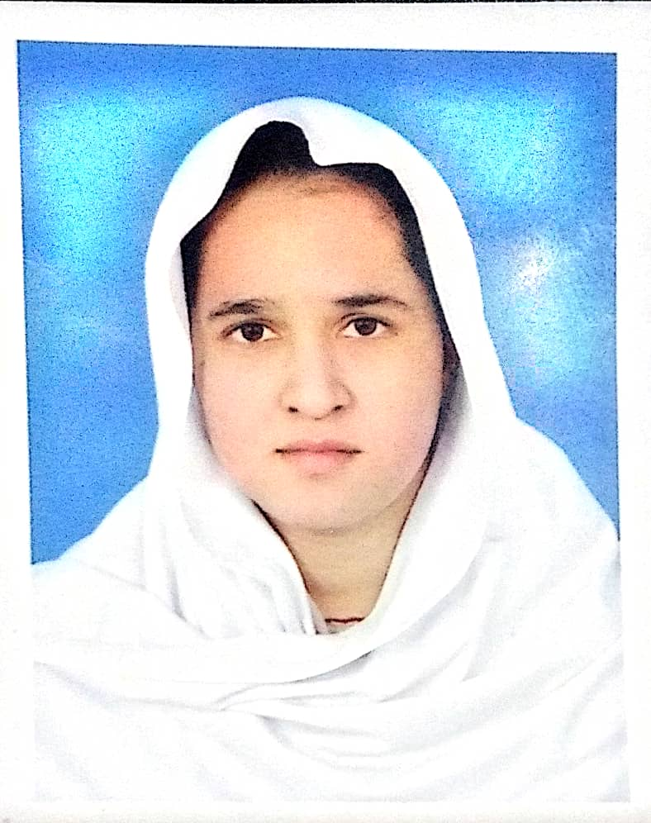

Presenter Name: Ishrat Anwar
Type of Presentation: Speaker
Contact Number: +923066283364

