MSi₂H₂⁺ structure (M:Cr, Mn and W) theoretical and FT-IRC Mass spectrometry study

A.Ferhati¹

¹LCCE, Laboratoire de chimie et chimie de l’environnement, faculté des sciences, département de chimie, université de Batna, 05000 Batna Algérie

Email : ferhati_azedine@hotmail.com; azeddine.ferhati@univ-batna.dz

Progress have been made in the knowledge of the nature of the M-X bonding ( M=Cr, Mn and W ; X=C, Si…) both experimentally and theoretically. A Fourier Transform Ion Cyclotron Resonance Mass Spectrometry (FT-ICR MS) study of the gas phase reaction I of M⁺ with SiH₄ is reported here in order to give more insight on the structure of the MSi₂H₂⁺ ion

M⁺ + 2SiH₄ → MSi₂H₂⁺ + 2H₂ (I)

The structure of the MSi₂H₂⁺ ions are discussed in term of CIDª result confronted to the theoretical calculation at the DFT level on the different structural geometries.

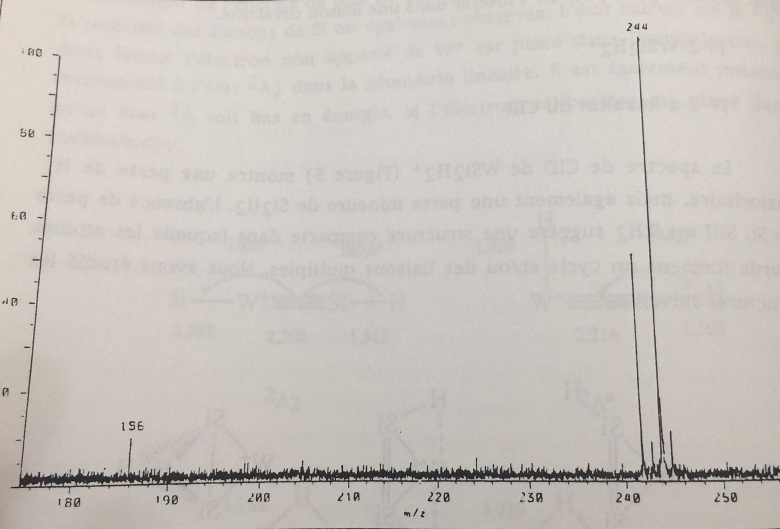
ª WSi₂H₂⁺ CID spectra obtained with 17 eV collision energy

