Long-term Maintenance of Human Pluripotent Stem Cells in Defined Media and Feder-Free Condition
using Recombinant Protein
Dr. Julee Kim, Seoul National University College of Medicine, Seoul, Republic of Korea

Abstract (300 word limit)

Conventional human pluripotent stem cell (hPSC) cultures require high concentrations of expensive human fibroblast growth factor 2 (hFGF-2) for hPSC self-renewal and pluripotency in defined media for long-term culture. The hPSC culture media need to be changed every day partly due to the hFGF-2 thermal instability in solution at 37°C. It has been known that the binding site of human DJ-1 (hDJ-1), also known as PARK-7 is FGF receptor-1. In the present study, for the first time, we have demonstrated that recombinant protein human FGF-2 can replace hDJ-1 in the essential eight media to maintain the pluripotency of H9 human embryonic stem cells (hESCs) under feeder-free condition. After more than ten passages, H9 hESCs cultured with human FGF-2 or human DJ-1 successfully sustained the distinctive hESC morphology. Furthermore, DNA microarray revealed that more than 97% of the 21,448 tested genes, including the pluripotency markers, Sox2, Nanog, Klf4, Lin28A, Lin28B, and Myc, have similar mRNA levels between the two groups. Karyotyping revealed no chromosome abnormalities in both groups. They also differentiated sufficiently into three germ layers by forming in vitro embryoid bodies and in vivo teratomas. There were moderate difference in H9 hESCs in both groups was shown in the real-time PCR assay using several pluripotency markers and three germ layer markers. The proliferation rate measured at different concentration of growth factors and the structural analysis of mitochondria using transmission electron microscopy demonstrated the distinguishable feature of H9 hESCs in two groups, namely hFGF2 and hDJ-1. On the whole, in-house made recombinant protein hDJ-1 can maintain the self-renewal and the pluripotency of H9 hESCs in a feeder-free system for long-term without alteration of their characteristics. The established culture system can be used in different research studies including drug screening, medical compound screening and cell therapy.
Image
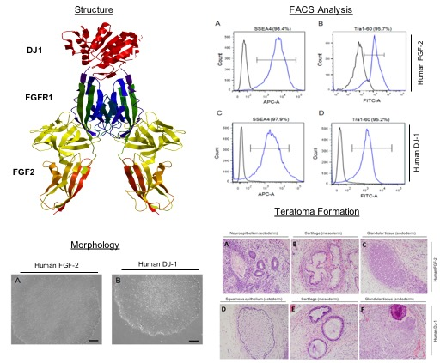

Figure 1. In vitro and in vivo pluripotency of human embryonic stem cells cultured with recombinant protein human FGF2 or human DJ-1

Recent Publications (minimum 5)
1. DJ-1 Can Replace FGF-2 for Long-Term Culture of Human Pluripotent Stem Cells in Defined Media and Feeder-Free Condition
Kim J, Baek S, Hong YJ, de Paula MN, Jahan Prima M, Oh YM, Cha SS, Do JT, Jang YJ, Choe H.Int J Mol Sci. 2021 May 31;22(11):5954. doi: 10.3390/ijms22115954.
2. Prokaryotic soluble overexpression and purification of oncostatin M using a fusion approach and genetically engineered E. coli strains.
Nguyen MT, Prima MJ, Song JA, Kim J, Do BH, Yoo J, Park S, Jang J, Lee S, Lee E, Novais MP, Seo HB, Lee SY, Cho ML, Kim CJ, Jang YJ, Choe H.
Sci Rep. 2019 Sep 23;9(1):13706.2
3. A chemical conjugate between HER2-targeting antibody fragment and Pseudomonas exotoxin A fragment demonstrates cytotoxic effects on HER2-expressing breast cancer cells.
Lee S, Park S, Nguyen MT, Lee E, Kim J, Baek S, Kim CJ, Jang YJ, Choe H.
BMB Rep. 2019 Aug;52(8):496-501.
4. Generation of functional endothelial-like cells from adult germline-derived pluripotent cells
Kim J, Eligehausen S, Stehling M, Nikol S, Ko K, Waltenberger J, Klocke R.
Biochem Biophys Res Commun. 2014 Jan 10;443(2):700-5
5. Autologous pluripotent stem cells generated from adult mouse testicular biopsy
Ko K, Wu G, Araúzo-Bravo MJ, Kim J, Francine J, Greber B, Mühlisch J, Joo JY, Sabour D, Frühwald MC, Tapia N, Schöler HR.
6. Conversion of adult mouse unipotent germline stem cells into pluripotent stem cells
Ko K, Araúzo-Bravo MJ, Kim J, Stehling M, Schöler HR.
Nat Protoc. 2010 May;5(5):921-8.

Photograph

Biography (150 word limit)
Dr. Julee Kim received her diplom degree in Biotechnology at the Westfaelisch Wilhelms University of Muenster in 2007. She graduated from the Westfaelisch Wilhelms University of Muenster with a PhD degree in Biology at the Max Planck Institute for Molecular Biomedicine in 2013. She completed her post-doctoral training at the University of California San Francisco and at Columbia University, Irving Cancer Research Center. She worked as a research assistant professor at the University of Ulsan College of Medicine, Asan Medical Center and as a research professor at CHA University. Currently, she is a senior researcher at the Seoul National University College of Medicine. She has 8 publications in international journals. She presented papers in more than 10 national and international conferences..
Email: juleekim119@gmail.com

Notes/Comments:

Significance Statement: DJ-1 is known to bind to FGFR at a site different from FGF-2. Human pluripotent stem cell can be grown in a defined medium with DJ-1 without FGF-2 in feeder-free conditions, which was deduced from the stem cell markers’ results, karyotyping, DNA microarray,
transmission electron microscopy, in vitro differentiation assay, and the teratoma assay. Therefore, DJ-1 can replace or supplement expensive FGF-2 in maintenance of human pluripotent stem cell.

