NCoR1 and SMRT fine-tune inflammatory versus tolerogenic balance in dendritic cells by differentially regulating STAT3 signaling

Atimukta Jha, Institute of Life Sciences, India

Abstract (300 word limit)

Dendritic cells are professional antigen presenting cells that fine-tune tolerogenic versus inflammatory responses. Through a combinatorial action of transcription factors (nuclear receptors) and their co-regulators. Among the best characterized co-regulators, NCoR1 and NCoR2/SMRT are known to interact with a plethora of regulatory factors and our objective is to unravel their impact on immune function. Moreover, their role in immune regulation in DCs is an untouched theme. Our finding shows that NCoR1 and its ortholog NCoR2 can have opposing effects in DC immune function. Silencing of NCoR2/SMRT in DCs led to increase in activation and resulted in a pro-inflammatory phenotype marked by increased IL6, IL12 and IL23 and a concomitant decrease in IL10 production. Consequently, co-culture experiment displayed that priming of naïve T cells with SMRT KD DCs led to increased proliferation of CD4+ and CD8+ T cells complimented with an increased Th1, Th17 and cytotoxic T cell response compared to control cells. SMRT depletion repressed mTOR-STAT3-IL10 signaling in cDC1 by down-regulating NR4A1. Besides, NFkBIA and SOCS3 were down-regulated in SMRT knockdown cDC1, supporting increased production of inflammatory cytokines. Moreover, adoptive transfer of SMRT knockdown cDC1 in OVA-DTH induced footpad inflammation led to increased Th1/Th17 and reduced tumor burden after B16 melanoma injection by enhancing oncolytic CD8+ T-cell frequency, respectively. We also depicted decreased Smrt expression in Rheumatoid Arthritis, a Th1/Th17 disease.
Image
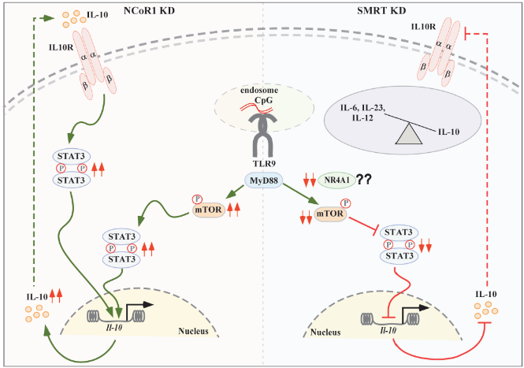
Figure:
Differential pathways in SMRT versus NCoR1 KD DCs suggests a role of NR4A1-mTOR-STAT3-IL10 axis in fine tuning tolerogenic versus inflammatory balance.

Recent Publications (minimum 5)
- NCoR1 and SMRT fine-tune inflammatory versus tolerogenic balance in dendritic cells by differentially regulating STAT3 signaling A. Jha, A. Ahad, G. P. Mishra, K. Sen, S. Smita, A. P. Minz, V. K. Biswas, A. Tripathy, S. B. Senapati, B. Gupta, H. A. Orbea, S. K. Raghav bioRxiv 2021.03.11.434976; doi: https://doi.org/10.1101/2021.03.11.434976.

Photograph

Biography (150 word limit)
Atimukta Jha is a PhD scholar who is working in the field of immunology under Dr. Sunil K. Raghav. The main focus of the work is finding a balance between inflammatory and tolerogenic functions of dendritic cells and using system’s biology approach to unravel the genome wide view.
Email: ajmuktaj917@gmail.com

Notes/Comments:

