Computational approaches for characterizing the tumor immune microenvironment
Fatemeh Babaie, Cellular and Molecular Biology Student, Biology Group, Basic Science Department, Faculty of Cellular and Molecular Biology, Semnan University, Semnan, Iran

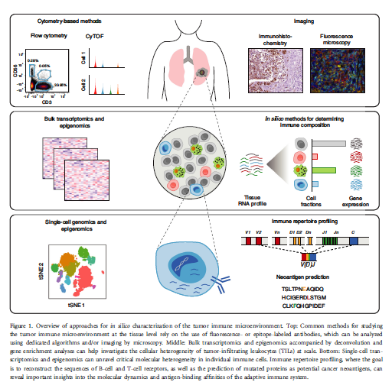

Abstract

Recent advances in high-throughput molecular profiling technologies and multiplexed imaging platforms have revolutionized our ability to characterize the tumor immune microenvironment. As a result, studies of tumor-associated immune cells increasingly involve complex data sets that require sophisticated methods of computational analysis. In this review, we present an overview of key assays and related bioinformatics tools for analyzing the tumor-associated immune system in bulk tissues and at the single-cell level. In parallel, we describe how data science strategies and novel technologies have advanced tumor immunology and opened the door for new opportunities to exploit host immunity to improve cancer clinical outcomes.
Image

Recent Publications
- Mantovani A, Allavena P, Sica A, Balkwill F. Cancer-related inflammation. Nature 2008; 454:436.
- Hanahan D, Weinberg Robert A. Hallmarks of cancer: the next generation. Cell 2011;144:646–74.
- Gajewski TF, Schreiber H, Fu Y-X. Innate and adaptive immune cells in the tumor microenvironment. Nat Immunol 2013; 14:1014.
- Binnewies M, Roberts EW, Kersten K, Chan V, Fearon DF, Merad M et al. Understanding the tumor immune microenvironment (TIME) for effective therapy. Nat Med 2018; 24:541–50.
- Noy R, Pollard Jeffrey W. Tumor-associated macrophages: from mechanisms to therapy. Immunity 2014; 41:49–61.

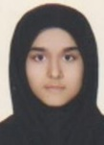

Biography
Student of cellular and molecular biology, Medical researcher, International degree in genetic engineering, Participated in the 3rd international neuroinflammation congress and the 3rd international student festival of neuroscience organized by neuroscience department, mashhad university of medical science, Participated in the 3rd international biotechnology congress of Islamic republic of Iran, Participated in the 3rd international congress on biomedicine2019, Participated in the 8th International Conference on Women’s Health, Tehran, Iran

Email: mahijk1997@yahoo.com

