Allicin promotes antimycobacterial activity of macrophages during Mycobacterium tuberculosis infection

Mona Singhª, Ved Prakash Dwivedi^{b}, Debapriya Bhattacharya^{c}, Ashima Bhaskar^{d}, Santosh Kumar^{b}, Parveen Sobia^{e}, Luc Van Kaer^{f}, Gobardhan Dasª

ª Special Centre for Molecular Medicine, Jawaharlal Nehru University, New Delhi, India.
^{b} Immunology Group, International Centre for Genetic Engineering and Biotechnology, New Delhi, India.
^{c}Center of Biotechnology, Siksha 'O' Anusandhan University Kalinganagar, Ghatikia Bhubaneswar, Orissa, India
^{d} Signal Transduction Laboratory-1, National Institute of Immunology, New Delhi, India
^{e}College of Health Sciences, Laboratory of Medicine and Medical Sciences, University of KwaZulu-Natal, Durban, South Africa. ^{f}Department of Pathology, Microbiology and Immunology, Vanderbilt University School of Medicine, Nashville, TN, USA.

Abstract
The emergence of drug-resistant Mycobacterium tuberculosis (M.tb) strains has severely hampered global efforts towards tuberculosis (TB) eradication. The internationally accepted therapy “Directly Observed Treatment Short-course (DOTS)” is lengthy, and incorporates risks for the generation of drug-resistant M.tb variants. Multiple and extremely drug-resistant (MDR and XDR) variants of TB are now widespread throughout the globe, and totally drug resistant (TDR) strains have appeared. Therefore, new classes of antibiotics are urgently needed to combat these deadly organisms. Historically, garlic is known to kill mycobacterial strains, and its active compound, allicin, kills various microorganisms. Here we have shown that allicin not only reduced the bacterial burden in the lungs of mice infected with Mycobacterium tuberculosis (M.tb), but also induces strong anti-tubercular immunity.
In the present study, the anti-mycobacterial and immunomodulatory activity of garlic extract and its pure constituent allicin were demonstrated based on several in vitro and in vivo experiments in murine model of tuberculosis. Furthermore, the validation of study was done by immunoblots showing the modulation of MAPK and SAPK/JNK signaling by allicin in macrophages. Here, we report that allicin/garlic extract exhibits strong anti-mycobacterial responses in vitro and in vivo against drug-sensitive, MDR and XDR strains of TB. In addition to direct killing, allicin also induced pro-inflammatory cytokines in macrophages. Moreover, allicin/garlic extract treatment in murine models of infection resulted in induction of strong protective Th1 response, leading to drastic reduction in mycobacterial burden. These results indicated that allicin/garlic extract has both antibacterial and immunomodulatory activity. Furthermore, garlic extract reversed the immune dampening effects of frontline anti-TB drugs. Allicin/garlic extract alone or as an adjunct to classical antibiotics holds great promise for treatment of drug-sensitive as well as drug-resistant TB. These results warrant further study and validation of allicin for treatment of TB.

Image
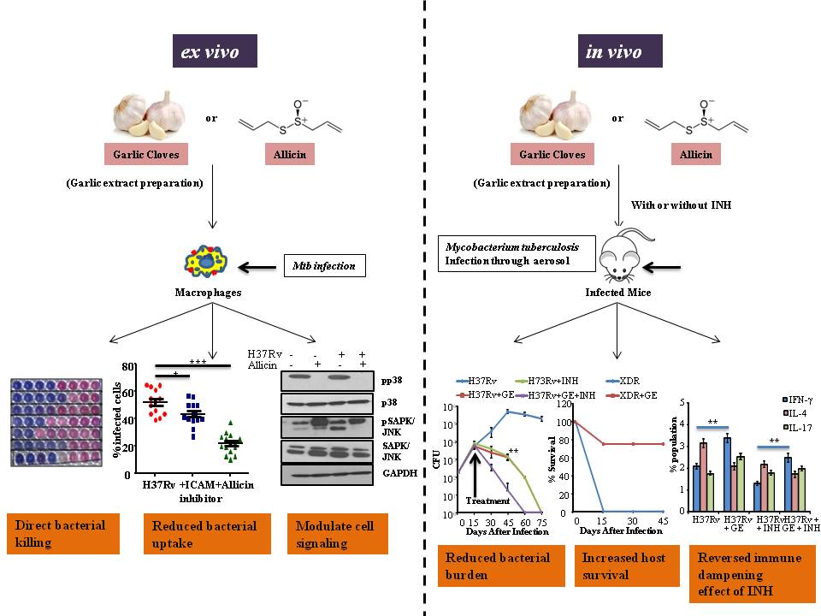

Recent Publications
- Ved Prakash Dwivedi*, Debapriya Bhattacharya*, Mona Singh*, Ashima Bhaskar, Santosh Kumar, Parveen Sobia, Luc Van Kaer, Gobardhan Das. Allicin enhances antimicrobial activity of macrophages during Mycobacterium tuberculosis infection. Journal of Ethnopharmacology. 2018. (https://doi.org/10. 1016/j.jep.2018.12.008) (*equal contribution- first author)
- Mona Singh, Vinod Yadav, Gobardhan Das. Host Epigenetic Modifications in Mycobacterium tuberculosis Infection: A Boon or Bane. The Value of BCG and TNF in Autoimmunity. Second Edition 2018.Page 39-55. Academic Press. An imprint of Elsevier. Elsevier.com/books-books-and-journals. ISBN: 978-0-12-814603-3
- Ved Prakash Dwivedi, Debapriya Bhattacharya, Vinod Yadav, Dhiraj K. Singh, Santosh Kumar, Mona Singh, Durbadal Ojha, Anand Ranganathan, Luc Van Kaer, Debprasad Chattopadhyay, Gobardhan Das. The phytochemical bergenin enhances T helper 1 responses and anti-Mycobacterial immunity by activating the MAP kinase pathway in macrophages. 2017. Front. Cell. Infec. Microbiol. 7: 149.doi:10.3389/fcimb.2017.00149
- Debapriya Bhattacharya., Ved Prakash Dwivedi, Mona, Vinod Yadav, Gobardhan Das. Understanding the Role of Mesenchymal Stem Cells in Infectious Diseases: Focus on Tuberculosis, Malaria, Sepsis and HIV.2016. Electronic J Biol .12(3): 247-253.
- Roshan Kumar, Utkarsh Sood, Vipin Gupta, Mona Singh, Joy Scaria, Rup Lal. Recent Advancements in the Development of Modern Probiotics for Restoring Human Gut Microbiome Dysbiosis. 2019. Indian J Microbiol. (https://doi.org/10.1007/s12088-019-00808-y).

Photograph


Biography
Mona Singh is currently pursuing her Ph.D. from Jawaharlal Nehru University, Delhi, India. She was the alumni of Banaras Hindu University and University of Delhi, while pursuing her Bachelor and Masters degrees, respectively. Her research focus lies in studying the immunomodulatory effect of different compounds using mice models. She has published her papers in several reputed journals.
Email: mnsngh414@gmail.com

