Killing of Latently HIV-Infected CD4 T Cells by Autologous CD8 T Cells is Modulated by Nef.
Ziv Sevilya^{1,2}, Ehud Chorin^{2,3}, Orit Gal-Garber⁴, Einat Zelinger⁴, Dan Turner^{2,3}, Boaz Avidor^{2,3}, Gideon Berke⁵ and David Hassin^{1,2,3,6,7}
¹Internal medicine department A , Assuta Ashdod Medical Center ²Crusaid Kobler AIDS center, Tel-Aviv Sourasky Medical Center; ³Sackler Faculty of Medicine, Tel-Aviv University, Tel-Aviv; ⁴Interdepartmental Equipment Facility, Robert H. Smith Faculty of Agriculture, Food and Environment, the Hebrew University, Rehovot; ⁵Department of Immunology, Weizmann Institute of Science, Rehovot; ⁶ Faculty of Health Sciences, Ben Gurion University of the Negev ; Israel

The role of HIV-specific CD8 T cell activity in the course of HIV infection and the way it affects the virus that resides in the latent reservoir resting memory cells is debated. The PBMC of HIV-infected patients contain HIV-specific CD8 T cells and their potential targets, CD4 T cells latently infected by HIV. CD4 T cells and CD8 T cells procured from PBMC of HIV-infected patients were co-incubated and analyzed: Formation of CD8 T cells and HIV-infected CD4 T cell conjugates and apoptosis of these CD4 T cells were observed by fluorescence microscopy with in situ PCR of HIV LTR DNA and quantified by imaging flow cytometry using anti-human activated caspase 3 antibody and TUNEL assay. The conjugation activity and apoptosis were found to be much higher in patients with acute HIV infection or AIDS compared to patients in chronic infection on antiretroviral therapy (ART) or not. Patients on ART had low grade conjugation and apoptosis of isolated CD69, CD25 and HLA-DR-negative CD4 T cells (latent reservoir cells) by CD8 T cells. We demonstrate in HIV-infected patients, that CD8 T cells conjugate with and kill HIV-infected CD4 T cells, including HIV-infected resting memory CD4 T cells, throughout the course of HIV infection. We propose that in HIV-infected patients CD4 T cell annihilation is caused in part by ongoing activity of HIV-specific CD8 T cells. HIV Nef protein interacts with ASK 1 and inhibits its pro-apoptotic death signaling by Fas/FasL, thus protecting HIV-infected cells from CD8 T cells killing. A peptide that interrupts Nef-ASK1 interaction that had been delivered into CD4 T cells procured from patients on ART resulted in the increase of their apoptosis inflicted by autologous CD8 T cells. We suggest that elimination of the HIV-infected latent reservoir CD4 T cells can be achieved by Nef inhibition.

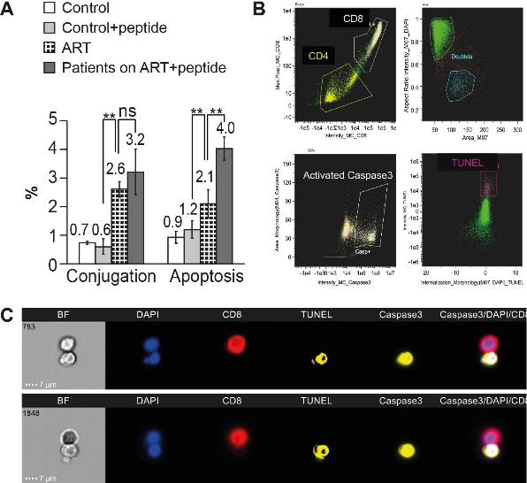
Figure 1. Inhibition of HIV Nef interaction with ASK1 in the CD4 T cells procured from patients on ART results in increased susceptibility to killing by autologous CD8 T cells.
Recent Publications (minimum 5)
- Sevilya Z, Chorin E, Gal-Garber O, Zelinger E, Turner D, Avidor B, Berke G, Hassin D. (2018) Killing of Latently HIV-Infected CD4 T Cells by Autologous CD8 T Cells Is Modulated by Nef. Front Immunol. 11;9:2068.
- Chorin E, Gal-Garber O, Yagel Y, Turner D, Avidor B, Berke G, Hassin D. (2015) Peripheral blood mononuclear cells of HIV-infected patients contain CD8 T cells that form conjugates with and kill HIV-infected autologous CD4 T cells. Immunology. 144(3):412-421.
- Hassin D, Garber OG, Meiraz A, Schiffenbauer YS, Berke G. (2011) Cytotoxic T lymphocyte perforin and Fas ligand working in concert even when Fas ligand lytic action is still not detectable. Immunology. Jun;133(2):190-6.
- Meiraz A, Garber OG, Harari S, Hassin D, Berke G. (2009) Switch from perforin-expressing to perforin-deficient CD8(+) T cells accounts for two distinct types of effector cytotoxic T lymphocytes in vivo. Immunology. 128(1):69-82.
- Hassin D, Fixler R, Shimoni Y, Rubinstein E, Raz S, Gotsman MS, Hasin Y. (1987) Physiological changes induced in cardiac myocytes by cytotoxic T lymphocytes. Am J Physiol. ;252(1Pt 1):C10

Biography
David Hassin, MD, specializations in internal medicine, infectious diseases and AIDS medicine. Research experience: 1) adenovirus in vitro DNA replication. 2) DNA amplification of SV40 DNA in cells transformed by SV40 exposed to carcinogens. 3) The study of cytotoxic T lymphocytes (CTL) in mice infected by mengovirus (picornavirus). 4) The physiological effect of CTL on myocytes in vitro. 5) The study of Fas/Fas ligand and perforin granzyme activity of CTL interacting with allogeneic cells in a mouse model. 6) Killing of latently HIV-infected CD4 T cells by autologous CD8 T cells
Email: hassindavid@gmail.com

Notes/Comments:

