HOTAIR lncRNA expression can be a marker for disease activity and prognosis in Multiple Myeloma
Nahla Osman, Amira Shehata, Mohamed Helwa, Samar Kamal
Hematology Unit, Department of Clinical Pathology, Menoufia University, Egypt

Abstract (300 word limit)

Background: There has been an increasing evidence of involvement of long non-coding RNA sequences in tumorigenesis (lncRNAs) and is currently being investigated as diagnostic and prognostic markers in a number of malignancies. HOX transcript antisense intergenic RNA (HOTAIR), lncRNA is suggested to play an oncogenic role by enhancing cancer progression, migration and invasion. HOTAIR interacts with and downregulates epigenetic regulators that act as silencer of the epigenetic genes implicated in tumorigenesis. Aim of the work: to assess HOTAIR lncRNA expression and its prognostic implications in Multiple Myeloma (MM) patients. Subjects and methods: The study involved 62 patients in 3 groups; 24 newly diagnosed MM, 23 patients in complete or very good partial response (CR or VGPR) and 15 patients who had either primary refractory disease (PR) or relapse as well as a 20 healthy controls. The groups were age and sex matched, p was 0.883 and 0.952 respectively. HOTAIR lncRNA expression was measured by quantitative reverse transcription polymerase chain reactions. Results: HOTAIR was significantly upregulated in newly diagnosed and PD/relapse groups (3.13±1.48 and 2.83±1.26 respectively) compared to controls and patients in CR or VGPR (1.02±0.45 and 0.99±0.38 respectively, p<0.001). In addition, higher HOTAIR expression levels were seen in patients with higher percentage of malignant plasma cells (≥ 50 versus < 50%) in bone marrow (2.29±0.67 and 3.97±1.60 respectively, p=0.006) and in those with higher RISS stage (expression levels were 1.85 ± 0.58, 3.06 ± 1.17 and 3.91 ± 1.69 for stages I, II and III respectively p=0.031). Conclusion: HOTAIR expression levels are associated disease activity in MM patients which might reflect a role in pathogenesis. In addition, higher levels are shown to be associated with other well established adverse prognostic factors, thus, HOTAIR can be a prognostic marker and may serve as novel therapeutic target for those patients.

Role of lncRNA (including HOTAIR) in cell cycle

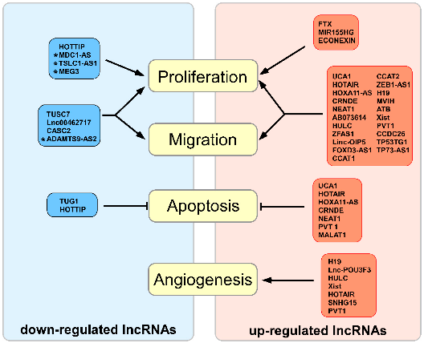

Rynkeviciene et al (2019)

Recent Publications (minimum 5)
- Hajjari M et al: HOTAIR Long Non-coding RNA: Characterizing the Locus Features by the In Silico Approaches. Genomics Inform. 2017; 15:170.
- Bhan A, Mandal SS. LncRNA HOTAIR: A master regulator of chromatin dynamics and cancer. Biochim Biophys Acta. 2015; 1856:151-164
- Rynkeviciene et al: Non-Coding RNAs in Glioma. Cancers. 2019; 11(1): 17

Photograph

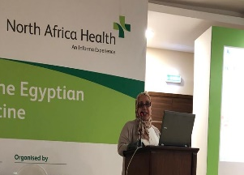
Nahla Osman, MD, MRCP and FRCPath UK. Works as assistant professor and consultant haematologist, Menoufia University

