Two Hodgkin lymphoma homozygotic triplets displaying diverse DNA methylation profiles as compared to the third non-affected homozygotic triplet.
Chuanyou Xia¹, Thale Kristin Olsen², Ali Zirakzadeh⁴, Radwa Almamoun³, Louise K Sjöholm³, Jan Sjöberg¹, Hans-Erik Claesson¹, John Inge Johnsen², Ola Winqvist⁴, Jenny Dahlström⁵，Dawei Xu¹, Tomas J Ekström³, Magnus Björkholm¹, Klas Strååt¹

¹ Department of Medicine, Division of Hematology, BioClinicum and Centre for Molecular Medicine, Karolinska University Hospital Solna and Karolinska Institutet, Stockholm, Sweden.
² Childhood Cancer Research Unit, Department of Women’s and Children’s Health, Karolinska Institutet, Karolinska University Hospital, Stockholm, Sweden.
³ Department of Clinical Neuroscience, Karolinska Institutet, Center for Molecular Medicine, Stockholm, Sweden.
⁴ Unit of Translational Immunology, Department of Medicine, Karolinska Institutet, Stockholm, Sweden.
⁵ Perioperative Medicine & Intensive Care, Karolinska Institutet, Karolinska University Hospital, Stockholm, Sweden.

Abstract

We previously reported Hodgkin lymphoma (HL) development in two triplets where all three were homozygotic and had a constitutional deletion in the first intron of the megakaryoblastic leukemia 1 gene (MKL1) ( Bjorkholm M et al, Development of Hodgkin lymphoma in homozygotic triplets with constitutional deletion in MKL1. Blood. 2013;121(23):4807). DNA methylation is thought to play an important role in carcinogenesis. Due to the accordant genome in all triplets, the epigenetic pattern especially the methylation status is of great interest. Four types of cells were isolated from peripheral blood samples of triplets: Naïve B-cells, CD34+ cells, switched Memory B-cells, and marginal zone like B-cells. Subsequently, DNA methylation was analyzed using the Illumina EPIC array with 850.000 CpG site-specific probes. Differences in DNA methylation were found in CD34+ cells, naïve B-cells and marginal zone like B-cells. An overview of the workflow and results is presented in (Fig. 1). In naïve B-cells we found one region on chromosome 19 that differed in DNA methylation, however, one of the HL-affected triplets displayed a hypermethylated region while the other HL-triplet displayed a hypomethylated region as compared to the non-affected triplet. In marginal zone like B-cells, we found 14 genomic regions (two regions had almost complete overlap), spread out on 9 chromosomes, which were all hypermethylated in both HL-affected triplets as opposed to the non-affected triplet. In these regions, genes related to HL and other cancers or hematopoiesis (CYGB;
ISM1; KLHL22; MRAS; SNHG16; KDR) were identified. In CD34+ cells we found one region on chromosome 12 where the two HL-affected triplets showed a hypomethylated region as compared to the non-affected triplet. This region was located between gene CCDC65 and FKBP11. These DNA-methylation differences in CD34+ cells and specific B-cell subtypes may contribute to the HL pathogenesis in two of the triplets.
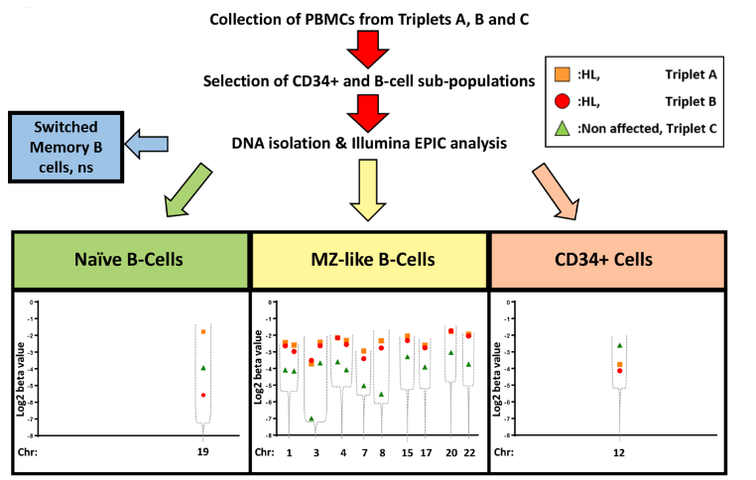

Figure 1. The workflow of cell isolation and results of the DNA methylation status in four subtypes of cells from HL triplets as compared to the non-affected triplet, genome-wide methylation was evaluated with the Illumina EPIC platform. No significant difference in DNA methylation was found in switched Memory B-cells. A significant difference in DNA methylation was recognized in Naïve B cells, Marginal like B cells and CD34+ cells in the two HL triplets as compared to the third non-affected homozygotic triplet. (MZ-like B-cells: Marginal zone like B cells；PBMC: peripheral blood mononuclear cell )


Chuanyou has expertise in hematological diseases. Currently, he is performing Ph.D. studies at the Department of Medicine, Karolinska Institutet. During the past years, he has been actively involved in several projects, such as studies of the role of the PDL1 promoter in Hodgkin lymphoma, the role of lipoxygenases in the micro-environment of Hodgkin lymphoma and projects related to how lipoxygenases are acting in CLL and mantle cell lymphoma

Email: chuanyou.xia@ki.se

