Co-transplantation of Bone Marrow-derived Mesenchymal Stem Cells with Hematopoietic Stem Cells Does Not Improve Transplantation Outcome in Class III Beta-Thalassemia Major

Nasrollah Maleki¹, Tahereh Rostami², Azadeh Kiumarsi³, Mohsen Nikbakht⁴, Amir Kasaeian⁵, Ardeshir Ghavamzadeh⁶
¹⁻⁶ Hematology, Oncology and Stem Cell Transplantation Research Center, Shariati Hospital, Tehran University of Medical Sciences, Tehran, Iran

Abstract
Background
Bone marrow transplantation is the only curative treatment for beta-thalassemia major. Data on the Co-transplantation of mesenchymal stem cells (MSCs) with hematopoietic stem cells (HSCs) in beta-thalassemia major patients are scarce. We aimed to investigate the outcomes of thalassemia major patients who underwent bone marrow-derived MSCs co-transplantation with HSCs compared with those who only received HSCs.
Method
This prospective randomized study included patients with class III thalassemia major undergoing HSCT divided randomly into two groups: 33 patients underwent co-transplantation of bone marrow derived MSCs with HSCs, and 26 patients only received HSCs. Five-year overall survival (OS), thalassemia-free survival (TFS), transplant related mortality (TRM), graft rejection rate, and graft-versus-host disease (GVHD) were estimated.
Results
The 5-year OS was 66.54% (95% CI, 47.8% to 79.9%) in patients who underwent co-transplantation of MSCs with HSCs versus 76.92% (95% CI, 55.7% to 88.9%) in patients who only received HSCs (P = 0.54). No significant difference was observed in the 5-year TFS between the two groups (59.1% vs. 69.2%; P = 0.49). The 5-year cumulative incidence of TRM was not statistically significant among patients who underwent co-transplantation of MSCs with HSCs (27.27%) versus those who only received HSCs (19.23%; P = 0.61). There was no statistically significant difference in graft rejection, acute GvHD, and chronic GvHD between the two groups.
Conclusion
Based on our findings, the co-transplantation of MSCs and HSCs to class III thalassemia major patients does not alter their transplantation outcomes including OS, TFS, rejection rate, transplant-related mortality and GvHD.
.

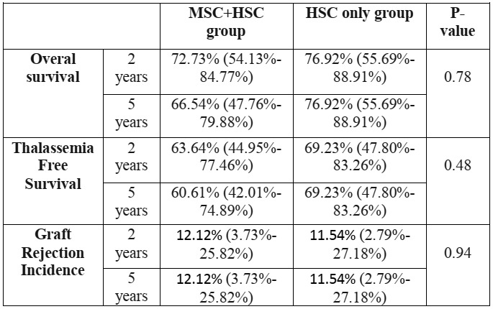

Table 1. Transplantation outcomes of the two groups of patients

Recent Publications (minimum 5)
- Kamranzadeh H, Ardekani RM, Kasaeian A, Sadighi S, Maghsudi S, Jahanzad I, Maleki N. Association between Ki-67 expression and clinicopathological features in prognosis of breast cancer: A retrospective cohort study. J Res Med Sci. 2019 Apr 26;24:30.
- Habibzadeh S, Yazdanbod A , Mohammadshahi J , Maleki N, Ataei S . Hepatotoxicity After Exposure to Tebuconazole: A Case Report and Brief Review, Hepat Mon; 19(7):e94548.
- Habibzadeh S, Sheikh Rahimi M, Edalatkhah H, Piri H, Maleki N. Effectiveness of booster dose of tetanus and diphtheria toxoids (Td) vaccine in management of recurrent aphthous stomatitis: A prospective, randomized, triple-blind and placebo-controlled clinical trial. J Dermatolog Treat. 2019 Aug 12:1-19.
- Bahtouee M, Eghbali SS, Maleki N, Rastgou V, Motamed N. Acute Physiology and Chronic Health Evaluation II score for the assessment of mortality prediction in the intensive care unit: a single-centre study from Iran. Nurs Crit Care. 2019 Mar 29.
- Mohammadi Kebar S, Hosseini Nia S, Maleki N, Sharghi A, Sheshgelani A. The Incidence Rate, Risk Factors and Clinical Outcome of Acute Kidney Injury in Critical Patients. Iran J Public Health. 2018 Nov;47(11):1717-1724.

Corresponding Author:
Dr Nasrollah Maleki has expertise in hematopoietic stem cell transplantation in hematological diseases. I have built this experience in research, evaluation, teaching and administration both in hospital and education institutions.
Email: malekinasrollah@gmail.com, nmaleki@razi.tums.ac.ir

