EFFICACY OF ORAL VERSUS INTRAVENOUS ANTIBIOTICS FOR IN-PATIENT MANAGEMENT OF LOW-RISK FEBRILE NEUTROPENIA IN PEDIATRIC ACUTE LYMPHOBLASTIC LEUKEMIA – AN OPEN LABEL RANDOMIZED CONTROLLED TRIAL
Dr. Madhuchandan M, MBBS, M.D. 3rd year resident, Department of Pediatrics, University College of Medical Sciences and Guru Teg Bahadur Hospital, Delhi-110095
Dr. Sunil Gomber, Director Professor, Department of Pediatrics, University College of Medical Sciences and Guru Teg Bahadur Hospital, Delhi-110095
Dr. Pooja Dewan, Professor, Department of Pediatrics, University College of Medical Sciences and Guru Teg Bahadur Hospital, Delhi-110095
Dr. Shukla Das, Director Professor, Department of Microbiology, University College of Medical Sciences and Guru Teg Bahadur Hospital, Delhi-110095
ABSTRACT
Objectives: To compare the efficacy of empirical oral antibiotics with intravenous antibiotics in terms of success rate of treatment
Design: Open label randomized controlled trial
Setting: Division of Pediatric Oncology, Department of Pediatrics, University College of Medical Sciences & Guru Teg Bahadur Hospital, Delhi, between November 2017 to April 2019
Participants: Total 112 episodes of febrile neutropenia in children aged <12 years with acute lymphoblastic leukemia (ALL) were screened for eligibility. We recruited 80 episodes of low risk febrile neutropenia (Group A=40, Group B=40).
Methodology: ALL was managed as per the institutional protocol (modified MCP-841 protocol). 80 consecutive LRFN episodes in children with ALL were randomized into two groups comprising of 40 each. Group 1 received oral antibiotics - Amoxicillin-clavulanate and Ciprofloxacin while Group 2 received intravenous antibiotics - Ceftriaxone and Amikacin. Complete blood count with ANC, temperature measurement and clinical evaluation for development of any complications and need for switching antibiotics were assessed daily. hsCRP on day 1 and serum procalcitonin level on day 1 and day 3 were estimated besides routine investigations in all participants.
Results: Oral antibiotic group had a treatment success in 31/40 (77.5%) LRFN episodes while intravenous antibiotic group had a treatment success in 32/40 (80%). Non-inferiority could not be established because of the wide confidence interval (-0.18 to 0.13) of proportion of difference in the treatment success. However, the difference in the treatment success proportion between oral antibiotic group and intravenous antibiotic group was not statistically significant.
Conclusion: We conclude that either oral or intravenous antibiotics can be used for the treatment of low-risk febrile neutropenia as per the existing guidelines even in the Indian population. We also recommend the use of biomarkers such as procalcitonin and hsCRP which would help in detection of cases at risk of having an adverse outcome at an early stage leading to a decrease in morbidity and mortality in these already immunocompromised children with acute lymphoblastic leukemia. More studies with larger sample size and meta analyses are required to prove the non-inferiority of oral antibiotics over intravenous antibiotics which if used exclusively would significantly reduce the healthcare cost, improve quality of life and decrease the exposure to nosocomial pathogens.
Key words: febrile neutropenia, acute lymphoblastic leukemia, antibiotics
Table: Outcome Measure:
Outcome | Outcome | Oral antibiotics  (group 1) | IV antibiotics  (group 2) | P value
Primary outcome measure | Treatment success  [n(%)] | 31 (77.5) | 32 (80) | -
Primary outcome measure | Treatment failure  [n(%)] | 9 (22.5) | 8 (20) | -
Secondary outcome measure | Fever clearance time in days  [mean (SD)] | 5.21 (3.994) | 4.5 (2.729) | 0.368
Secondary outcome measure | Time required for recovery of counts in days  [mean (SD)] | 6.58 (4.458) | 5.76 (3.575) | 0.382
Secondary outcome measure | Readmission within 7 days of discharge  [in number of episodes] | 3 | 2 | 1.000
Secondary outcome measure | Procalcitonin clearance (Pct_c=Pct1-Pct3/Pct1 X 100)  [Median (IQR)] | 31.49 (10.3-44.3) | 33.08 (6.84-60.11) | 0.658
Secondary outcome measure | hsCRP in mg/L  [Median (IQR)] | 29.66 (10.10-47.26) | 26.36 (19.22-50.36) | 0.392

ALL patients with low risk febrile neutropenia
Randomization
Group 1
Oral antibiotics
(Amoxycillin-Clavulanate + Ciprofloxacin)
Group 2
Intravenous antibiotics
(Ceftriaxone + Amikacin)
Remains clinically stable
Clinical unstable / develop serious medical complications
Remains clinically stable
Clinical unstable / develop serious medical complications
Switched to intravenous antibiotics (Ceftriaxone + Amikacin)
Resolution of febrile neutropenia
Persistence of fever >4 days
Switched to higher IV antibiotic regimen (Meropenem + Vancomycin)
Resolution of febrile neutropenia
Persistence of fever >4 days
Treatment success
Add empirical antifungal treatment (regarded as treatment modification; not as treatment failure)
Treatment failure
Treatment success
Add empirical antifungal treatment (regarded as treatment modification; not as treatment failure)
Treatment failure
Resolution of febrile neutropenia
Persistence of fever > 7 days of empirical oral antibiotics (>3days of empirical antifungal treatment)
Resolution of febrile neutropenia
Persistence of fever > 7 days of empirical IV antibiotics (>3days of empirical antifungal treatment)
Treatment success
Treatment
failure
Treatment success
Treatment
failure

Figure 1. Consort flow chart

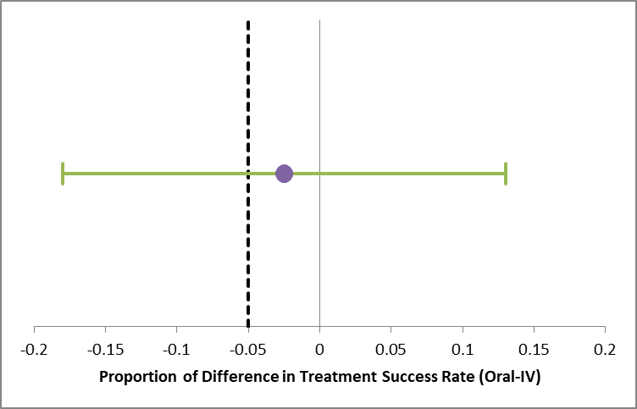
Figure 2. Interpretation of the proportion of difference in treatment success rate

BIOGRAPHY
Photograph



Dr Madhuchandan M is currently a third year post-graduate resident in the Department of Pediatrics, University College of Medical Sciences and GTB hospital, Delhi. He has his expertise in evaluation and passion in improving the health and wellbeing of children. He has great interest in the field of pediatric hematology and oncology. He undertook the above study under the expert guidance of Dr Sunil Gomber. The study was conducted over a period of one and half years at Pediatric Oncology Division, Department of Pediatrics, University College of Medical Sciences and GTB hospital, Delhi
Email: madhuchandanrims@gmail.com
Phone: +91 7204549449, +91 8147197454

