CYTOGENETIC PROFILE OF PHILADELPHIA CHROMOSOME POSITIVE CHRONIC MYELOID LEUKEMIA

Dr Nazia Hafeez, FCPS II, Pk
Dr Ikramdin Ujjan, FCPS II, M.Phil., PhD, Pk

Abstract

Chronic myeloid leukemia; a clonal hematopoietic stem cell disorder characterized by a specific chromosomal translocation, t (9;22), results in a shortened chromosome 22; The Philadelphia (Ph) chromosome. Emergence of non-random chromosomal abnormalities in addition to the Philadelphia chromosome is a well-recognized event in CML and is referred to as clonal evolution. Detection of these cytogenetic abnormalities is imperative in stratifying patients into different prognostic groups and to offer appropriate treatment options.The study aimed to analyze various other Chromosomal abnormalities in Philadelphia positive Chronic Myeloid Leukemia patients.

Patients diagnosed as CML were included and Cytogenetic studies were performed with the Conventional G-banding technique. A minimum of 20 metaphases were analyzed and described according to the International System for Human Cytogenetic Nomenclature (ISCN) guidelines. The diagnosis of CML was based on characteristic peripheral blood smear and bone marrow examination findings and was confirmed by presence of the Philadelphia chromosome on bone marrow cytogenetic studies. Early identification of these abnormalities may help in adapting to a more appropriate therapeutic approach. A risk stratification system based on prognostic relevance of individual ACAs may be a useful guide to prognosticate and guide treatment of CML at diagnosis and clonal evolution.

Image

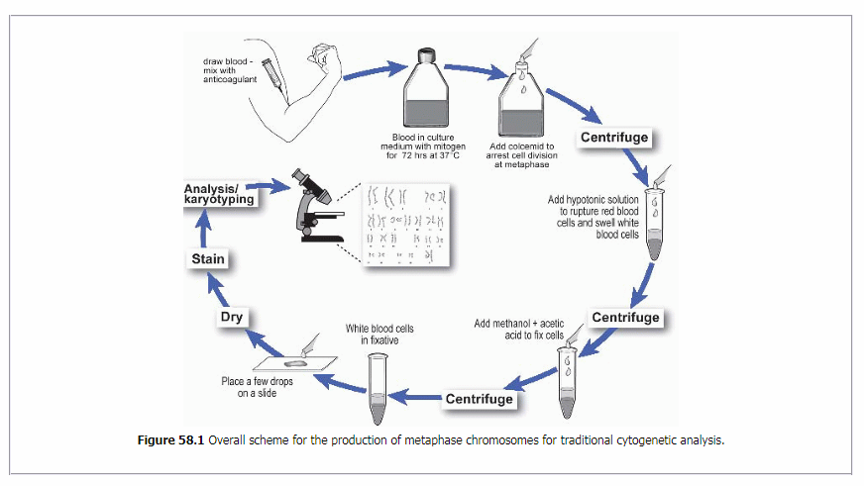

References
- Safaei, A., Monabati, A.,(2018). Additional cytogenetic aberrations in chronic myeloid leukemia: a single-center experience in the Middle East. Blood research, 53(1), 49-52.
- Souza, C.A.D. (2018). Age and cytogenetic abnormalities. Hematology, transfusion and cell therapy, 40(3), 199-199.
- Bourlon, C., Morales-Chacon,. (2018). Impact of additional cytogenetic abnormalities on clinical outcomes in chronic myeloid leukemia: First report in a Latin American population.
- Dorfman, L. E., Floriani, M. A.,(2018). The role of cytogenetics and molecular biology in the diagnosis, treatment and monitoring of patients with chronic myeloid leukemia. Jornal Brasileiro de Patologia e Medicina Laboratorial, 54(2), 83-91.
- Yue, Y. H., He, X. F., (2018). Effect of Additional Chromosomal Abnormalities on the Outcome of CML-CP Patients Receiving TKI Therapy. Zhongguo shi yan xue ye xue za zhi, 26(5), 1275-1280.

Photograph



Dr. Nazia Hafeez, currently working as a Chief Resident in Hematology Postgraduate Training FCPS II in a tertiary care hospital laboratory in Hyderabad. We are looking forward to establish much more facilities as it’s much limited resources in this under privileged area catering to mostly the poor communities. Email:drnaziahafeez@gmail.com

