TWO NOVEL DNMT3A MUTATIONS IN ACUTE MYELOID LEUKEMIA

Bruno S, 1, Bochicchio MT, 2, Franchini E, 1, Padella A, 1, Pazzaglia M, 1, Raffini M, Bandini L, Venturi C, 1, Simonetti G, 2, Soverini S,1, Ottaviani M,1, and Martinelli G, 2.

1 Department of Experimental, Diagnostic and Specialty Medicine, University of Bologna.
2 Istituto Scientifico Romagnolo Per Lo Studio e la Cura dei Tumori, Meldola, Italy.

Abstract (300 word limit)
Statement of the Problem: Recurrent somatic mutations of DNMT3A occur in about 20% of acute myeloid leukemia (AML) patients, targeting a hot spot site at R882 codon [1]. DNMT3A mutations in primary AML samples are often heterozygous and are associated with CpG hypomethylation [2], which result in high myeloblast counts, and poor prognosis [3]. The study aims to characterize two new mutations in the DNMT3A gene, identified in two AML patients. Methodology & Theoretical Orientation: DNA was extracted from mononucleated cells and it was sequenced by Sanger Sequencing and Next-Generation sequencing. Sequences obtained were mapped to human reference genome GRCh37/hg19 and annotated using Ion Reporter 5.10.2.0. The MethylFlash Methylated DNA Quantification Kit was used to detect CpG methylation status. DNMT3A protein level was assessed by western blot. Findings: Patient #1 had 70% of blasts in the BM at diagnosis and showed an undescribed single nucleotide variant of DNMT3A at exon 20 causing a premature STOP codon (cDNA c.2385G>A; tgG/tgA p.Trp795*; NM_022552;), coupled with IDH2 R172K mutation. The DNMT3A mutation load increased from 4% in the diagnosis sample to 38.2% in the follow-up, which had stable disease, evaluated 4 month after treatment in multicentric clinical trial. The increase of mutation rate correlated with DNA hypo-methylation and lead to loss of protein expression. Patient #2 had 80% of blasts in the BM at diagnosis and 90% at relapse, with a new insertion of 36 nucleotides in exon 22 of the DNMT3A gene (c.2924_2925ins36: TCATGAATGAGAAAGAGGACATCTTATGGTGCACT), along with FLT3-ITD. DNMT3A mutation load was 27.5% at diagnosis and increased at 48% at relapse, which occurred 7 month after completion of chemotherapy treatment. We did not observe a significant variation of protein levels, neither of DNA methylation. Conclusion & Significance: Obtained data support the hypothesis that DNMT3A mutations may be involved in pre-leukemic clonal hematopoietic expansion.

Image
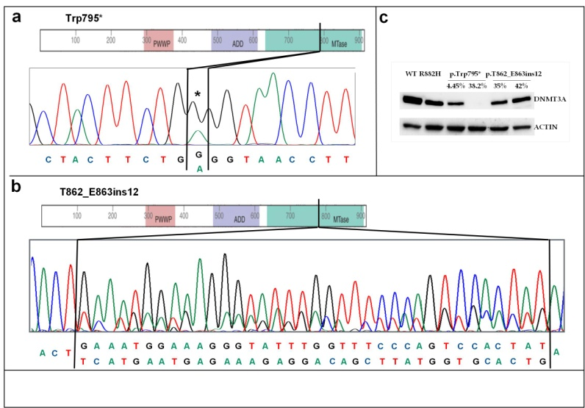
Recent Publications (minimum 5)
- X.J. Yan, J. Xu, Z.H. Gu, C.M. Pan, G. Lu, Y. Shen, et al. Exome sequencing identifies somatic mutations of DNA methyltransferase gene DNMT3A in acute monocytic leukemia. Nat. Genet. 43 (4) (2011) 309–315.
- McDevitt MA. Clinical applications of epigenetic markers and epigenetic profiling in myeloid malignancies. Semin Oncol. 2012;39(1):109–22.
- Marcucci G, Metzeler KH, Schwind S, Becker H, Maharry K, Mrozek K, et al. Age-related prognostic impact of different types of DNMT3A mutations in adults with primary cytogenetically normal acute myeloid leukemia. J Clin Oncol. 2012;30(7):742–50.

Photograph

 Biography (150 word limit)
Dr. Samantha Bruno is a PhD student in hematology on university of Bologna. She has her expertise in molecular and cellular biology. Her research is mainly focused on molecular characterization of acute myeloid leukemia primary sample and in vitro study in order to identify new drugs for personalized therapy of acute myeloid leukemia patients.
Email: samantha.bruno2@unibo.it

Notes/Comments:

