Comparative study of bone marrow and blood plasma level of IL-2 in aplastic anemia and their relation with disease severity
Dr. Rajib De, DM, Clinical Hematology, Nilratan Sircar Medical College, Kolkata, India
Atreyee Duttab, Tuphan Kanti Dolaia, Kakoli Ghoshb and Ajanta Halderb

Abstract
Statement of the Problem: Interleukin-2 is a potent
signalling molecule in the signalling cascade of the immune-mediated activation of T Lymphocytes leading to the destruction of haematopoietic stem cell. This forms the basis
of acquired aplastic anaemia (AAA). The objective was to study the association of IL-2 in the bone marrow plasma (BMP) and peripheral blood plasma (PBP) in AAA patients. Methodology & Theoretical Orientation: Institutional ethical clearance was obtained and 52 BMP and PBP-paired samples were collected from the confirmed AAA patients and 10 non-aplastic anaemia controls. The level of IL-2 was measured by the quantitative enzyme-linked immunosorbent assay. The IL-2 level was compared between the AAA and control subjects as well as among the various severity grades of AAA. Mann– Whitney U test was used for statistical analysis. Findings: Significantly higher level of IL-2 was found in the BMP (75.33 ± 41.9 vs. 3.12 ± 1.82; p<0.00001) and PBP (48.54 ± 21.89 vs. 1.99 ± 1.25 p<0.00001) of AAA patients compared to the control subjects. The IL-2 levels were higher in patients with VSAA and SAA than those with NSAA in the PBP (65.6 ± 23.61 vs. 31.72 ± 7.64; p=0.00338) and (45.37 ± 16.25 vs. 31.72 ± 7.64; p=0.01468) respectively. The IL-2 levels were higher in patients with VSAA and SAA than those with NSAA in the BMP (115.01 ± 38.91 vs. 38.32 ± 19.49; p<0.00001) and (66.44 ± 23.34 vs. 38.32 ± 19.49; p=0.0006). The IL-2 level was higher in VSAA than SAA in PBP (65.6 ± 23.61vs. 45.37 ± 16.25; p=0.0114) and BMP (115.01 ± 38.91 vs. 66.44 ± 23.34; p=0.00044). Conclusion & Significance: Higher level of IL-2 in AAA patients compared to controls implies its role in the disease pathogenesis. Also, the higher the level of IL-2, more severe is the disease emphasizing its role in the disease severity.

Image
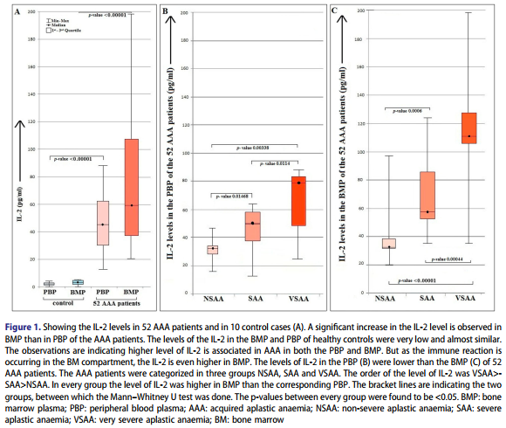
Recent Publications (minimum 5)
- Meet Kumar1, Prakas Mandal1, Rajib De (2015) Atypical HUS
caused by anti- complement factor H antibody: Blood Research
Volume 50 Issue 1: 63-65
- Ganguly BB, Dolai TK, De R, Kadam NN(2016) Spectrum of complex
chromosomal aberrations in a myelodysplastic syndrome and a brief review.
J Can Res Ther;12:1203-6.
- Prakas Kumar Mandal,Suman Kumar Maji,Tuphan Kanti Dolai , Rajib De(2014) Micro-organisms Associated with Febrile Neutropenia in Patients with Haematological Malignancies in a Tertiary Care Hospital in Eastern India. Indian J Hematol Blood Transfus Volume 31, Issue 1: 46-50
- Atreyee Dutta, Rajib De(2017) Cytogenetic study is not essential in patients with aplastic anemia. Am J Blood Res 7(5):49-58
- Rajib De, Atreyee Dutta (2018) Comparative study of bone marrow and blood plasma levels of IL-2 in aplastic anaemia and their relationship with disease severity, Hematology

Photograph

 Biography (150 word limit)
Dr. Rajib De(MD, DM-Clinical Hematology) is associate professor in the Department of Hematology, NRS Medical College & Hospital. He is Hemato-onlogist and bone marrow transplant physician. His area of interest is Thalassemia, Acute Lymphoblastic Leukemia and Aplastic Anemia. He has more than 10 publications in different national & international index journals. Some of his research areas are screening of Thalassemia carrier by nanotechnology based method, Label Free Characterization for Hematopoietic Stem Cells by Nanotechnology based methods, Development of Spion( super paramagnetic iron oxide nanoparticle) based ferritin sensor, Gene micromapping of Thalassaemia in West Bengal, Etiological role of environmental and genetic factors in Aplastic Anaemia, phenotypic variation of Hb E-Beta Thalassaemia. Present study looks into the etiological association of different cytokines in pathogenesis of aplastic anemia and in determining the disease severity.
Email: rajibdrde@gmail.com

Notes/Comments:

