Outcome of treatment with decitabine for acute myeloid leukemia developing as a secondary primary malignancy in a filipino man with multiple myeloma
Haidee Michelle L. Chua, MD, UP-PGH, Philippines
Maria Clariza M. Santos, MD, UP-PGH, Philippines

Abstract

Multiple myeloma treatment has evolved over the past two decades. The introduction of novel agents, has significantly improved overall survival. With marked improvement in survival rates, the development of secondary primary malignancies now posts a new challenge among patients with multiple myeloma.
We report the case of a 69 year old Filipino male who was diagnosed with multiple myeloma in 2012. He underwent therapy with melphalan and prednisone, and was eventually shifted to bortezomib with dexamethasone and thalidomide. Remission was documented in 2015 and maintenance therapy with monthly bortezomib and daily thalidomide were given. In April of 2016, he developed acute myeloid leukemia.
Although there have been reports of secondary primary malignancies specially acute myeloid leukemia developing in patients with multiple myeloma, to our knowledge, this is the first reported case in the Philippines.
Secondary primary malignancies carry with them a poor outcome regardless of the treatment regimen used for multiple myeloma. Our patient underwent treatment with decitabine and achieved complete remission after the sixth cycle.

Image
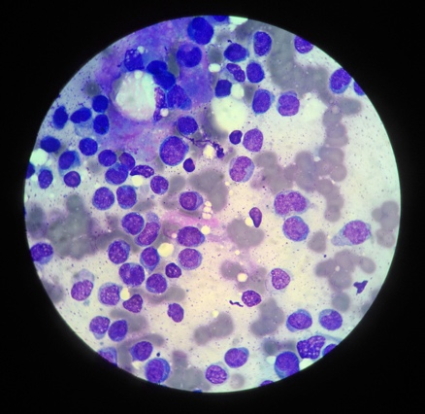

Bone Marrow is cellular with trilineage Hematopoeisis; M:E Ratio 2-3:1. Megakaryocytes and Erythroid precursors seen. Marked increase in medium to large mononuclear cells, mostly with multiple nuclear indentations, fine chromatin, and moderate agranular cytoplasm. Plasma cells ~ 2%

Recent Publications

- A Thomas, S Mailankody, N Korde, et. al. Second malignancies after multiple myeloma: from 1960s to 2010s. Blood 2012: 119; 2731-2737.
- P Razavi, KA Rand, W Cozen, et. al. Patterns of second primary malignancy risk in multiple myeloma patients before and after the introduction of novel therapeutics. Blood Cancer Journal 2013:3; e121
- W Lu-qun, L Xiang-xin, et. al. A case of simultaneous occurrence of acute myeloid leukemia and multiple myeloma. BMC Cancer (2015) 15:724.
- S Mailankody, RM Pfeiffer, SY Kristinsson, et. al. Risk of acute myeloid leukemia and myelodysplastic syndromes following multiple myeloma and its precursor disease (MGUS). Blood. 2011; 118(15): 4086-4092.
- S Ailawadhi, A Swaika, P Razavi, et. al. Variable risk of second primary malignancy in multiple myeloma patients of different ethnic subgroups. Blood Cancer Journal 2014:4; e243

Photograph

Biography

Dr. Haidee Michelle Chua is currently a Hematology fellow-in-training at the University of the Philippines, Philippine General Hospital.

Email: dee2limmd@gmail.com

Notes/Comments:

