KNOWLEDGE, ATTITUDES AND PRACTICES ON BLOOD TRANSFUSION OF MEDICAL RESIDENTS IN A TERTIARY HOSPITAL: A QUESTIONNAIRE-BASED STUDY
Dr. Rmin Sheila Miranda, MD, FPCP, Philippines

Abstract
Aim
Blood transfusion remains to be one of the most common procedures performed in hospitals. Knowledge of doctors on transfusion has a substantial influence on rational blood product utilization. We aim to assess the knowledge, attitudes and practices on transfusion of internal medicine (IM) residents at the Philippine General Hospital, using the a validated questionnaire on transfusion medicine (TM).
Methodology
This is a descriptive cross-sectional study design. General data on demographics were collected, and participants answered the BEST-TEST validated questionnaire on TM.
Results
The 63 residents included in this study had a mean score of 39.1%, 40.0%, and 41.0% for the first, second, and third year residents, respectively. There is no significant correlation between test scores and number of hours of training in TM. There is a significant correlation between the quality of residency training on TM and test scores with scores increasing as the year level increases.
Conclusion
Results has shown inadequacy in the knowledge on TM among IM residents. Further training on TM may necessary help strengthen this competency.

Image

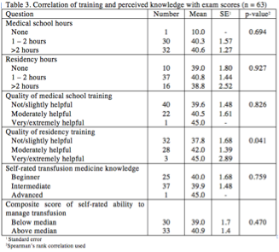

Recent Publications
Photograph


Dr. Rmin Sheila Miranda is a graduate of University of the East, Ramon Magsaysay Memorial Medical Center, School of Medicine. She then completed her residency training in Internal Medicine at San Juan Medical Center, Philippines, and later pursued fellowship training in Hematology at the University of the Philippines – Philippine General Hospital. At UP-PGH, she had the opportunity to learn from the best, and provide a vast array of treatment plans to patients of different socio-economic backgrounds dealing with hematologic diseases. While working with a diversity of population, she has developed proficiency in providing evidence-based medicine and clinical management to all patients referred to her.
Email: rsjmmd@gmail.com

Notes/Comments:

