Factors affecting utilization of sexual and reproductive health services among women with disabilities- A mixed-method cross-sectional study from Ilam district, Nepal
Rupa Shiwakoti, M.Phil., MPH, Country Coordinating Mechanism Nepal, Kathmandu, Nepal
Rupa Shiwakoti^{,2*}, Yogendra Bahadur Gurung¹, Ram Chandra Poudel^{1,3}, Sandesh Neupane², Ram Krishna Thapa⁴, Sailendra Deuja⁵, Ram Sharan Pathak¹

Abstract (300 word limit)
Statement of the Problem: Despite SDGs call for “universal access to sexual and reproductive health (SRH)”, women with disabilities (WwDs) continue to experience barriers to access SRH services in Nepal. This study evaluated factors affecting the utilization of SRH services among WwDs in Ilam district, Nepal. Methodology & Theoretical Orientation: A mixed-method study with 384 WwDs of reproductive age was conducted in Ilam district, eastern Nepal. Quantitative data were collected using a structured questionnaire. Relationships between utilization of SRH services and associated factors were explored using multivariate logistic regression analysis. Qualitative data were collected from focus groups with female community health volunteers and interviews with WwDs, health workers and local political leaders. They were audio-recorded, translated and transcribed into English and were thematically analyzed. Findings: Among 384 respondents, only 15 percent had ever utilized any SRH services. No requirement (57%) and unaware of SRH services (24%) were the major reasons for not utilizing SRH services. Multivariate analysis showed that being married (AOR=121.7, 95% CI: 12.206-1214.338), having perceived need for SRH services (AOR=5.5; 95% CI: 1.419-21.357) and perceived susceptibility to SRH related disease/condition (AOR=6.0; 95% CI:1.978-18.370) were positively associated with the utilization of SRH services. Qualitative findings revealed that illiteracy, poor socioeconomic status, and lack of information hindered the utilization of SRH services. WwDs faced socioeconomic (lack of empowerment and family support), structural (distant health facility, inaccessible-infrastructure), and attitudinal (stigmatization, bad behavior of health care providers, perception that SRH is needed only for married) barriers to access SRH services. Conclusion & Significance: Utilization of SRH services among WwDs was very low in Ilam district, Nepal. The findings of this study warrant a need to promote awareness-raising programs to WwDs and their family members, sensitization programs to health service providers, and ensure the provision of disability-inclusive SRH services in all health facilities.

Image

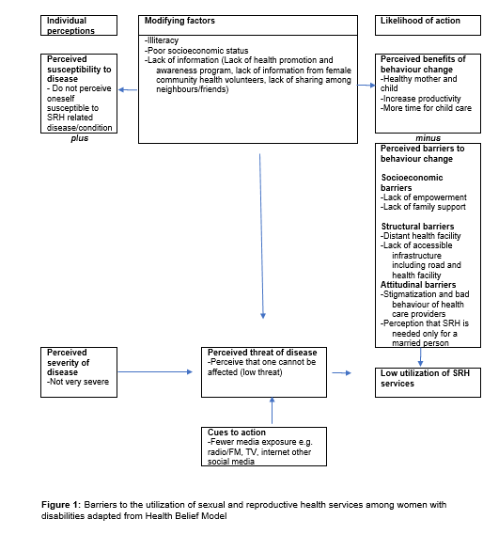
Recent Publications (minimum 5)
- Horner‐Johnson, W., Dissanayake, M., Wu, J. P., Caughey, A. B., & Darney, B. G. (2020). Pregnancy intendedness by maternal disability status and type in the United States. Perspectives on Sexual and Reproductive Health, 52(1), 31–38. https://doi.org/10.1363/psrh.12130
- Shrestha, S., & Wærdahl, R. (2020). Girls’ access to adolescent friendly sexual and reproductive health services in Kaski, Nepal. Asia & the Pacific Policy Studies, 7(3), 278–292. https://doi.org/10.1002/app5.305
- Tarasoff, L. A., Murtaza, F., Carty, A., Salaeva, D., Hamilton, A. D., & Brown, H. K. (2020). Health of newborns and infants born to women with disabilities: A meta-analysis. Pediatrics, 146(6), 1–9. https://doi.org/10.1542/peds.2020-1635
- Pandey, P. L., Seale, H., & Razee, H. (2019). Exploring the factors impacting on access and acceptance of sexual and reproductive health services provided by adolescent-friendly health services in Nepal. PLoS ONE, 14(8), e0220855. https://doi.org/10.1371/journal.pone.0220855
- Mitra, M., Clements, K. M., Zhang, J., & Smith, L. D. (2016). Disparities in adverse preconception risk factors between women with and without disabilities. Maternal and Child Health Journal, 20(3), 507–515. https://doi.org/10.1007/s10995-015-1848-1

Photograph


Email: rupa.shiwakoti@gmail.com

Biography (150 word limit)
Mrs. Shiwakoti received the M.Phil. in Population Studies from Central Department of Population Studies, Nepal in 2020 and the Master of Public Health from Maharajgunj Medical Campus, Nepal in 2015. She has more than a decade of experience in the health sector. She has her expertise in monitoring and evaluation and is passionate to improve the health and wellbeing of people particularly focusing on disadvantaged and marginalized communities. She currently works as an oversight officer in Country Coordinating Mechanism Nepal and overseeing national programs on HIV, TB and Malaria. Her research interest is in sexual and reproductive health, disability, nutrition and community engagement.

*Correspondence: rupa.shiwakoti@gmail.com Central Department of Population Studies, Tribhuvan University, Kirtipur, Kathmandu, Nepal ² Country Coordinating Mechanism Nepal, Teku, Kathmandu, Nepal ³ Health Inspector, Health Section, Nagarjuna Municipality, Kathmandu, Nepal ⁴ Master Degree in International Humanitarian Action, University of Warsaw, Poland ⁵ Karuna Foundation Nepal, Central Office, Kathmandu, Nepal

