MiR-191-5p is upregulated in culture media of implanted human embryo on day 5th of development
Dr Acuna-Gonzalez, MD, MSc Immunobiochemistry Dept INPer, Mexico
Dr Flores Herrera, PhD, Immunobiochemistry Dept INPer, Mexico

Abstract (300 word limit)
Background: Morphological features are the most common criteria used to select human embryos for transfer to a receptive uterine cavity. However, such characteristics are not valid for embryos in cellular arrest. Even aneuploid embryos can have normal morphology, and some euploid embryos have aberrant morphology. The aim of this study was to quantify the expression profile of hsa-miR-21-3p, -24-1-5p, -191-5p, and -372-5p in culture media on day 5 of in vitro embryo development, and compare the profiles of two groups of media classified by outcome: successful (n = 25) or unsuccessful (n = 25) implantation pregnancy. Methods: Fifty patients were accepted in the Department of Reproductive Biology of a Hospital in México City, based on the Institutional inclusion criteria for in vitro fertilization. Embryos were transferred to the women on day 5 of cultivation, and the culture media were collected. RNA was isolated from each culture medium with TRIzol reagent, and microRNA (miRNA) expression was detected through RT-PCR with specific primers. Expression bands were quantified by reading optical density. Results: There was a 5.2-fold greater expression of hsa-miR-191-5p in the pregnancy-related culture media (p ≤ 0.001) and a 1.6-fold greater level of hsa-miR-24-1-5p (p = 0.043) in the media corresponding to non-pregnant women. No significant difference existed between the two groups hsa-miR-21-3p (p = 0.38) or hsa-miR-372-5p (p = 0.41). Conclusions: Regarding adequate in vitro embryo development, hsa-miR-191-5p could possibly represent a positive biomarker, while has-miR-24-1-5p may indicate poor prognosis. This former miRNA modulates IGF2BP-1 and IGF2R, associated with the implantation window. On the other hand, hsa-miR-24-1-5p may be related to a poor prognosis of human embryo development. Keywords: MiRNA expression, Embryo development, Implantation, Embryo culture media, In vitro fertilization

Image

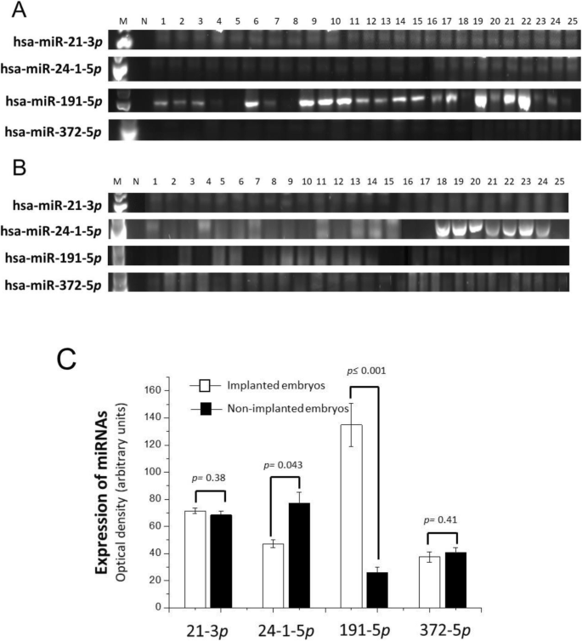

Expression of hsa-miRNAs in the culture medium of human embryos with type II development. Marker (Lane 1), negative control (Lane 2) samples of the culture medium of the 25 implanted (A, pregnant patients) and non-implanted embryos (B non-pregnant patients). The optical density of each band was determined and the mean ± standard deviation is shown (C). The significant difference is indicated which was made by the Student's t-test and was taken as a difference of less than 0.05

Recent Publications (minimum 5)
1.Wilczynska A, Bushell M. The complexity of miRNA-mediated repression. Cell Death Differ. 2015;22:22–33.

2.Bartolucci AF, Uliasz T, Peluso JJ. MicroRNA-21 as a regulator of human cumulus cell viability and its potential influence on the developmental potential of the oocyte. Biol Reprod. 2020;103:94–103.
3. Azizi E, Ghaffari Novin M, Naji M, Amidi F, Shams Mofarahe Z. Does in vitro fertilization affect the expression of miRNAs and their biogenesis pathway in preimplantation mouse embryos? Birth Defects Res. 2020;112:62–70.
4. Kropp J, Khatib H. Characterization of microRNA in bovine in vitro culture media associated with embryo quality and development. J Dairy Sci. 2015;98:6552–63.
5. Paul ABM, Sadek ST, Mahesan AM. The role of microRNAs in human embryo implantation: a review. J Assist Reprod Genet. 2019;36:179–87.

Photograph

Biography (150 word limit)
Dr Acuna has expertise in evaluation and treatment of infertile couples, particularly those participating in In Vitro Fertilization programs in Mexico. His focus of research has been recurrent implantation failure and embryo quality assessment. His aim is to develop analytic embryo assessment models in order to offer a more accurate prognosis on IVF results to patients based on non-invasive techniques, for example quantification of metabolites in embryo culture media.
Email: acugyomedik@gmail.com

Notes/Comments:

