In vitro Anti-diabetic Properties of Traditional Rice
GAS Premakumara¹ & WKMS Abeysekera²
¹Faculty of Nursing, University of Colombo
²Faculty of Technology, University of Colombo

Over half of the world population eat rice as their staple diet. Many countries have traditional rice native to those countries which they have consumed from civilization. However, eating traditional rice have been change with the introduction of improved rice varieties with the green revolution. It is now a known fact that deviation from traditional food pattern may have contributed to the noncommunicable disease epidemic including incidence of high levels of diabetic and prediabetic situation. Joint WHO/FOA consultation report on Diet, Nutrition and the Prevention of Chronic Diseases published in 2003 attribute largely to the change in dietary pattern. In this context we screened a range of traditional rice varieties in Sri Lanka for antidiabetic properties using in vitro bioassay techniques. We report here the antidiabetic activities of four most active traditional rice varieties in Sri Lanka.
70% Ethanolic extracts of brans of the four rice varieties [Sudu Heeneti, Goda Heeneti, Masuran, Dikwee: (Oriza sativa L.)] were tested in vitro for anti α-Amylase, α-Glucosidase, Acetyl & Butyryl cholinesterase enzymes and anti-glycation and glycation reversing properties and starch digestion rate. Out of the 4 traditional varieties, 3 showed significant α-Amylase inhibition over standard drug Acarbose. Interestingly no α-Glucosidase inhibition could be observed. Anti-glycation activity in all 4 varieties were statistically significant compared to the standard Rutin. All the varieties had glycation reversing activity. Cholinesterase inhibition of all rice bran were low compared to control drug Galantamine. The in vitro starch digestion was moderate compared to white bread (See figure).
The study clearly shows that the traditional rice which people have been consuming before Green revolution has some beneficial effects related to management of diabetic. This is the 1st study to show anti-glycation and glycation reversing properties from any rice variety in the world.
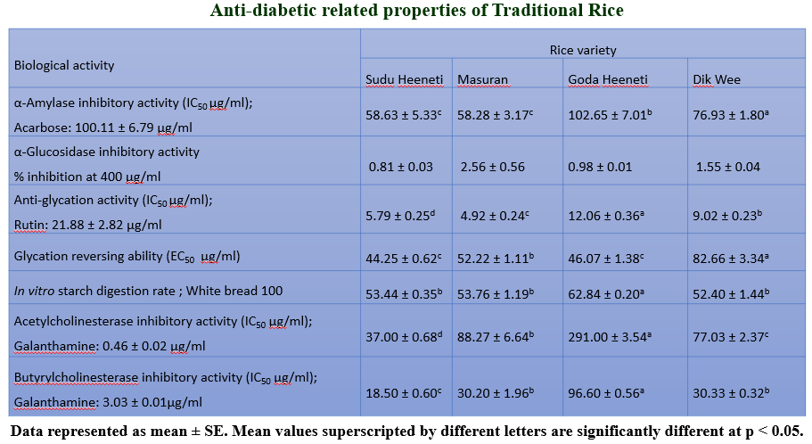
Keywords: Anti-amylase, Anti-diabetic, Anti-glycation, Traditional rice

Professional Biography

Dr.GAS Premakumara holds a PhD in Chemical Biology from University of Colombo and postdoctoral training in Nutrition Biochemistry & Health Food Biotechnology from National Food Research Institute, Japan. He is a Senior Lecturer and Head of Department of Basic Sciences & Social Science of Faculty of Nursing, University of Colombo, Sri Lanka. He was the Director General of CISIR-Sri Lanka before he joined Colombo University. He has published over 80 papers in reputed journals and over 200 research communications in national and international conferences in the areas of Bioactive Natural Products, Health Food and Nutrition Biochemistry. He is a recipient of Presidential Award for Research Publications and two National Awards from Government of Sri Lanka. He has also won the First Three Finalist Award at WAITRO World Innovation Award-2016. He is a Visiting Research Fellow at International Centre for Chemical & Biological Science, Pakistan and Visiting Academic at Southern Cross University, Australia.


Paste your Photograph here

Email Id: sirimalpremakumara@gmail.com
Any Comments:

