

STRESS DYSAUTONOMIA AND CARDIO-DIABETES
RAMESH ADIRAJU MD, FACC
RENU-CA RESEARCH INSTITUTE
501 BATH RD, BRISTOL, PA, USA 19007
Email – Renu-ca@comcast.net
Web site - renu-ca.org
Autonomic system with sympathetic (fight-n-flight) and parasympathetic (regulator) is the autoregulatory system that maintains body homeostasis. There is a central control mechanism – Central Clinical Autonomic Loop (CCAL fig-1) that regulates the functioning of the autonomic system. CCAL comprises of hypothalamus, central vagal nucleus and other brainstem nuclei. Hypothalamus – Vagal reflex communication (HPV axis) is the key control center for autonomic system. When autonomic system is in optimal balance there is autonomic coherence, imbalance in the system causes autonomic resistance.
Hormonal regulation and cardiovascular system are under maximum autonomic regulation. Dysautonomia is the underlying physiologic dysfunction for type II diabetes and Cardiovascular illnesses. Therefore, they occur together “Cardio-Diabetes”. Vascular inflammation due to endothelial dysfunction and insulin resistance due to leptin resistance are caused by dysautonomia (fig-2). Pardoxic parasympathetic stimulation causes hypothalamic suppression through HPV axis. Hence stress induces dysautonomia and cardio-diabetes is a consequence of dysautonomia.
At RENU-CA research institute we have developed dysautonomia assessment and treatment protocols based on heart rate variability/respiratory frequency testing to assess dysautonomia and treatment algorithms based on regulating HPV axis at the brainstem. Over 1000 patients with cardio-diabetes have been successfully treated between 2005 – 2018 at our institute.

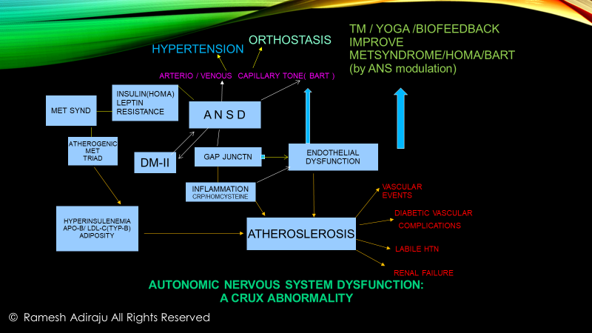
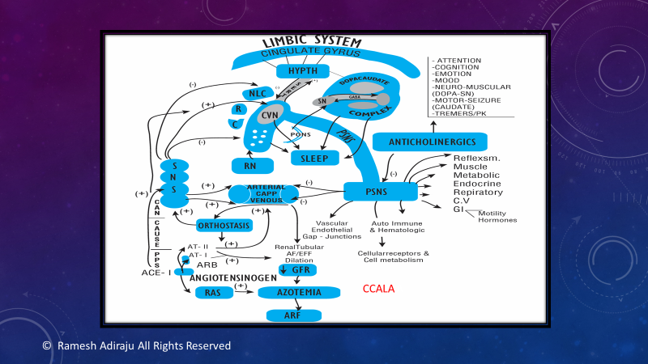
Fig-1
Fig-2

KEY WORDS: Dysautonomia, Cardio-diabetes, Pardoxic parasympathetic dysfunction, Autonomic coherence, Autonomic resistance .

Biography:
Dr. Ramesh Adiraju obtained his medical degree from Kasturba Medical college, Mangalore India in 1985. He emigrated to USA and has specialized in Internal Medicine and cardiovascular diseases. He has been practicing clinical and interventional cardiology for 25 years. Dr. Adiraju developed novel approaches to assess dysautonomia and applied dysautonomia based treatment approaches for type II diabetes and cardiovascular diseases. Dr. Adiraju established a research Institute in 2005 to pursue his clinical research and currently practices in Philadelphia, Pennsylvania, USA.

