Amsterdam Conference, 2019.

Name: Owusu A. Bempah, Ph.D

Affiliation: fv Supplement limited

Address: 59, Brewery Road, London. SE18 1NB. United Kingdom.

Tel: +44(0)7914 120 175.

Email: kb436@outlook.com

Abstract

Title: Long-term Chronic Diabetes Complications: the Cause, Cure and Prevention.
.
Introduction. The glucose model for the study of diabetes complications has failed because researchers are still looking for cure for individual dysfunctional organs. A Poluyria Model has therefore, been proposed and tested.

Theory. Diabetes-induced polyuria causes daily temporary deficiency in blood plasma vitamin B that sustains vasodilatation in the microcirculation. The deficiency causes vasoconstriction which impacts adversely on the exchange of nutrients, gases and particles between blood and tissue, resulting in tissue damage. With time, the accumulated tissue damage manifests as organ dysfunction – so-called diabetes complications.

Hypothesis: Vitamin B supplementation to ensure full 24-hour vasodilatation in the microcirculation will stop tissue damage and allow cures of manifested symptoms of diabetes complications.

Method. In on-going Open Trial beginning in 2008, tablets containing vitamin B {nicotinamide (15.0mg); thiamine hydrochloride (12.5mg); and calcium-d-panthothenate (11.0mg)}, were ingested by patients with suspected diabetes complications in single/multiple organs.

Results. Over 200 cures reported included early-stage symptoms of complications in: the eye (rectinopathy); kidney (swollen feet/ankles); skin (leg, gum, toe sores). Restored erectile functions were also reported. As prophylactic, the tablets have prevented manifestation of symptoms of complications for over 8 years. The new theory also explains the reported cures of diabetes complications accomplished with high doses of benfotiamine and thiamine.

Conclusion. So-called diabetes complications, like scurvy, is not a disease but manifestation of the effects of vitamin deficiency and is curable and preventable.

Key words: Vitamin B deficiency model, diabetes complications, cure and prevention, vitamin B supplementation. Words 243.

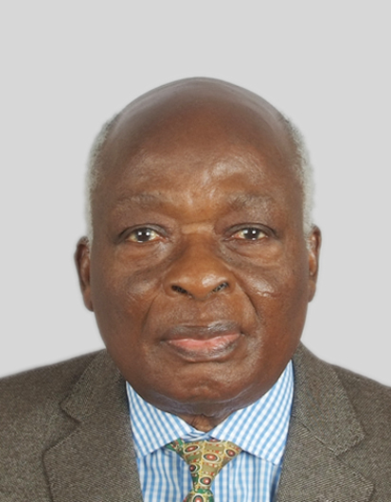

A brief autobiography of Dr O. A. Bempah.

Dr Bempah graduated with M.Sc. in radiochemistry from Lomonosov Moscow State University in 1967 and Ph.D in analytical chemistry from McMaster University, Hamilton, Ontario, Canada; in 1972. He taught Chemistry at Cape Coast University and Ghana Atomic Energy Commission before moving to settle in the United Kingdom. Diagnosed with Type 2 diabetes mellitus in 1988, he focussed his research efforts on Diabetes Complications. He has published and presented papers at conferences on his thesis that long-term, chronic diabetes complications are caused by vitamin deficiency and are curable and preventable. He is currently the CEO of fv Supplement ltd.

Words.99

