Double bandaging with focal compression on the wound bed. A compression technique with bandages for healing vascular ulcers, with other cardiovascular health benefits.

Dr. Carlos Sánchez Fernández de la Vega.
Galician Health Service, SERGAS, LUGO, SPAIN.

Abstract

Double focal compression bandaging is an efficient and effective technique of compression therapy that, by applying local pressure on the wound bed, leads to vascular ulcers healing. Two physiological concepts as arteriogenesis and angiogenesis, explain the results in more than 150 patients healed by this technique. Material: We only used a simple material as: Bandages, gauzes, physiological saline solution, scissors and sticking plaster. Method: We use two bandages. The first one is used for making the focal compression on the wound bed and the second bandage covers the first, to achieve a gradual external compression from the toes to the knee, each turn of the band covers the preceding tour by 50-70%. Diagnostic tools are: A/ Hand held Doppler ultrasound device. B/ 5.07 Monofilament and 128 Hz tuning fork. C/ Scales. D/ The Edinburgh claudication questionnaire. E/ Camera. Before applying this technique is necessary: A/ To make a differential diagnosis. B/ To establish a clinical diagnosis. C/ Measurement of the Ankle Brachial Index to exclude severe peripheral arterial disease. Results: We achieved to heal the ulcers and to improve the quality of life of patients. These are the most relevant clinical facts: 1.- Early treatment is essential for healing venous leg ulcers. 2.- Local compression over the wound bed provokes an autolytic debridement by effect of the arteriogenesis/angiogenesis 3.- We have observed contamination of wound bed, but not infection. Oral antibiotics should only be used, if there are signs of infection, such as fever and cellulitis. Local pressure on the wound bed avoids using any kind of antimicrobial agents. 4.- Compression therapy can be used, by expert hands, in patients with peripheral arterial disease, making a daily follow up of the clinical course of the ulcer. 5.- We have to be patient, since the ulcer may take months, even years, to fully heal. 6.- New ulcers may appear on another part of the same leg being treated, even on the other leg. 7.- We did not observe recurrence of the ulcer, on the treated area. 8.- Several patients with cardiac failure (excluded grade IV) were treated by compression therapy, and we noticed an improvement in their quality of life. We can explain this as follows:: Compression therapy in the legs leads to an increase in cardiac preload and a stress to the cardiac chambers, which stimulates a physiological secretion of natriuretic peptides. Natriuretic peptides have diuretic, natriuretic and antihypertensive effects We show the most relevant cases. Conclusions: This is an efficient and effective technique for healing vascular ulcers, with cardiovascular health benefits.
Image

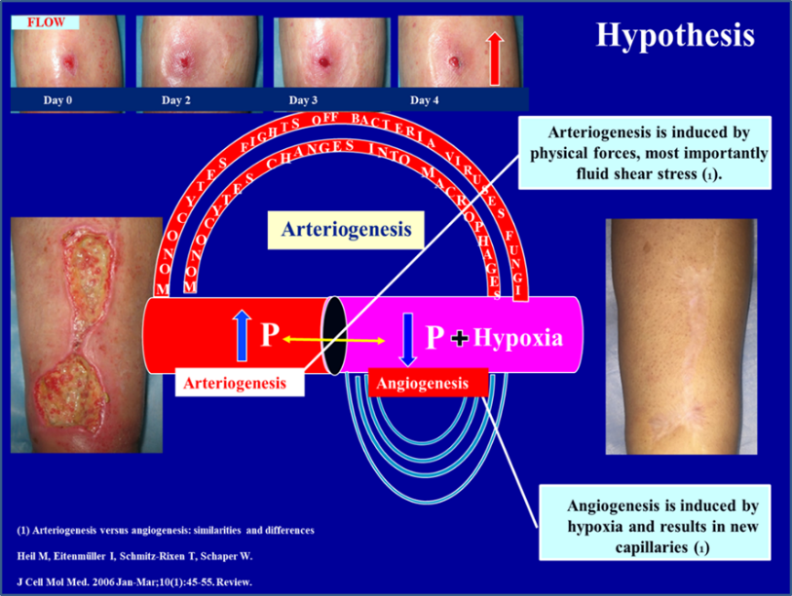

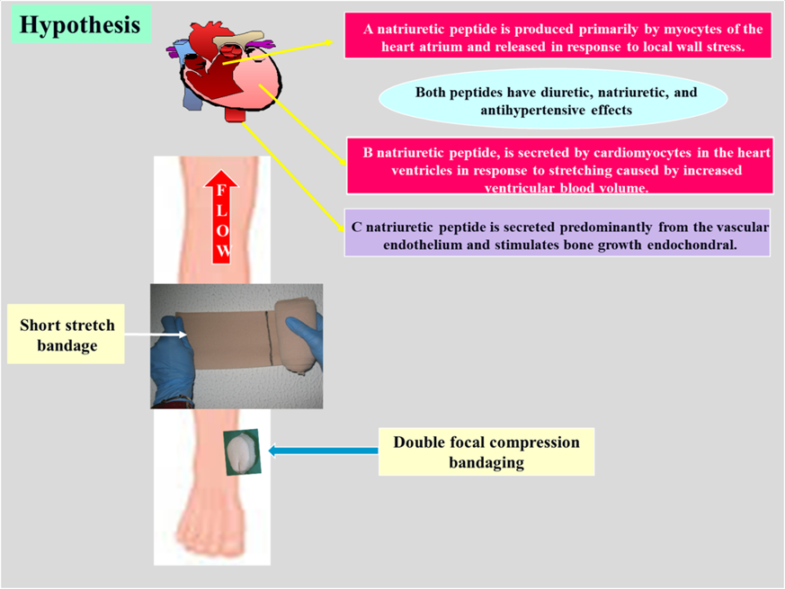
Recent Publications.
- Venous Leg Ulcers. Double focal compression bandaging. 15th World Congress Union International of Phlebology: October 2005, Rio (Brazil)Volume: ISBN 88-7587-182-5.
- Healing of an arterial leg ulcer by compression bandaging: A case report. February 2017, Journal of Wound Care 26 (Sup 2): S18-S22.
- Compression to reduce leg edema in patients with arterial occlusive disease. Double focal compression bandaging. Veins and Lymphatics, Vol 7, No 3 (2018).
- Type 2 diabetes mellitus. Methodology in primary care. Special article. Clin Investig Arterioscler. DOI:10.1016/j.arteri.2010.05.003. ISSN: 02149168.
- Dyslipidemias. Methodology in primary care. Special article. Clin Invest Arterioscl 2008;20:30-4 DOI: 10.1016/S0214-9168(08)72578-6.
- Arterial Hypertension. Methodology in primary care Conference: 17th Annual Scientific meeting / American Society of Hypertension: New York (EEUU)Volume: Volume 15 , Number 4, part 2 of 2. ISSN 0895-7061. Poster presentation.
- Double Bandaging with focal compression on the wound bed, A compression technique with bandages, for healing vascular ulcers, with other cardiovascular health benefits. The Hungarian Journal of Vascular diseases. Conference Another Phlebology, Vascular disease, XXVL, 2019/3. (Budapest, 4-5 October 2019).

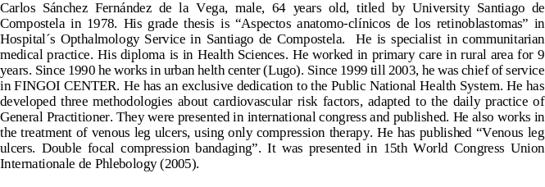


Biography

Carlos Sánchez Fernández de la Vega, male, 64 years old, titled by University of Santiago de Compostela in 1978. His grade thesis is “Aspectos anatomo-clínicos de los retinoblastomas” in Hospital´s Opthalmology Service in Santiago de Compostela. He is specialist in communitarian medical practice. His diploma is in Health Sciences. He worked in primary care in rural area for 9 years. Since 1990 he works in an urban health center (Lugo). Since 1999 till 2003, he was chief of service in FINGOI CENTER. He has an exclusive dedication to the Public National Health System. He has developed three methodologies about cardiovascular risk factors, adapted to the daily practice of a General Practitioner. They were presented in international congresses and published (4, 5, 6). He also works in the treatment of venous leg ulcers, using only compression therapy. He has published “Venous leg ulcers. Double focal compression bandaging”. It was presented in 15th World Congress Union International of Phlebology (2005).

Email: camesues@gmail.com

Notes/Comments: According to the results obtained in this clinical experience, we mention four relevant points:
A/ Local pressure on the wound bed avoids the usage of any kind antimicrobial agent. This could be the explanation: Blood monocytes (fight off bacteria, viruses, and fungi) flow to wound bed, by effect of the arteriogenesis.
B/ This technique involves making two types of debridement mechanical, when we remove the gauze, and autolytic by monocytes transformed in Macrophages (arteriogenesis).
C/ The healing of an arterial ulcer with this technique, in a diabetic patient, is a relevant case published (2). We did achieve to increase her Ankle Brachial Index from 0.55 (August 2015) to 1.08 (November 2019).
D/ We used compression therapy for years, as only treatment in patients with vascular ulcers (legs). Some of them with heart disease, and one of our fears were that the compression could worsen their symptoms. They were subjected to special follow-up to detect any signs and symptoms of cardiac decompensation, in which case, we would remove the bandaging However, we observed, in all this time, that there was not any event cardiac decompensation, and their quality of life went better.

