Surgical treatment of a spontaneous rupture of a mycotic aneurysm

Author:
Pedro Pinto Sousa
Rua António Bentes nº30, Lote 2, 2ºD
3030-487 Coimbra
Portugal
Pedro_psousa@hotmail.com
00351 918356470

Abstract
Saccular mycotic aorto-iliac aneurysms are extremely rare and when presented with ruptured, they are an important life-threatening condition.
We present a 52 years old male transferred from another Hospital and admitted to the emergency room with a ruptured iliac artery aneurysm. He complained of persistent fever and abdominal discomfort that swiftly established as hemorrhagic shock. Imagiological study with angioCT revealed a ruptured left common iliac artery saccular aneurysm with 90mm.
The patient was instantaneously and successfully submitted to endoaneurismorraphy of the hypogastric artery, common and external iliac artery ligation and construction of an extra anatomic bypass, right to left femoro-femoral bypass.
Blood culture revealed a Streptococcus anginosus and the patient received appropriate targeted antibiotics.
Post-operative period was uneventful and the patient discharged ten days after admission. He has now eleven months of follow up with no intercurrences.
Long term antibiotics along with aggressive surgical debridement of the infected tissue and vascular revascularization with an extra anatomic bypass remain the most definitive solution while endovascular aneurysm repair may generally constitute a bridge life- saving procedure in mycotic infected aneurysms. Even though surgical approach carries a relative risk of perioperative morbidity it is a feasible and durable solution for extreme situations like the one here described.

Introduction
Mycotic aortic aneurysms are a rare entity comprising 0.65-1.3%¹ of all aortic aneurysm. Isolated mycotic iliac aneurysm occurs at even lower rates with only case reports described in the literature.
If left untreated the natural course will be expansion and rupture. When presented with rupture the intervention is obligatory. Despite that, the mortality is very high, up to 40%¹.
Surgical resection of the infected arterial bed, extensive debridement of surrounding tissues and reconstruction of the aorta with in situ or extra-anatomically along with long-term antibiotics is the most definite treatment.
Objective
The authors report the successful treatment of a ruptured mycotic left iliac artery aneurysm.
Case report
A 52 years old male, without relevant medical records was admitted at his residence Hospital with persistent fever and abdominal discomfort that lasted for one week. Physical examination revealed mild left lower quadrant tenderness.
Upon presentation and during evaluation, his clinical status swiftly established as hemorrhagic shock, so he was submitted to angioCT that reveled a ruptured left common iliac artery aneurysm with 90mm, saccular morphology and extension of the aneurysmal degeneration to the internal iliac artery concomitantly with a significant surrounding periaortic infiltration and left iliopsoas abscess infiltration (Fig.1 and 2). The contact with our Hospital was established and the patient transferred.
He was admitted in the emergency room. The vital signs corroborated his clinical instability: Glasgow score of 14, temperature of 38.3º Celsius, tachycardia (113 beats per minute) and hypotension (65/40 mmHg) requiring noradrenaline support.
Abnormal laboratory values included platelets value of 57x10E3/uL, hemoglobin of 9g/dL and elevated white blood cell count of 17.000 with normal renal function but metabolic acidosis.
Once presented with the diagnosis of ruptured mycotic iliac artery aneurysm and clinical instability, the patient was submitted to emergent surgical intervention. We decided to proceed with an open surgical approach through a transabdominal incision. The common iliac artery was found to be ruptured along with a purulent fluid within the peri vessel conduit. We conducted a total common iliac artery aneurismectomy and iliac stump closure, external iliac artery ligation and hypogastric artery endoaneurismorraphy. Concomitantly we proceeded with abscess drainage so as extensive debridement of the infected tissues.
After completion of this first intervention, the surgical approach was sealed, and subsequent extra-anatomic revascularization was conducted, which consisted of a right common femoral artery to left common femoral artery bypass performed with ePTFE along the subcutaneous tissue. (Fig.3)
The patient started empirical endovenous antbiotherapy with ertapenem and vancomycin. The microbiology from the blood cultured demonstrated a Streptococcus anginosus sensitive amoxicillin that was the antibiotic of choice till performing six months after the procedure. Cultures of operative tissue corroborated the specimen previously identified.
Despite no peri-operative vascular adverse events, the patient developed infectious colitis, on the third day after intervention. A Clostridium dificcille was identified and the patient received complementary Metronidazole with clinical resolution and no need for surgical approach.
The patient has actually, one-year follow-up with no clinical, analytical or imagiological signs of persistent infection. We conducted a control with angioCT at one, six and twelve months that showed a patent femoro – femoral bypass and progressive resolution of the peri-vessel inflammation.
On physical examination the patient presented always with distal pulses and no kind of claudication.

Discussion
Mycotic aneurysms of the aorta and iliac arteries remain a dreadful disease, with a very high morbidity and mortality due to the exertion to make an early diagnosis and its rapid progress to the late stage, with fulminant sepsis and aneurysm rupture.
Despite their incidence being higher in elderly patients with endocarditis or atherosclerotic disease, our patient was healthy with normal infra renal aorta so as right iliac axis on the angioCT. Numerous cases of contiguous spread of local infection have also been reported, which might have been the case here reported. As for etiology, the pathogenesis of infected aortic aneurysm is affected by both immune deficiency status and arteriosclerosis. The infection rate is higher in patients with immunodeficiency-like conditions, such as malnutrition, diabetes, use of immunosuppressive drugs and malignancy which we could not neither identify.
Clinical feature normally shows the findings that we also described for this patient, such as: abdominal pain, back pain, fever, leukocytosis and elevated C- reactive protein, aneurysm rupture on imagiolocial study and eventual death.
The computed tomography scan remains the best diagnostic image for infected aortic and iliac artery aneurysms². Positron emission tomography (PET) alone or in combination with CT and magnetic resonance imaging has also been used effectively for the detection of arterial infection but both exams were not readily available and the patient clinical instable.
Antibiotic therapy is also of ultimate importance. According to the literature, the most frequently reported microorganisms related to mycotic aneurysms are Staphylococcus species accounting 28-71% of cases, Salmonella species as the second most common reported between 15 and 24% and Streptococcus in less than 10%³. Based on that, we empirically lead our decision to choose the antibiotics previous to the tissue and blood culture results. After that, we adjusted according to the results of the cultures obtained.
Although there is still intense debate in the literature trying to define guidelines for the best treatment approach, treatment therapy is dependent on the location and extent of infection so as with patient comorbidities.
The literature describes many viable alternatives. Sorelius K et al⁴ described an endovascular aortic repair for patients with mycotic aortic aneurysm. In that study, 5% of patients were converted to open repair during a mean follow-up period of 35 months, and the 5-year survival rate was 55%. Nevertheless, long term outcomes of EVAR for infected aneurysms are still lacking and the concern with the risk for persistent and extended infection is still important. Many authors though believe that it should be reserved as a short-term temporary bridge to a more definitive therapy.
Dubois M et al⁵ presented an investigation comparing the repair of mycotic aneurysms submitted to extra-anatomic reconstruction that presented an in-hospital mortality of 22.7% versus 18.9% in the in situ repair group. Hyo-Hyun Kim et al⁶ also presented an article with MA patients submitted to in situ repair with an in-hospital mortality rate of 10.5% and a 5-year survival rate of 74.9%±11.5% during the 43.2-month follow-up period. Nevertheless, in-situ reconstructing should be preferred when the infection extends to the juxtarenal or visceral segments and consideration about re-infection is very high.
Options for in-situ reconstructions also do not present incredible outcomes. Morbidity with neo-aortoiliac system procedures is very high and ccryopreserved arterial homograft’s have higher rates of aneurysmal degeneration and rupture (0%–9%)⁷. Other option is rifampicin-impregnated grafts or cryopreserved arterial homograft’s. However, no studies have confirmed the superiority of that, despite still high rates of-reinfection that may reach 20%.
Following all above described, the decision for which type of surgery and thought, the most definitive practice is to combine antibiotic therapy with surgical resection and extra-anatomic graft interposition. This patient presented extensive infected surrounding tissues only achievable by open surgery and that also limited in-situ revascularization.
Repair of this mycotic ruptured aneurysm proved to be challenging. A hostile surgical abdomen and a frailty instable patient further complicated the surgical approach, nevertheless, this case displays a successful approach to this rare but morbid condition.
References
- Vallejo N, Picardo NE, Bourke P, et al. The changing management of the primary mycotic aortic aneurysm. J Vasc Surg 2011; 54:334-40
- Lee WK, Mossop PJ, Little AF, Fitt GJ, Vrazas JI, Hoang JK, et al. Infected (mycotic) aneurysms: spectrum of imaging appearances and management. Radiographics. 2008;28(7):1853–68
- Cartery C, et al: Abdominal infectious aortitis caused by streptococus pneumoniae: a case report and literatur review. Ann Vasc Surg 25 (2): 266. E9-266.e16, 2011
- Sorelius K, Mani K, Bjorck M, et al. Endovascular treatment of mycotic aortic aneurysms: a European multicenter study. Circulation. 2014;130:2136–42. doi: 10.1161/CIRCULATIONAHA.114.009481
- Dubois M, Daenens K, Houthoofd S, Peetermans WE, Fourneau I. Treatment of mycotic aneurysms with involvement of the abdominal aorta: single-centre experience in 44 consecutive cases. Eur J Vasc Endovasc Surg. 2010;40:450–6. doi: 10.1016/j.ejvs.2010.07.017
- Hyo-Hyun Kim, M.D., Do Jung Kim, M.D., and Hyun-Chel Joo, M.D.; Hyo-Hyun Kim, M.D., Do Jung Kim, M.D., and Hyun-Chel Joo, M.D. Korean J Thorac Cardiovasc Surg. 2017 Dec; 50(6): 430–435
- Touma J, Cochennec F, Parisot J, et al. In situ reconstruction in native and prosthetic aortic infections using cryopreserved arterial allografts. Eur J Vasc Endovasc Surg. 2014;48:292–9. doi: 10.1016/j.ejvs.2014.04.023.
- Muller BT, Wegener OR, Grabitz K, Pillny M, Thomas L, Sandmann W. Mycotic aneurysms of the thoracic and abdominal aorta and iliac arteries: experience with anatomic and extra-anatomic repair in 33 cases. J Vasc Surg. 2001;33:106–13. doi: 10.1067/mva.2001.110356
- Cina C.S., Arena G.O., Fiture A.O., Clase C.M., Doobay B. Ruptured mycotic thoracoabdominal aortic aneurysms: a report of three cases and a systematic review. J Vasc Surg. 2001;33:861–867
- Fillmore AJ, Valentine RJ. Surgical mortality in patients with infected aortic aneurysms. J Am Coll Surg. 2003;196(3):435–41
- Chang-Chih Tsai,¹ Chien-Chin Hsu,² and Kuo-Tai Chen; Infected aortic and iliac aneurysms: Clinical manifestations in the emergency departments of two hospitals in southern Taiwan, China; World J Emerg Med. 2017; 8(2): 121–125

Figure legend page
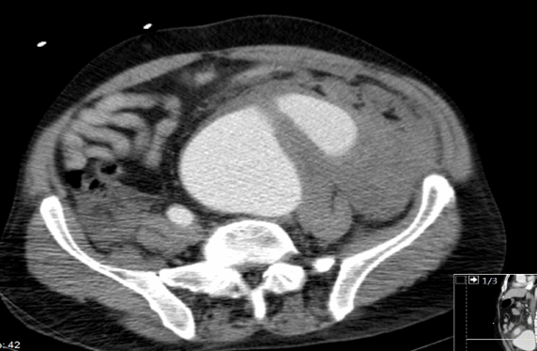

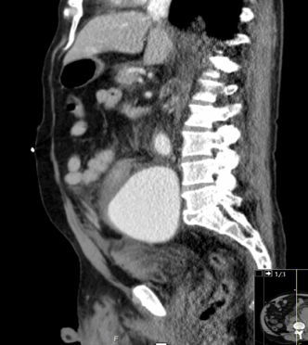
Fig 1. Axial plane of the AngioCT at admission with the mycotic common iliac artery aneurysm with rupture

Fig 2. Sagittal plane of the AngioCT at admission with the mycotic common iliac artery aneurysm with rupture
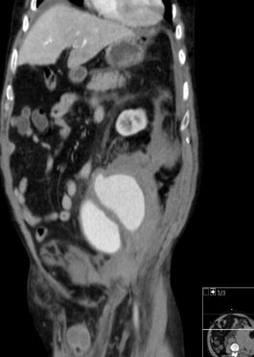

Fig 3. Coronal plane of the AngioCT at admission with the mycotic common iliac artery aneurysm with rupture

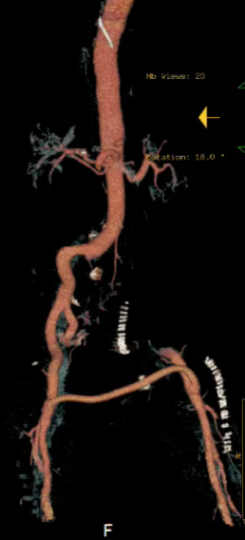

Fig 4. Post – operative angioCT reconstruction with femoro – femoral bypass

