Abstract Template
Abstract Title: Many Cells Make Life Work – Multicellularity in Stem Cell-Based Cardiac Disease Modelling
Brian X. Wang ¹, Worrapong Kit-Anan ² and Cesare M. N. Terracciano ¹
¹ National Heart and Lung Institute, (Imperial College London, UK)
²Department of Materials, Department of Bioengineering and Institute of Biomedical Engineering (Imperial College London, UK)

Abstract (not more than 300 words)
Cardiac disease causes 33% of deaths worldwide but our knowledge of disease progression is still very limited. In vitro models utilising and combining multiple, differentiated cell types have been used to recapitulate the range of myocardial microenvironments in an effort to delineate the mechanical, humoral, and electrical interactions that modulate the cardiac contractile function in health and the pathogenesis of human disease. However, due to limitations in isolating these cell types and changes in their structure and function in vitro, the field is now focused on the development and use of stem cell-derived cell types, most notably, human-induced pluripotent stem cell-derived cardiomyocytes (hiPSC-CMs), in modelling the cardiomyocyte function in health and patient-specific diseases. It is becoming increasingly appreciated that communications between cardiomyocytes, the contractile cell of the heart, and the non-myocyte components of the heart not only regulate cardiac development and maintenance of health and adult cardiomyocyte functions, including the contractile state, but they also regulate remodelling in diseases, which may cause the chronic impairment of the contractile function of the myocardium, ultimately leading to heart failure. Within the myocardium, each cardiomyocytes is surrounded by an intricate network of cell types including endothelial cells, fibroblasts, vascular smooth muscle cells, sympathetic neurons, and resident macrophages, and the extracellular matrix, forming complex interactions, and models utilizing hiPSC-derived cell types offer a great opportunity to investigate these interactions further. We outline the historical and current state of disease modelling, focusing on the major milestones in the development of stem cell-derived cell types, and how this technology has contributed to our knowledge about the interactions between cardiomyocytes and key non-myocyte components of the heart in health and disease, in particular, heart failure. Understanding where we stand in the field will be critical for stem cell-based applications - including modelling diseases that have complex multicellular dysfunctions.

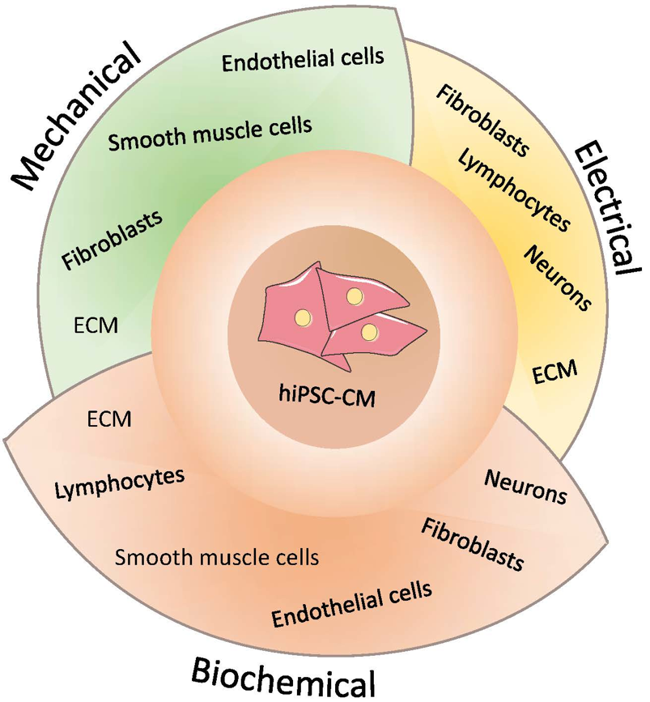

Keywords—cardiomyocyte, disease modelling, human induced pluripotent stem cells, patient-specific,

Professional Biography (100-150 words)

Brian Wang completed his BA from the University of Cambridge and is currently an MBBS/PhD student at the National Heart and Lung Institute, Imperial College London. His main area of interest is Cardiac Electrophysiology; primarily investigating the cell-cell interactions that occur between cardiomyocytes and cardiac fibroblasts in health and disease, using human stem-cell derived cardiomyocytes as a model for the interactions that occur between the two cell types that modulate maturation of the healthy, adult phenotype and the changes that occur in heart failure. He recently published a review in the IJMS on the importance of heterocellularity in stem-cell based cardiac disease modelling (Wang et al., 2018).
Wang B., Kit-Anan W., Terracciano C. Many Cells Make Life Work—Multicellularity in Stem Cell-Based Cardiac Disease Modelling. Int J Mol Sci. 2018;19(11):3361. doi:10.3390/ijms19113361


Email Id: brian.wang15@imperial.ac.uk

Any Comments: Please accept this abstract with the graphical abstract instead of the previous submission without the graphical abstract.
Many thanks.

