Abstract Title: Integrin ligands on human cardiac fibroblast-secreted extracellular vesicles increase sarcoplasmic reticulum-dependency of human cardiomyocyte calcium handling
Brian X. Wang¹, Worrapong Kit-Anan^{1,2}, Thomas Whittaker², Liam Couch¹, Anika Nagelkerke², Graziano Deidda³, Anna Mitraki³, Sian E. Harding¹, Molly M. Stevens², Kenneth T. MacLeod¹ and Cesare M. Terracciano¹

¹ National Heart and Lung Institute (Imperial College London, UK)
²Institute of Biomedical Engineering, Department of Materials (Imperial College London, UK)
³Foundation for Research and Technology-Hellas (University of Crete, Greece)

Abstract
Introduction: A key feature of adult cardiomyocytes (CMs) is Ca²⁺-induced Ca²⁺ release (CICR), mediating efficient excitation-contraction coupling. This is poorly utilised in developing CMs & impaired in disease. We have reviewed the importance of heterocellularity in disease modelling (Wang B. et al., 2018). Notably, cardiac fibroblasts regulate turnover of extracellular matrix (ECM) proteins that bind to CM integrins. Our group identified that cardiac fibroblasts improve calcium cycling efficiency by recruiting the sarcoplasmic reticulum (SR) (Kane C. & Terracciano C., 2018), but the role of integrins and fibroblast-secreted extracellular vesicles (EVs) has not yet been explored.
Hypothesis: Cardiac fibroblast-secreted EVs and integrin ligands signal between human fibroblasts & CMs.
Method: Human induced pluripotent stem cell-derived CMs were treated with human cardiac fibroblast EVs or EV inhibitor GW4869. Alternatively, CMs were treated with integrin-binding RGDSGAITIGA (RGD_A) or RGDSGAITIGC (RGD_C). CM Ca²⁺ transients were monitored with Fluo4-AM.
Results: Fibroblast contact shortens CM Ca²⁺ transient time to peak (A) & increase rate of decay (B); the latter due to increased sarcoplasmic reticulum (SR) Ca²⁺ uptake, which is attenuated by GW4869 (C & D). Fibroblast EVs abbreviate time to peak compared to serum-free control & fibroblast-naïve (E). RGD_A & RGD_C abbreviate Ca²⁺ transients (G) & change CMs to a more rod-like morphology (H & I). Size exclusion chromatography (SEC) fractions (J) with CD63-expressing EVs (fractions 8-12) (K) contain fibronectin, a prominent integrin-binding protein (L).
Conclusion: Fibroblast EVs increase CICR efficiency due to increased SR contribution to Ca²⁺ regulation. Integrin ligands mimicking ECM proteins also abbreviate Ca²⁺ transients. This increase in decay efficiency is due to increased SR Ca²⁺ reuptake rate to closer reflect healthy adult CMs. We suggest that fibroblast-secreted EVs and integrin ligands-receptor interactions are modalities by which fibroblasts modulate CM structure and function in health and may be important in disease.
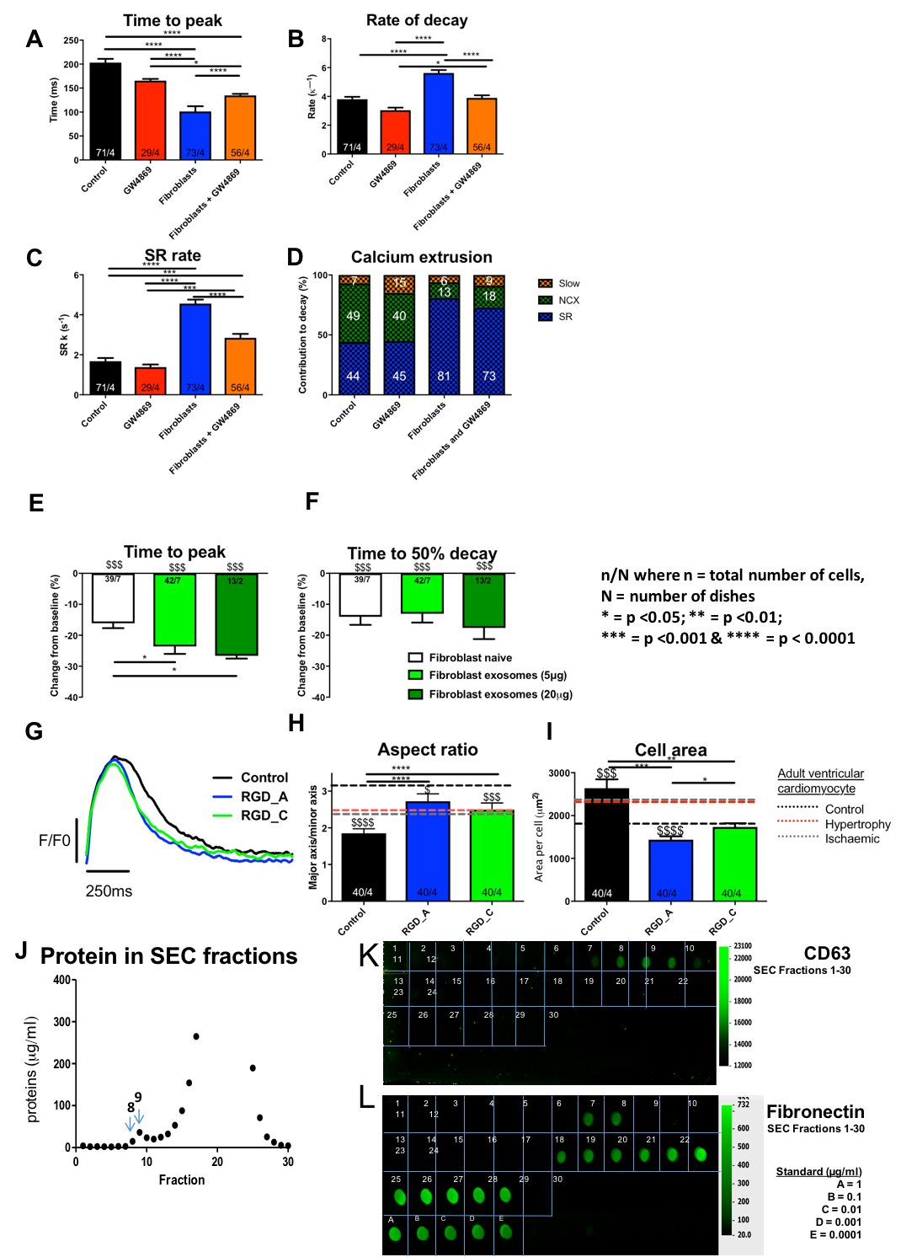

Keywords—disease modelling; cardiac fibroblast; stem cells; calcium handling

Professional Biography (100-150 words)

Brian Wang completed his BA from the University of Cambridge and is currently an MBBS/PhD student at the National Heart and Lung Institute, Imperial College London. His main area of interest is Cardiac Electrophysiology; primarily investigating the cell-cell interactions that occur between cardiomyocytes and cardiac fibroblasts in health and disease, using human stem-cell derived cardiomyocytes as a model for the interactions that occur between the two cell types that modulate maturation of the healthy, adult phenotype and the changes that occur in heart failure. He recently published a review in the IJMS on the importance of heterocellularity in stem-cell based cardiac disease modelling (Wang et al., 2018).
Wang B., Kit-Anan W., Terracciano C. Many Cells Make Life Work—Multicellularity in Stem Cell-Based Cardiac Disease Modelling. Int J Mol Sci. 2018;19(11):3361. doi:10.3390/ijms19113361



Email Id: brian.wang15@imperial.ac.uk

Any Comments:

