Role of dietary edible mushrooms in the modulation of gut microbiota

Alicia Cobos
¹Nutricuantica organisation, Patagonia, Argentina.

Abstract

Edible mushrooms as valuable health foods have beneficial and health-enhancing effects, and these beneficial activities are related to the modulation of the gut microbiota. In this meeting, we discuss the regulation of the gut microbiota by edible fungi. Ganoderma lucidum increases the Bacteroides/Firmicutes ratio and promotes the growth of bacteria that produce short-chain fatty acids (SCFA) and anti-inflammatories. Hericium erinaceus maintains the integrity of the intestinal barrier and increases the diversity and richness of the intestinal microbiota. Psilocybe cubensis acts as a prebiotic, increasing SCFA-producing bacteria and regulating the Bacteroides/Firmicutes ratio. We also discuss the effects of different edible mushrooms on the gut microbiota in different diseases and introduce a perspective of application of mushrooms as adjuvant therapies to modulate the gut microbiota in clinical treatments. The statement on the modulation of the composition of the intestinal microbiota by edible fungi will provide a new perspective for future research that is already opening up in the field.
Image

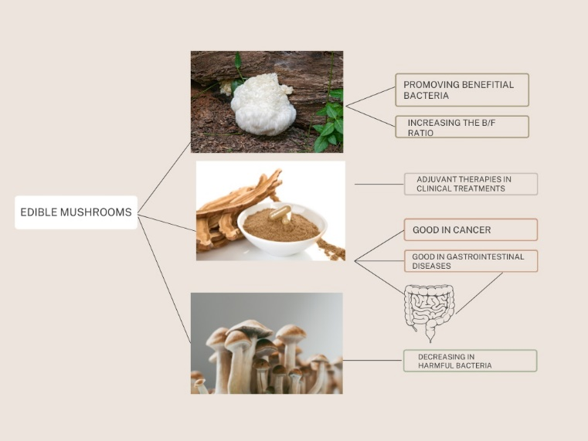

Recent Publications
Parasites as Accumulation Indicators of Heavy Metal Pollution: a solution to repair the dysbiosis in relation with inflammatory pathologies, Alicia Cobos. Nutricuantica organisation, Patagonia, Argentina.

Biography of presenting author

Alicia Cobos graduated in nutrition and dietetics from the Barceló medical school (Argentina), continued her specializations in microbiology, in the area of parasitology and entomology (at Kilimanjaro Christian Medical University College, Africa), chronobiology at the Ludwig Maximilian University of Munich (Germany), a certification on edible and medicinal mushroom, and is currently participating in a research in Bulgaria, on traditional products, especially on the use and benefits of "boza", a fermented cereal drink, for its lactic acid amylolytic bacteria (ALAB).

Mail: aliciacobosfuhr@nutricuantica.net

