A Case of Postmenopausal Bleeding with an Unusual Finding
Dr. Samar Rudra, MD, Dr. D. Y. Patil Vidyapeeth, pimpri, pune.
Dr. Manasi Thakur, MS, Dr. D. Y. Patil Vidyapeeth, pimpri, pune.

We report the case of a 55 year old patient who presented with postmenopausal bleeding. On clinical evaluation uterus was 12 weeks size with a left sided adnexal cystic mass of 8 × 6 cm size. Further imaging studies revealed uterus size of 11.5×6.7×6.3 cm, left ovarian mass of size 8.4×6.7×6 cm and endometrial thickness of 17 mm on ultrasonography. She underwent endometrial biopsy to exclude endometrial cancer. The report of which came to be endometrial hyperplasia without atypia. Further MRI study confirmed the findings of USG of a complex cystic lesion of left adnexa 75 × 57 × 60 mm. Tumor marker for ovarian tumors were sent and inhibin B was found to be markedly raised. A provisional diagnosis of GCT (Granulosa cell tumour) was made and staging laparotomy was done. The uterus was found to be 12 × 8 cm size and a left sided ovarian cyst of 8-9 cm size with smooth wall and intact capsule was found. Patient had an uneventful postoperative recovery. Finally the histopathology report came to be granulosa cell tumor of the ovary as predicted by us. Significance : Postmenopausal bleeding in a women should never be ignored. Postmenopausal bleeding commonly indicates carcinoma cervix or carcinoma endometrium, but rare possibilities like these ovarian tumors should always be ruled out.

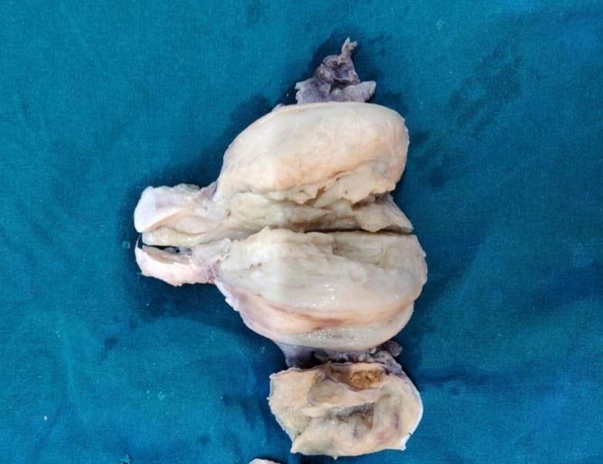
Fig 1: Gross specimen of uterus with endometrial hyperplasia and left sided ovarian tumour.

Recent publications
- Korach J, Perri T, Beiner M, et al. Promising effect of aromatase inhibitors on recurrent granulosa cell tumors. Int J Gynecol Cancer 2009;19:830–833.
- Cornelius O Ukah, Okechukwu C Ikpeze, George U Eleje and Ahizechukwu C Eke. Adult granulosa cell tumor associated with endometrial carcinoma: a case report. Journal of Medical Case Reports 2011, 5:340.
- Reed SD, Newton KM, Clinton WL, et al. Incidence of endometrial hyperplasia. Am J Obstet Gynecol 2009;200:678.e1–6.
- Neetha Vyas M., Lakshmi Manjeera, Supriya Rai. Delayed menopause due to ovarian granulosa cell tumour. Journal of Clinical and Diagnostic Research. 2013 Oct, Vol-7(10): 2306-2307.
- Mom CH, Engelen MJ, Willemse PH, et al. Granulosa cell tumors of the ovary: The clinical value of serum inhibin A and B levels in a large single center cohort. Gynecol Oncol 2007;105(2): 365–372.
- Hardy RD, Bell JG, Nicely CJ, et al. Hormonal treatment of a recurrent granulosa cell tumor of the ovary: Case report and review of the literature. Gynecol Oncol 2005;96:865–869.
Dr. Manasi Thakur, is a gynaecologist and obstetrician, currently working in DR. D Y Patil Medical College and Hospital, Pune. She has done a lot of work in this field and wish to do more.
.

