Use of 2-3 wave channels for symptom detection and treatment

¹ DR. ISSA SALIM, Rashid Hospital, DUBAI, UAE

Abstract

A method to diagnose and then provide therapy and/or treating humans to relieve or reduce the symptoms of various disease and/or conditions, and in certain embodiments reduce the factors causing the symptoms and/or diseases. The present method also relates to systems for determining heretofore-unknown internal characteristics of patients and external environmental factors.

Diagnosis, Symptoms, Treatment, Wave Channels

Professional Biography (100-150 words)

Issa SALIM has completed his Master degree in medical cybernetic at the age of twenty six years from Ilmenau University in Germany, and his PhD in monitoring the brain signals from Graz university in Austria. He is a Member of the Bioresonance international association. In addition, he was Deputy of World university Service in UN- Austria and the Director of electrophysiology in Wurzburg Germany. He is the director of medical center of Bioresonance in RH in DUBAI, a premier Bio-Soft service organization. Furthermore, He was awarded by Dubai’s Government (Excellence Program for the year 2010) In recognition of outstanding, creative achievements and initiatives.

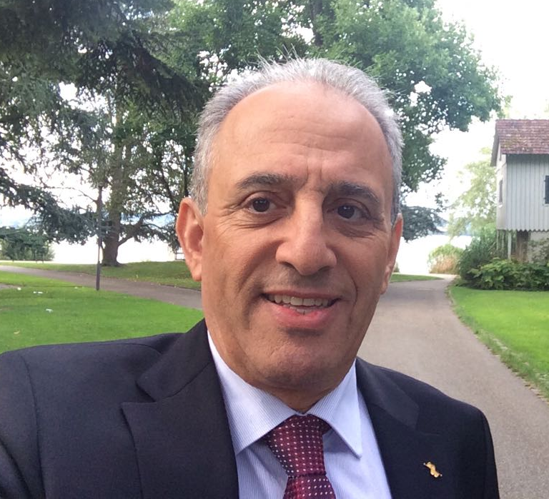

Email Id: bioresonancedxb@yahoo.com

