WASTE TO ENERGY
(Track 23)
Abstract:
“Waste-to-energy (WtE) is defined as a process that involves the conversion of waste materials into another form of energy such as; electricity, heat, or fuel. This typically involves the processing of recyclable waste materials in specially designed waste-to-energy power facilities that permits the end-product to be converted into combustible fuel to produce energy.”
This WtE technology can help much in reducing the amount of wastage that usually goes to landfill, and also be used in the provision of the ‘recycled’ energy as a newly pronounced source of renewable energy. There are, however, several different technologies that can be used for waste-to-energy, including incineration, gasification, and pyrolysis. In elaboration; incineration involves the burning of waste at high temperatures to generate heat, which is then used to produce steam and so generate electricity. Gasification and pyrolysis involve the use of high temperatures and low oxygen environments to break down waste into a gas or oil that can also be used to generate energy.

Introduction:
Howsoever, in the context of this text, the process that will be considered is the so-called Refused Derived Fuel (RDF). RDF is the kind of energy fuel that is converted from collected garbage into rods at a processing facility, which is basically made through sorting, crushing, drying and other necessary processing processes. The dried wastage is then compressed into briquettes or pellets, which are known as RDF ‘fuel’ rods.
They can be made from various types of waste materials ranging from household and commercial waste to industrial disposals that would otherwise end up in landfills. Hence, some of the most common materials used in RDF rods are; paper, plastic, and food residuals. But they can also be manufactured from commodities such as textiles, wood, and rubber, as well.

As further explained, waste-to-energy technology can be utilized in generating energy from a wide range of waste materials that can fundamentally be used as feedstock. Amongst other, waste materials which are considered to be good options for making RDF ‘fuel’ rods include; municipal solid waste (MSW) and so is agricultural waste, as well as industrial waste.

- Municipal solid waste (MSW): This refers to the everyday wastage that is generated by households, businesses and office places, such as paper, plastics and food scraps.

- Agricultural waste: This is generally the wastage such as straw, animal waste and plant matter that is generated from the farms and other agricultural facilities. Some of this wastage is composted or used as fertilizer, but a significant amount ends up in landfills or is burned.

- Industrial waste: This is the wastage that is generated by factories and other industrial facilities, ranging from textiles, metals, chemicals, and electronics to food packages.
The waste collected by a waste management company is taken to a landfill or an incinerator.
The RDF process is simplistically illustrated as shown in the figure below:
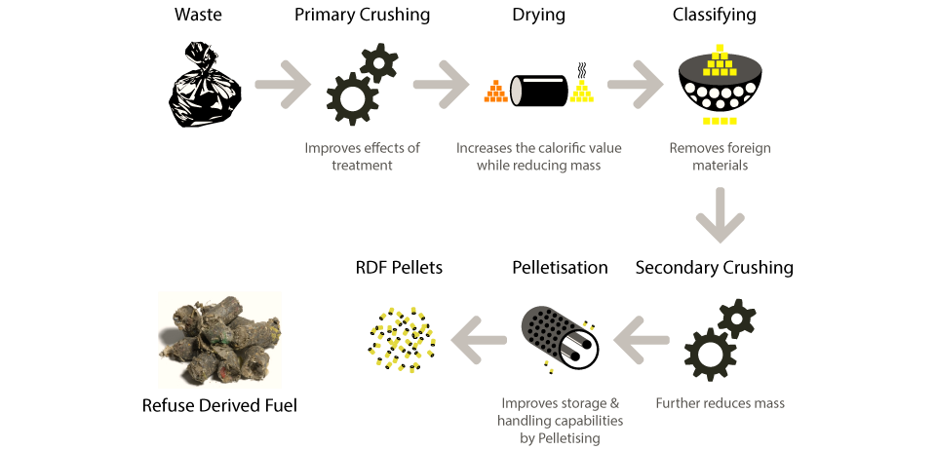
RDF illustration process

Nonetheless, there are other types of industrial waste which can be utilized in RDF rods. Surely, RDF ‘fuel’ rods are a relatively novice and innovative way to generate “cleaner” energy, while on the other hand helping in keeping the environment more cleaner, hence tidy streets. Also, RDF ‘fuel’ rods can essentially replace the traditional fossil fuels and be used in thermal energy equipment in industrial furnaces and boilers as used to generate heat and electricity.
On the contrary, there are also some types of waste that cannot be used in RDF ‘fuel’ rods. These include hazardous materials, such as asbestos and lead, as well as metals. Metals can be segregated from the other waste materials and recycled instead of being used in fuel rods. RDF (refuse-derived fuel) is a promising technology for converting waste material into energy.
Advantages:
There are numerous discovered advantages to using RDF ‘fuel’ rods:
- Firstly, they help in reduction of a large quantity of wastage seemingly going to landfills.

- Also, they can generate energy relatively more efficiently than traditional fossil fuels.

- Again, they can contribute in mitigating carbon footprint via less air pollution and reduced greenhouse gas emissions since their usage will implicate an alleviated use of fossil fuels which basically reduces their associated adverse environmental impacts.

- And, they can be used to create energy locally, which helps to improve energy security.

- Moreover, they are alleged to provide a cost-effective source of energy.

- One other advantage of RDF ‘fuel’ rods is that they can be used in a variety of settings. Thus, on other developments, they can be used in existing thermal energy equipment, such as boilers and industrial furnaces. They can further be used in new types of thermal energy equipment, such as combined heat and power (CHP) plants. RDF ‘fuel’ rods can also be used in smaller, decentralized energy systems. These systems can be used to meet the energy needs of individual homes, businesses, or communities.

- RDF ‘fuel’ rods are also being explored as a possible feedstock for the potential production of advanced biofuels which could be used to power vehicles or other types of equipment.

Benefits in Lesotho:
Even though it might have raised some concerns about the overall safety of RDF ‘fuel’ rods, research studies are showing that they pose no much significant health or environmental risks. Instead, emissions from RDF rods are factually found to be less harmful than those from traditional coal-fired power plants. Another thing worth noting is that RDF ‘fuel’ rods are not only limited to being used for heat and electricity but can also be used to generate steam, which can in turn be used for other purposes as in industrial processes or district heating systems.
There are several other reasons why RDF fuel rods are considered to be significant and can have a great potential even though in terms of potential, their usage is still in its infant stages. In Lesotho, the RDF potential will;
- Help to enhance government policy regarding cleaning campaigns which usually sees civil servants leaving their other office tasks and duties to go out and clean the streets.

- Help to avoid re-scattering of the discarded garbage from wind blows and scavenging by dislodging the already collected waste while looking for food scraps and other stuff.

- Insinuate responsibility upon cleanliness amongst local people and also enforce the law on littering of which failure to comply may lead to related fines as littering is a crime. Hence, reduced littering in Lesotho, leading to hygienic towns, streets and villages.

- Improve tourist attraction and so evolve tourism potential which Lesotho possesses.

- Avoid potential health risks to nearby residents at Maseru dumping area in Ha-Tsósane.

- Avoid contamination of the water in dams like Maqalika which is downstream from the Maseru dumping area (Ha-Tsósane) of which the run-off water from the dumping site may contain harmful chemical residue which affect the aqua-life and may also cause potential harm to domestic animals which drink from the same dam as well as human life since Maqalika water is deemed to sometimes being used for human consumption during dry spells in the country. So, this will mitigate a lot of waste in the dam coming from blown-away materials from the street, adjacent businesses and nearby households, intentionally dumped litter into the dam by passers-by and encroaching residents as well as polluted run-off from the dumpsite and other tributaries channeling water into the dam.

Conclusion and Recommendations:
However, there is growing interest in using this waste to produce energy, through methods such as RDF and anaerobic digestion. Therefore, further research is necessary because it has the potential to improve the development and so is efficiency of RDF ‘fuel’ facilities.
Of equal importance is funding as the funds will help a lot in testing the best and appropriate methods in a lab setting and compare their efficiency, cost, and environmental impact before the actual facility is constructed. Other areas which will be dealt with via such funding include, but are not limited to:
- Types of locally appropriate waste-to-energy technologies,
- Emissions control and environmental impacts of waste-to-energy,
- Feasibility and economic viability of waste-to-energy facilities,
- Integration and significance of WtE with other renewable energy sources,
- Existing waste-to-energy projects and case studies,
- Waste-to-energy in the circular economy,
- Capacity and potential of waste-to-energy in Lesotho,
- Job creation and youth development and involvement in renewable energy,
- Socio-economic impact in the country across the energy sector.

