Renewable energy production under climate change, decentralized smart grid and sustainable energy system: Evidence in Togo
Kokou Amega, West African Science Service Centre on Climate Change and Adapted Land Use (Wascal), University Abdou Moumouni of Niamey, Niger
Yendoubé Laré, Department of physics; University of Lomé, Togo.
Ramchandra Bhandari, Institute for Technology and Resources Management in the Tropics and Subtropics (ITT), Technische Hochschule Köln, Cologne, Germany.
Yacouba Moumouni,Higher Colleges of Technology, Electrical and Electronics Engineering, Ras Al Khaimah Women’s Campus, Ras Al Khaimah, UAE.
Aklesso Y. G. Egbendewe, Faculty of Economic and Management Sciences, University of Lomé, Togo
Windmanagda Sawadogo, Chair for Regional Climate and Hydrology, University of Augsburg; Augsburg Germany
Saidou Madougou, University Abdou Moumouni of Niamey, Niamey

Abstract
A smart and decentralized electrical system, powered by grid-connected renewable energy (RE) with a reliable storage system, has the potential to change the future socio-economic dynamics. Climate change may, however, affect the potential of RE and its related technologies. This study investigated the impact of climate change on photovoltaic cells’ temperature response and energy potential under two CO2 emission scenarios, RCP2.6 and 8.5, for the near future (2024–2040) and mid-century (2041–2065) in Togo. An integrated Regional Climate Model version 4 (RegCM4) from the CORDEX-CORE initiative datasets has been used as input. The latter platform recorded various weather variables, such as solar irradiance, air temperature, wind speed and direction, and relative humidity. Results showed that PV cells’ temperature would likely rise over all five regions in the country and may trigger a decline in the PV potential under RCP2.6 and 8.5. However, the magnitude of the induced change, caused by the changing climate, depended on two major factors: (1) the PV technology and (2) geographical position. Results also revealed that these dissimilarities were more pronounced under RCP8.5 with the amorphous technology. It was further found that, nationally, the average cell temperature would have risen by 1 °C and 1.82 °C under RCP2.6 and 8.5, in that order, during the 2024–2065 period for a-Si technology. Finally, the PV potential would likely decrease, on average, by 0.23% for RCP2.6 and 0.4% for RCP8.5 for a-Si technology.

Image
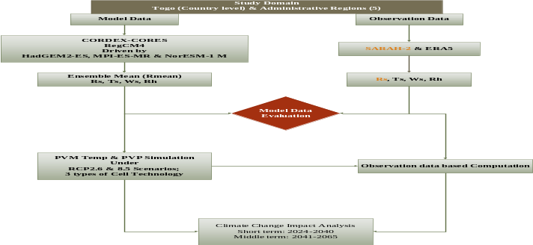
Recent Publications (minimum 5)
- Torres-Alavez, J. A., Das, S., Corrales-Suastegui, A., Coppola, E., Giorgi, F., Raffaele, F., Bukovsky, M. S., Ashfaq, M., Salinas, J. A., & Sines, T. (2021). Future projections in the climatology of global low-level jets from CORDEX-CORE simulations. Climate Dynamics, 57(5–6), 1551–1569. https://doi.org/10.1007/s00382-021-05671-6
- Teichmann, C., Jacob, D., Remedio, A. R., Remke, T., Buntemeyer, L., Hoffmann, P., Kriegsmann, A., Lierhammer, L., Bülow, K., Weber, T., Sieck, K., Rechid, D., Langendijk, G. S., Coppola, E., Giorgi, F., Ciarlo, J. M., Raffaele, F., Giuliani, G., Xuejie, G., … Im, E. S. (2021). Assessing mean climate change signals in the global CORDEX-CORE ensemble. Climate Dynamics, 57(5–6), 1269–1292. https://doi.org/10.1007/s00382-020-05494-x
- Sawadogo, W., Reboita, M. S., Faye, A., da Rocha, R. P., Odoulami, R. C., Olusegun, C. F., Adeniyi, M. O., Abiodun, B. J., Sylla, M. B., Diallo, I., Coppola, E., & Giorgi, F. (2020). Current and future potential of solar and wind energy over Africa using the RegCM4 CORDEX-CORE ensemble. Climate Dynamics, 57(5–6), 1647–1672. https://doi.org/10.1007/s00382-020-05377-1
- Patchali, T. E., Ajide, O. O., Matthew, O. J., Salau, T. A. O., & Oyewola, O. M. (2020). Examination of potential impacts of future climate change on solar radiation in Togo, West Africa. SN Applied Sciences, 2(12). https://doi.org/10.1007/s42452-020-03738-3
- Sawadogo, W., Abiodun, B. J., & Okogbue, E. C. (2019). Impacts of global warming on photovoltaic power generation over West Africa. Renewable Energy, 151, 263–277. https://doi.org/10.1016/j.renene.2019.11.0325.

Photograph

Biography
Mr. Kokou Amega is a PhD candidate / researcher in West African Science Service Center on Climate Change and Adapted Land Use (WASCAL) on Climate Change and Energy (DRP-CCE) hosted by the University Abdou Moumouni, Niamey, Niger. His research interests include renewable energy, energy efficiency, decentralized energy system planning (rural electrification), sustainable energy system and smart grid, energy supply and demand modeling utilizing, protection of the environment and sustainable development, disaster risks reduction, environmental risk assessment, climate change and renewable energies education, development projects planning, monitoring and evaluation, and Psychological support and personal development. Kokou hold a Master’s degree in Climate Change and Energy from WASCAL MRP-CCE with emphasis on Renewable Energies, Mitigation and Adaptation to climate change. Kokou is an alumnus of the Faculty of Physics of the University of Lomé, Togo. Kokou is married and is father of two kids.
.
Email: amega.k@edu.wascal.org

Notes/Comments:

