Impact of Group vs. Individual Prenatal Care Provision on
Women’s Knowledge of Pregnancy-Related Topics: An Open,
Controlled, Semi-Randomized Community Trial

Dr Ronit Ratzon, RN PhD, Ben Gurion University of The Negev, Israel
Prof. Arnon Cohen, MD PhD, Clalit Health Services, Israel
Dr Amnon Hadar, MD, Clalit Health Services, Israel
Dr Miron Froimovici, MD, Clalit Health Services, Israel
Prof Natalya Bilenko, MD PhD, Ben Gurion University of The Negev, Ashkelon District, Ministry of Health, Israel

Abstract

Early and comprehensive prenatal-care can promote healthy pregnancies. Especially, there is a great importance in knowledge acquirement, as it leads to confidence and ability in decision-making. Conventional prenatal-care includes individual follow-ups provided by nurses and physicians in clinics providing health services. Due to lack of nurses, the care is limited and the guidance includes only essential elements. Around the world, group prenatal-care has replaced the routine - individual care. The literature describes several group intervention programs on childbirth, neonatal care, and prenatal care.

An open, controlled, semi-randomized community trial was conducted in order to evaluate the efficacy and feasibility of group prenatal-care (GPC) for low-risk pregnancies in Israel. The intervention arm received prenatal-care services in a group setting led by a nurse. The control arm received prenatal-care services in routine individual meetings with a nurse. Compliance to care, adherence to recommended tests and knowledge was assessed.

Women, in both groups were invited to the same number of nurse’s visits as required by the Ministry of Health. However, the average number of nurse’s visits was higher for women in GPC compared to the control arm (mean, 9.76 vs 7.17, p<0.001, respectively). Similarly, higher rates of adherence to tests were found among women in the GPC compared to control. The level of knowledge of the women in the GPC setting for the pre-service questionnaire was lower than that of the women in the individual group, but higher for the final questionnaire. After accounting for a starting point difference, the women in the GPC had a three-fold improvement in score compared to the women in the individual setting (p = 0.043).

Prenatal care provided in a group setting may lead to better knowledge acquisition, leading to better awareness of pregnancy-related medical conditions and to enhanced adherence to recommended pregnancy tests and healthy lifestyle.
Image

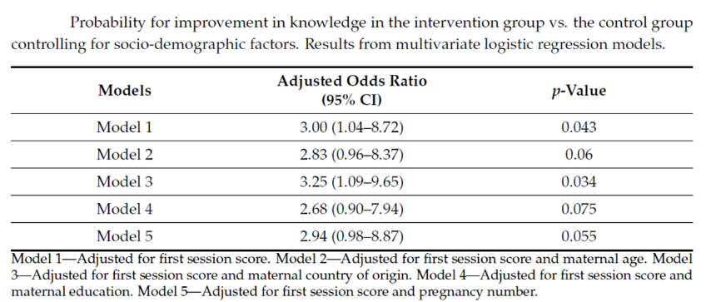

Publications
1. Ratzon, R.; Cohen, A.; Hadar, A.; Froimovici, M.; Bilenko, N. Impact of Group vs. Individual Prenatal Care Provision on Women’s Knowledge of Pregnancy-Related Topics: An Open, Controlled, Semi-Randomized Community Trial. J. Clin. Med. 2022, 11(17), 5015.
2. Reicher S*, Ratzon R*, Ben-Sahar S, Hermoni-Alon S, Mossinson D, Shenhar Y, Friger M, Lustig Y, Alroy-Preis S, Anis E, Sadetzki S, Kaliner E. Nationwide seroprevalence of antibodies against SARS-CoV-2 in Israel. Eur J Epidemiol. 2021 Apr 21:1–8. *Shay Reicher and Ronit Ratzon are the first authors who equally contributed to this work.
3. Daniel S, Koren G, Lunenfeld E, Bilenko N, Ratzon R, Levy A. Fetal exposure to nonsteroidal anti-inflammatory drugs and spontaneous abortions. Canadian Medical Association Journal. 2014. 2014 Mar 18;186(5):E177-82.
4. Bentolila Y, Ratzon R, Shoham-Vardi I, Serjienko R, Mazor M, Bashiri A. Effect of interpregnancy interval on outcomes of pregnancy after recurrent pregnancy loss. Journal of Maternal-Fetal & Neonatal Medicine. 2013 Sep;26(14):1459-64.
5. Ratzon R, Sheiner E, Shoham-Vardi I. The role of prenatal care in recurrent preterm birth. Eur J Obstet Gynecol Reprod Biol.


Biography
Dr Ronit Ratzon is dedicated to improving public health outcomes. As of now she is a researcher in the Israeli Health Intelligence Unit in the Division of Public Health, Ministry of Health. The unit specializes in threats monitoring and early alerts. Previous to that Ronit was a fellow in the Ministry of Health during COVID-19 and ran the National Serological Survey. During her PhD, Ronit performed this community clinical trial where she examined the effects of group prenatal care on different birth and behavioral outcomes. During her Masters, Ronit researched the recurrence of preterm birth in a population-based study and the relation to preterm birth (Ref 5).
Email: Ronit.pachol@gmail.com

