Photosensitizer-based nanoparticles: a promising approach in tumor management.
Dr Antonella Obinu, PhD, Department of Chemistry and Pharmacy, University of Sassari, Italy;
Dr Sara Demartis, PhD student, Ph.D. program in Chemical Science and Technology, Department of Chemistry and Pharmacy, University of Sassari, Italy;
Dr Giovanna Rassu, PhD Department of Chemistry and Pharmacy, University of Sassari, Italy;
Dr Paolo Giunchedi, PhD Department of Chemistry and Pharmacy, University of Sassari, Italy;
Dr Elisabetta Gavini, PhD Department of Chemistry and Pharmacy, University of Sassari, Italy;

Abstract
Statement of the Problem: Indocyanine green (ICG) and Rose Bengal (RB) are two photosensitizers widely used. ICG is a fluorescent dye employed for tumor diagnosis and treatment; RB is used in photodynamic therapy and it demonstrates intrinsic cytotoxicity against tumor cells. However, the clinical application of both photosensitizers is limited: ICG shows aqueous instability and photo-degradation, while RB has a short half-life and its hydrophilic tendency limited its cell accumulation. Our work focuses on the development of polymeric and lipid nanoparticles to improve the usefulness of ICG and RB in tumor management. In particular, ICG-loaded poly(ethyl 2-cyanoacrylate) nanoparticles (ICG-NPs), to increase the ICG chemical stability and as a new theranostic system, and RB-loaded solid lipid nanoparticles (RB-SLNs) to treat melanoma via dermal delivery in the absence of light were prepared. Methodology: Polymeric nanoparticles obtained by an emulsion polymerization method and lipid nanoparticles, obtained by solvent emulsification-evaporation, were prepared both blank and loaded. The nanoparticles were in vitro characterized and their potential in tumor treatment was evaluated. Findings: About ICG-NPs the results showed that the fluorescence intensity of ICG did not change when incorporated into nanoparticles, indicating an effective stabilization of dye in the aqueous media. The blank nanoparticles exhibited an interesting cytotoxic effect against 3D spheroid models of hepatic and kidney cancer, furthermore, color inclusions inside the cells treated with ICG-NPs demonstrated the internalization into tumor cells. The study relating to RB-SLNs is in progress and results of nanoparticle characterization and cytotoxicity will be present. Conclusion & Significance: ICG-NPs can be considered a good system to improve ICG stability and offer an interesting strategy to improve tumor treatment. The preliminary results of RB-SLNs assess the potential of these nanocarriers in eradicating melanoma via dermal delivery.

Image
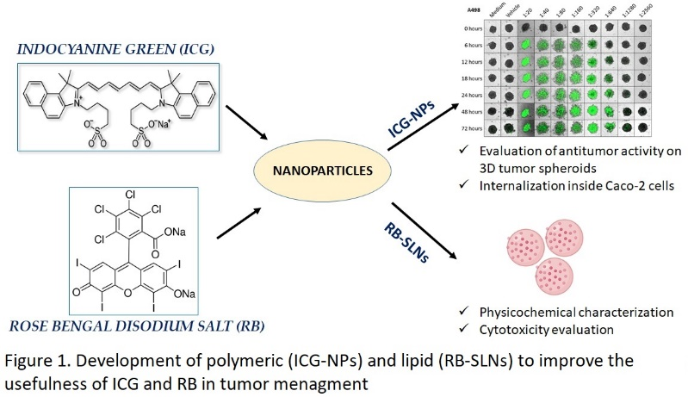
Recent Publications (minimum 5)
- Rizwan M, et al. (2019) Photodynamic-based therapeutic modalities to fight against cancer–A review from synergistic viewpoint. Journal of Drug Delivery Science and Technology 51:70-82.
- Porcu EP, et al. (2016) Indocyanine green delivery systems for tumour detection and treatments. Biotechnology advances 34:768-789
- Obinu A, et al. (2019) Poly (ethyl 2-cyanoacrylate) nanoparticles (PECA-NPs) as possible agents in tumor treatment. Colloids and Surfaces B: Biointerfaces 177:520-528.
- Obinu A, et al. 2020 Indocyanine green loaded polymeric nanoparticles: Physicochemical characterization and interaction studies with Caco-2 cell line by light and transmission electron microscopy. Nanomaterials 10:133.
- Demartis S, et al. (2021). Nanotechnology-based Rose Bengal: a broad-spectrum biomedical tool. Dyes and Pigments 109236.

Photograph

Biography
Dr. Antonella Obinu is a Postdoctoral researcher at the University of Sassari, Italy. She holds a PhD degree in Experimental Medicine from the University of Pavia, Italy, in 2019. The researcher activity of Dr. Antonella Obinu has developed mainly in the field of nano-drug delivery systems through the study of innovative therapeutic release systems. Particularly, her researcher activities are focused on the development of nanoparticles for tumor diagnosis and treatment.
Email: aobinu@uniss.it
Notes/Comments

