Association between the use of health services, metabolic syndrome and cardiovascular risk factors un Mexican Adults.
PhD. María Araceli Ortiz-Rodriguez
Msc, María Vanessa Aldaz Rodríguez
PhD. Josep A. Tur
BSc. Griselda Aldaz
BSc. Paola Kattyana Antunez Bautista

Abstract (300 word limit)
Objective: To assess association between use of health services and cardiovascular and metabolic syndrome risk factors among mexican adults.
METHODS: An analytical cross-sectional nationally representative study was carried out on workers and pensioners affiliated with ISSSTE in Mexico (2007), which covers health services of 8.8% of Mexicans.
The population was selected by means of a multiple-step, random selection, participants were randomization into subgroups, with delegations being the primary sampling units, and individuals within these delegations comprising the final sample units. Quality of cluster was 0.8; ratio of sizes: 1.22

A questionnaire incorporating the following questions was used: gender, age (20-39 y.o., 40-59 y.o., and ≥60 y.o.), region, scholar level, frequency of use of health services previous medical diagnoses of diabetes and hypertension. Smoking was also assessed,

It was evaluated: Anthropometric Measurements, Biochemical Analyses, Metabolic Syndrome, Cardiovascular Risk Factors. Prevalence was expressed in terms of percentages. Significant differences in prevalence were calculated using x² test. To evaluate the association between the use of health services (dependent variable) and the cardiovascular risk factors and sociodemographic variables (independent variables), logistic regression analyses with the estimation of the corresponding odds ratios (unadjusted and adjusted ORs) and the 95% confidence interval (CI) were used. Multivariate analyses (multiple logistic regressions considering the simultaneous effect of each explanatory variables) were performed. The level of significance was considered at p < 0.05 for all statistics.

RESULTS: The results are presented in figure 1

CONCLUSIONS: There is a positive, significant association between the use of health services and the presence of metabolic syndrome, obesity, diabetes, hypertension, hypertriglyceridemia, and hypercholesterolemia. Further studies are required in Mexico to study the determinants in the use and access to health services for chronic diseases and their risk factors

Image
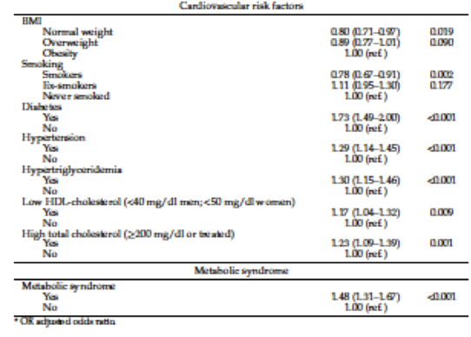
Recent Publications (minimum 5)
- Ortiz-Rodríguez, M.A.; Aldaz-Rodríguez, M.V.; González-Robledo, L.M.; Villa, A.; Bouzas, C.; Pastor, R.; Tur, J.A. Association between the Use of Health Services, Cardiovascular Risk Factors and Metabolic Syndrome in Mexican Adults. Int. J. Environ. Res. Public Health 2021, 18, 5336. https:// doi.org/10.3390/ijerph18105336
- Williams, J.; Allen, L.;Wickramasinghe, K.; Mikkelsen, B.; Roberts, N.; Townsend, N. A systematic review of associations between non-communicable diseases and socioeconomic status within low- and lower-middle-income countries. J. Glob. Health 2018, 8,
- Malta, D.C.; Bernal, R.T.I.; Lima, M.G.; Araújo, S.S.C.D.; Silva, M.M.A.D.; Freitas, M.I.D.F.; Barros, M.B.D.A. Noncommunicable diseases and the use of health services: Analysis of the National Health Survey in Brazil. Rev. Saúde Pública 2017, 51 (Suppl. S1), 4.
- Rojas, R.; Aguilar-Salinas, C.A.; Jiménez-Corona, A.; Shamah-Levy, T.; Rauda, J.; Avila-Burgos, L.; Villalpando, S.; Ponce, E.L. Metabolic syndrome in Mexican adults: Results from the National Health and Nutrition Survey 2006. Salud Publica Mex. 2010, 52 (Suppl. S1), S11–S18.
- Alberti, K.G.M.M.; Eckel, R.H.; Grundy, S.M.; Zimmet, P.Z.; Cleeman, J.I.; Donato, K.A.; Fruchart, J.C.; James,W.P.; Loria, C.M.; Smith, S.C., Jr.; et al. Harmonizing the metabolic syndrome: A joint interim statement of the International Diabetes

Photograph

Biography (150 word limit)
Faculty of Nutrition, Autonomous University of the State of Morelos, Mexico.
She has a degree in Nutrition (1999), from the Autonomous University of Nuevo León. Master in
Nutrition (2006) and a Doctor of Science in Population Nutrition (2011) from the Complutense University of
Madrid, Spain. In 2014. Has a post-doctorate at UNAM. Currently is a research professor at the
Faculty of Nutrition at UAEM. She has experience as a teacher and thesis director. She has directed research
projects, and has performed scientific publications national and international journals. Line of research: Evaluation of
the state of health and nutrition in older adults. Member of the National System of Researchers of CONACYT
and of the State Research System of the State of Morelos. Won first place in 4th. International Congress of Clinical
Nutrition, UPAEP.
Email araceli.ortiz@uaem.mx, araceli.ortiz@gmail.com

Notes/Comments:

