Approach patients with Diabetes and Covid -19
Dr. Wael AlMistehi, MD

Abstract
The Covid-19 pandemic caused by SARS-CoV-2 infection that first case reported in December 2019, which reach currently infected more than 8 million persons. As evidence is evolving rapidly, diabetes is an independent risk for morbidity and mortality in patients admitted to the hospital with Covid-19. There are multiple studies showed that Covid-19 and diabetes have an unknown relationship. Notably, case reports about new-onset diabetes with Covid-19. The mechanism of COVID-19 affected patients with diabetes is unclear. The acknowledged evidence involves in alteration of the immune system in many aspects for patients with diabetes. Other evolving research about angiotensin-converting enzyme 2 (ACE2), a key enzyme in the RAAS, catalyzes the conversion of angiotensin II to angiotensin ACE2 is highly expressed in the lungs, pancreas and serves as the entry point for SARS-CoV-2. After endocytosis of the virus complex, ACE2 expression is downregulated. Management of Covid-19 involved use of Dexamethasone, and previously some countries used methylprednisolone as part of the medications used for the treatment of severe Covid-19 pneumonia, which clearly can affect patients with diabetes and worsening hyperglycemia. During the pandemic, diabetes management needs more attention to alleviate the morbidity and mortality associated with Covid-19 patients with diabetes. Insulin therapy still the cornerstone treatment for in-hospital patients admitted in the critical care units. Continuous glucose monitoring did great help, as minimizing close contact with Covid-19 patients, which helps, to some degree, decrease infections to the staff. In conclusion, the physician should be aware of the adverse outcome of Covid-19 with diabetes and deliver the best quality care possible to those patients.

Image

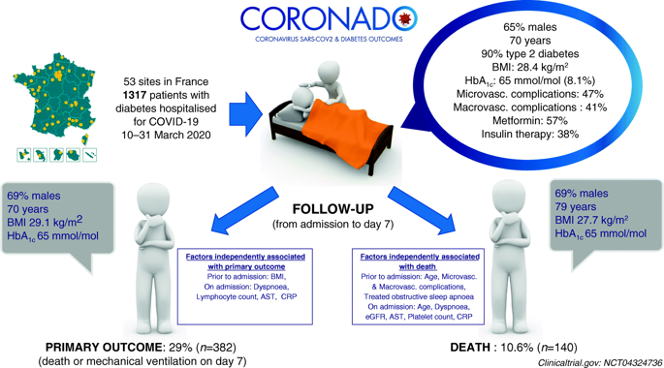
Recent Publications (minimum 5)
- Ali, Imran & Almistehi, Wael & Hebb, Andrea & Doucette, Steve & Tramble, Lisa & Clarke, David. (2019). The effect of tumor staining pattern on secondary hormonal deficiency in nonfunctioning pituitary adenomas. Endocrine Abstracts. 10.1530/endoabs.65.P276.
- Almistehi, Wael & AlQahtani, Saif & Mustafa, Syed & Vaninetti, Nadine & Imran, Fatima & Hebb, Andrea & Clarke, David & Imran, Syed. (2019). MON-LB076 Patterns of Secondary Hormonal Deficiency Vary among Different Types of Sellar Masses Despite Similar Tumour Size at Presentation. Journal of the Endocrine Society. 3. 10.1210/js.2019-MON-LB076.
- Almistehi WM, Almalki MH. Beat the giant: case of a giant prolactinoma during pregnancy on cabergoline. Endocrinol Diabetes Metab Case Rep. 2018;2018:18-0099. Published 2018 Aug 23. doi:10.1530/EDM-18-0099
- BaHammam AS, Almistehi W, Albatli A, AlShaya S. Distribution of chronotypes in a large sample of young adult Saudis [published correction appears in Ann Saudi Med. 2011 May-Jun;31(3):319. Almestehi, Wael [corrected to Almistehi, W]] [published correction appears in Ann Saudi Med. 2012 Jan-Feb;32(1):100]. Ann Saudi Med. 2011;31(2):183-186. doi:10.4103/0256-4947.78207

Photograph

Biography
Dr. Wael AlMistehi has his expertise in endocrinology, diabetes and neuropituitary. He completed his Saudi board of internal medicine in 2016, and Saudi fellowship in Adult endocrinology and metabolism in 2018. Neuropituitary fellowship certified by Dalhousie university 2019. He participated in many conferences with poster presentation. Has interest in research and currently addressing the incidence of Type 2 DKA in patients with Covid-19 in Saudi Arabia.
Email: wael.almistehi@gmail.com

Notes/Comments:

