Choosing the right graft for anterior cruciate ligament repair: 3-year results from a prospective cohort study.
Dr Remy Rees-Goddard, Trauma and Orthopaedic Surgery, Isle of Wight Trust, PO30 5TG, United Kingdom
Dr Mary Pissaridou, Oxford School Of Surgery, Oxford Business Park, Oxford, OX4 2GX, United Kingdom
Dr Kim Borsky, MRCS, MD, Oxford School Of Surgery, Oxford Business Park, Oxford, OX4 2GX, United Kingdom
Dr Michael Borsky, MD, Knee surgery division etzelclinic, Churerstr. 43, 8808 Pfaeffikon, Switzerland

Abstract

Objective: The best graft for anterior cruciate ligament (ACL) repair has long been an enthusiastically discussed topic in literature and amongst experts. We evaluated patients undergoing ACL replacement comparing the results of different types of grafts.

Methods: All ACL repairs at a single centre in 2016-2017 were included in a prospective, non-randomized manner. 3 years after ACL replacement Lysholm, Tegner and IKDC scores were evaluated. Anterior translation was measured with rollimeter and rotational stability tested by the pivot shift. Patients were asked to score donor site morbidity and anterior knee pain.

Results: Out of the 209 included patients, 183 were available to follow up. There were 29 bone tendon bone (BTB) autografts (A), 53 BTB allografts (B), 91 hamstring autografts (C) and 10 peroneus allografts (D) with no statistically significant demographic differences between the 4 groups. There was no significant difference regarding the Lysholm, IKDC and Tegner score or regarding patients with negative pivot shift (more than 93% each). The anterior translation was slightly better in the BTB allograft group -0.30 ±1.29 (B) versus 0.39 ±1.29 (A) and 0.46 ±1.23 (C) respectively (p<0.05). Anterior knee pain was absent only in 14% of the Patients in group A compared to 77% in group B, 97% in group C and 83% in group D respectively (p<0.001).

Conclusion: Beside financial arguments the BTB allograft could be the graft of choice for ACL reconstruction showing slightly better a/p stability at three years compared to BTB autograft and hamstring autograft whilst avoiding donor site morbidity.

Image
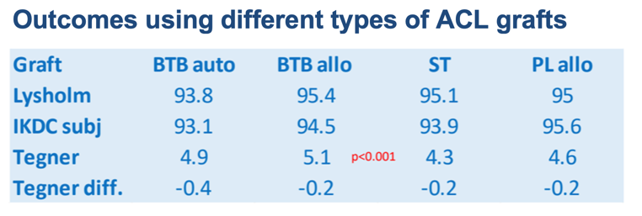
Recent Publications
- Muller B, Bowman KF Jr, Bedi A. ACL graft healing and biologics. Clin Sports Med. 2013 Jan;32(1):93-109.
- Samuelsen BT, Webster KE, Johnson NR, Hewett TE, Krych AJ. Hamstring Autograft versus Patellar Tendon Autograft for ACL Reconstruction: Is There a Difference in Graft Failure Rate? A Meta-analysis of 47,613 Patients. Clin Orthop Relat Res. 2017 Oct;475(10):2459-2468.
- Kaeding CC, Pedroza AD, Reinke EK, Huston LJ, Hewett TE, Flanigan DC; MOON Knee Group, Spindler KP. Change in Anterior Cruciate Ligament Graft Choice and Outcomes Over Time. Arthroscopy. 2017 Nov;33(11):2007-2014.
- Mouarbes D, Menetrey J, Marot V, Courtot L, Berard E, Cavaignac E. Anterior Cruciate Ligament Reconstruction: A Systematic Review and Meta-analysis of Outcomes for Quadriceps Tendon Autograft Versus Bone-Patellar Tendon-Bone and Hamstring-Tendon Autografts. Am J Sports Med. 2019 Dec;47(14):3531-3540.
5. MARS Group; MARS Group. Effect of graft choice on the outcome of revision anterior cruciate ligament reconstruction in the Multicenter ACL Revision Study (MARS) Cohort. Am J Sports Med. 2014 Oct;42(10):2301-10.


Biography
Dr Remy Rees-Goddard is a Surgical Trainee in the NHS, United Kingdom. He is an Affiliate member of the Royal College of Surgeons, with a focus on Trauma and Orthopaedic Surgery, Educational Teaching and Research. He completed his Undergraduate Medical Degree and Queen’s University Belfast and currently practices in the Region of Wessex, South-East England. He currently works both within his local Trust and the Deanery of Wessex in Surgical Education and Research. His current area of interest is anterior cruciate ligament (ACL) reconstruction where he collaborates with a Swiss Orthopedic Centre in research.
Email: remyrg@me.com

Notes/Comments:

