Influence of anesthesia on harvesting the semitendinosus tendon for ACL replacement
Dr Remy Rees-Goddard, Trauma and Orthopaedic Surgery, Isle of Wight Trust, PO30 5TG, United Kingdom
Dr Mary Pissaridou, Oxford School Of Surgery, Oxford Business Park, Oxford, OX4 2GX, United Kingdom
Dr Kim Borsky, MRCS, MD, Oxford School Of Surgery, Oxford Business Park, Oxford, OX4 2GX, United Kingdom
Dr Tobias Tessmann, MD, Institute of Anaesthesiology, Lachen Hospital, Oberdorfstr. 41, 8853 Lachen, Switzerland
Dr Thomas Wolf, MD, Institute of Anaesthesiology, Lachen Hospital, Oberdorfstr. 41, 8853 Lachen, Switzerland
Dr Thomas Boeker-Blum, MD, Institute of Anaesthesiology, Lachen Hospital, Oberdorfstr. 41, 8853 Lachen, Switzerland
Dr Michael Borsky, MD, Knee surgery division etzelclinic, Churerstr. 43, 8808 Pfaeffikon, Switzerland

Abstract (300 word limit)

Objective: Semitendinosus (ST) tendon is a commonly used graft for anterior cruciate ligament (ACL) repair. The longer the tendon, the more often can it be folded, yielding a bigger diameter and better stability. Our aim was to investigate, if the kind of anaesthesia is a relevant factor influencing the length of the harvested semitendinosus tendon.
Methods: This prospective, non-randomized study included patients undergoing ACL replacements at a single unit. The patients chose between spinal and general anaesthesia. If general anaesthesia was chosen, a short relaxation period was applied while harvesting the ST tendon. The data for tendon length, the folding factor and the diameter of the graft was collected. Except redo procedures and repairs with allograft, all patients undergoing an ACL replacement were included.
Results: 31 patients with general anaesthesia (GA) and 14 patients with spinal anaesthesia (SA) were examined. The ST tendon length was 29.03 cm ± 2.6 cm in the GA group and 25.4 cm ± 2.70 in the SA group (p=0.0001). The ST tendon could be quadrupled in 23 patients in the GA and 6 patients in the SA group (χ2=4.13, p=0.04). The graft diameter obtained was 8.53 mm ± 0.62 mm in the GA group and 7.71 mm ± 0.47 mm in the SA group (p<0.0001).
Conclusion: GA with short time relaxation while harvesting the ST tendon for ACL grafting allows to harvest longer ST tendons and consequently yields better results regarding the graft dimensions and should be offered to patients as a first choice.

Image
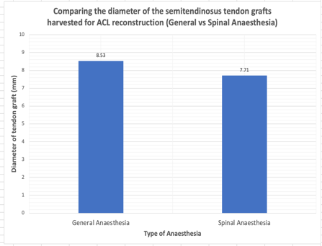
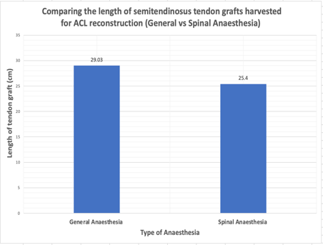
Recent Publications
- Park SY, Oh H, Park S, Lee JH, Lee SH, Yoon KH. Factors predicting hamstring tendon autograft diameters and resulting failure rates after anterior cruciate ligament reconstruction. Knee Surg Sports Traumatol Arthrosc. 2013;21(5):1111-8.
- Conte EJ, Hyatt AE, Gatt CJ, Dhawan A. Hamstring autograft size can be predicted and is a potential risk factor for anterior cruciate ligament reconstruction failure. Arthroscopy. 2014;30(7):882-90.
- Mariscalco MW, Flanigan DC, Mitchell J, Pedroza AD, Jones MH, Andrish JT, et al. The influence of hamstring autograft size on patient-reported outcomes and risk of revision after anterior cruciate ligament reconstruction: a Multicenter Orthopaedic Outcomes Network (MOON) Cohort Study. Arthroscopy. 2013;29(12):1948-53.
- Spragg L, Chen J, Mirzayan R, Love R, Maletis G. The Effect of Autologous Hamstring Graft Diameter on the Likelihood for Revision of Anterior Cruciate Ligament Reconstruction. Am J Sports Med. 2016;44(6):1475-81.
- Boniello MR, Schwingler PM, Bonner JM, Robinson SP, Cotter A, Bonner KF. Impact of Hamstring Graft Diameter on Tendon Strength: A Biomechanical Study. Arthroscopy. 2015;31(6):1084-90.

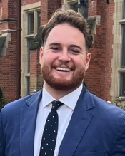
Biography
Dr Remy Rees-Goddard is a Surgical Trainee in the NHS, United Kingdom. He is an Affiliate member of the Royal College of Surgeons, with a focus on Trauma and Orthopaedic Surgery, Educational Teaching and Research. He completed his Undergraduate Medical Degree and Queen’s University Belfast and currently practices in the Region of Wessex, South-East England. He currently works both within his local Trust and the Deanery of Wessex in Surgical Education and Research. His current area of interest is anterior cruciate ligament (ACL) reconstruction where he collaborates with a Swiss Orthopedic Centre in research.
Email: remyrg@me.com
Notes/Comments:

