Bioaccumulation of Environmental Heavy Metals Related to Deregulation of Detoxifying Enzymes Expression in Osteoporosis

Visconti VV ¹, Gasperini B ², Greggi C ¹, Battistini B ², Alessandra M ², Renzi M ³, Bakhtafrouz K ³, Iundusi R ^{1,3}, Botta A ², Palombi L ², Tarantino U ^{1,3}
¹ Department of Clinical Sciences and Translational Medicine, University of Rome Tor Vergata, Via Montpellier 1, 00133 Rome, Italy
² Department of Biomedicine and Prevention, University of Rome Tor Vergata, Via Montpellier 1, 00133 Rome, Italy
³ Department of Orthopaedics and Traumatology, “Policlinico Tor Vergata” Foundation, Viale Oxford 81,
00133 Rome, Italy

Abstract
Heavy metals are toxic environmental pollutants that can accumulate in the human body. Metals bioaccumulation correlates with altered expression patterns of numerous genes, including detoxifying genes, thus interfering with multiple cellular events leading to increased susceptibility to several diseases. The presence of heavy metals in bone tissue appears to be related to osteoporosis, but the role of environmental pollution in the pathogenesis of the disease has yet to be elucidated. The purpose of this study is to analyse circulating heavy metals levels and the expression of detoxifying genes in osteoporotic patients (OP), compared with healthy subjects (CTRs). Heavy metals concentration was determined by Inductively Coupled Plasma Mass Spectrometry (ICP-MS), and the expression of NAD(P)H quinone dehydrogenase 1 (NQO1), Catalase (CAT), and Metallothionein 1E (MT1E) genes was assessed by real-time polymerase chain reaction (qRT-PCR). Copper (Cu), mercury (Hg), molybdenum (Mo) and lead (Pb) were found to be significantly higher in the plasma of OP patients compared to CTR subjects. Analysis of the expression levels of detoxifying genes showed a significant decrease in CAT and MT1E in OP subjects. In addition, Cu correlated positively with the expression levels of CAT and MT1E in CTRs group and MT1E in OP patients. This study suggests that bioaccumulation of certain metals is potentially related to an altered expression pattern of detoxifying genes in OP patients.

Image
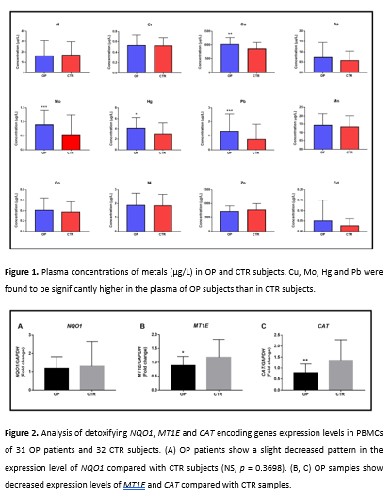
Recent Publications
- Hemmaphan, S.; Bordeerat, N.K. Genotoxic Effects of Lead and Their Impact on the Expression of DNA Repair Genes. Int. J. Environ. Res. Public Health 2022, 19, doi:10.3390/ijerph19074307.
- Banjabi, A.A.; Kannan, K.; Kumosani, T.A.; Yousef, J.M.; Abulnaja, K.O.; Moselhy, S.S. Association of Blood Heavy Metal Levels with Osteocalcin Abnormality and Incidence of Osteoporosis in Saudi Subjects. Braz. J. Biol. 2021, 83, e248828, doi:10.1590/1519-6984.248828.
- Mitra, P.; Sharma, S.; Purohit, P.; Sharma, P. Clinical and Molecular Aspects of Lead Toxicity: An Update. Crit. Rev. Clin. Lab. Sci. 2017, 54, 506–528, doi:10.1080/10408363.2017.1408562.
- Lim, H.-S.; Lee, H.-H.; Kim, T.-H.; Lee, B.-R. Relationship between Heavy Metal Exposure and Bone Mineral Density in Korean Adult. J. bone Metab. 2016, 23, 223–231, doi:10.11005/jbm.2016.23.4.223.
- Scimeca, M.; Feola, M.; Romano, L.; Rao, C.; Gasbarra, E.; Bonanno, E.; Brandi, M.L.; Tarantino, U. Heavy Metals Accumulation Affects Bone Microarchitecture in Osteoporotic Patients. Environ. Toxicol. 2017, 32, 1333–1342, doi:10.1002/tox.22327.

Photograph

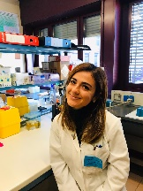
Biography
Dr Visconti has experience in the field of molecular genetics. In particular, she is involved in the study of pathologies of the musculoskeletal system, such as osteoporosis and osteoarthritis, and the involvement of epigenetic mechanisms in the pathogenesis of these diseases. Most recently, he has focused on the study of the role of heavy metals in negatively modulating bone health. Indeed, the purpose of this study is to analyse circulating heavy metals levels and the expression of detoxifying genes in osteoporotic patients, compared with healthy subjects.
Email: virginiaveronicavisconti@gmail.com

Notes/Comments:

