Transitioning Nursing Students’ Education from Traditional Classroom to Online Education During the COVID-19 Pandemic: A Case Study Applied to the Meleis Trial
Dr. Samar Thabet Jallad, RN PhD, Department of Nursing, Near East University, Faculty of Health Sciences Institute, Nicosia, Cyprus.
Dr. Burçin Işık, RN PhD, Assistant Professor, Department of Nursing, Gaziantep Islam Science and Technology University, Faculty of Health Sciences, Gaziantep, Turkey

Abstract

Theories can be used to determine the factors that affect a situation and the most appropriate ways to reach a goal. The coronavirus disease 2019 pandemic has deeply affected nursing education in which had considered a critical factor in the transition of teaching methods that is being and will be experienced today and in the future in nursing education. Transition is a process of changing from a known to an unknown state. Personal, community, and social factors can facilitate or prevent a transition. In this study, nursing education as well as nursing students and educators are at the center of these changes and transitions to online learning, which is an institutional (organizational) type of transition. Nursing students understand the level of awareness of an individual, responsibilities that they need to take, changes to be experienced, beginning and expected end time of the transition, critical turning points and important points, impact of the change on daily life, stages of the individual, and reactions during different stages of this process. This article discusses the transition process of a 21-year-old nursing student (initials: MN) from the traditional classroom to online education and the factors affecting this process. The transition from the traditional classroom to online education was facilitated by appropriate nursing interventions and follow-up to a nursing student experiencing transition, and preventive factors were controlled by support systems.
Image

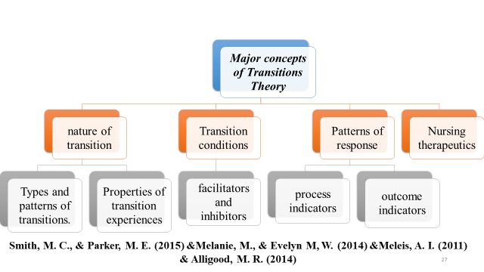
Recent Publications
- American Association of Colleges of Nursing (2020). Coronavirus Disease (COVID-19). https://www.nursingworld.org/practice-policy/work-environment/health-safety/disasterpreparedness/coronavirus/
- Bergstrand, K., & Savage, S. V. (2013). The chalkboard versus the avatar: Comparing the effectiveness of online and in-class courses. Teaching Sociology, 41(3), 294-306.
- Bodur, G., & Kaya, H. (2017). HEMŞİRELERİN GÖZÜYLE GELECEK: 2050’Lİ YILLAR. Ege Üniversitesi Hemşirelik Fakültesi Dergisi, 33(1), 47-58.
- Institute of Medicine (2011). Committee on the Robert Wood Johnson Foundation Initiative on the Future of Nursing. National Academies Press Washington, DC. https://doi.org/http://10.17226/12956
- Meleis. (2019). Facilitating and Managing Transitions: An Imperative for Quality Care. Investigación en Enfermería: Imagen y Desarrollo, 21(1).
- National League for Nursing (2016). Discover vSim for Nursing. http://thepoint.lww.com/Template/RenderTemplateByInstanceId/14
- Smith, G. G., Passmore, D., & Faught, T. (2009). The challenges of online nursing education. The Internet and Higher Education, 12(2), 98-103.
- Wicks, D. J. (2016). Emerging theories and online learning environments for adults. Theories of Educational Technology. https://sites.google.com/a/boisestate.edu/edtechtheories/emerging-theories-and-onlinelearning-environments-for-adults-1
- World Health organization (2020). "World Health Organization" Preparedness, prevention and control of coronavirus disease (COVID-19) for refugees and migrants in non-camp settings: interim guidance. 17 April 2020. https://apps.who.int/iris/bitstream/handle/10665/331777/WHO-2019-nCoV Refugees_Migrants-2020.1-eng.pdf

Photograph

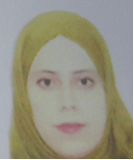 Biography
Samar Thabet Jallad is a Palestinian Ph.D. at Near East University, and a lecturer at Cyprus International University/Cyprus, has her field in nursing education that related to developing nursing curriculum, and improving learning strategies/methods that related to various skills like critical thinking and problem-solving facing nursing students in a practice field. And also, she is a specialist in her study for Virtual Reality Simulation (VRS) that effective as a learning/teaching strategy of acquisition skills in nursing education, which help to improve performance, increase satisfaction, and reduce anxiety among nursing students. On the other hand, she had a Master's degree in management of nursing, which assisted her to be effective in issues relating to organization and administration encountering nursing students and departments in faculties.
Email: sammar1986@live.com

Notes/Comments:

