Anemia in the problem of morbidities in reproductive health in Côte d'Ivoire
Adou Serge Judicaël ANOUA, Doctorate Degree of Health Socio-anthropology,
Alassane Ouattara University, Côte d’Ivoire

Abstract
Statement of the Problem: Anemia in pregnant women is an issue of concern even in urban areas. The city of Bouake in Côte d’Ivoire is no exception to this prevalence of anemia in pregnant women. This morbidity during pregnancy remains a risk basis for the survival of the mother-child relationship. Although it is admitted that several works according to various fields of research have been conducted to identify the causes, the consequences and the means of prevention of this morbid fact, it is nonetheless true to take into account the social perceptions that - extend this reality. This research aims to specify the explanatory model of anemia in pregnant women in order to contribute to the control of this disease during the prenatal period. Methodology & Theoretical Orientation: An ethnographic study supported by a semi-structured interview supported by structured questions on perceptions and attitudes related to anemia targeted pregnant women in consultation at Ahougnanssou urban health center, so as to explain the characters of this morbidity through the mode of thought relating to this social group. Findings: Pregnant women interviewed equate anemia with blood deficiency in the body. This predisposes them to the risk of obstetric complications and mortality. They also agree that the lack of financial resources is the key factor in the exposure to anemia. Beyond this financial factor, they explain this morbidity through the irregular monitoring of pregnancy, while inappropriate dietary habits are the complementary explanatory factor for these women. Conclusion & Significance: The recurring risk factors associated with anemia among pregnant women in this research require a solution approach that takes into account social relevance. This logic should lead to changes in the provision of antenatal care and help reduce the vulnerabilities of pregnant women in the fight against this indirect cause of maternal mortality.
.
Image
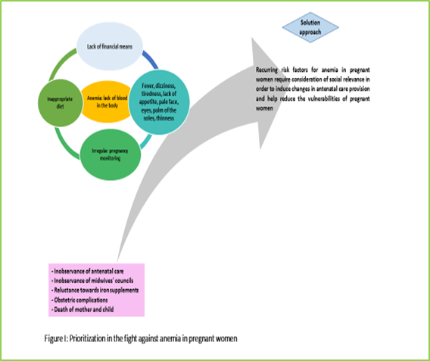
Recent publications
- Anoua ASJ (2017) Logiques de l’observance des interdits alimentaires en matière de surveillance prénatale chez les gestantes de Kongodékro (Côte d’Ivoire). International Journal of Multidisciplinary Research and Development 4(8): 237-241.
- Likilo Osundja J, Alworonga O, Katenga B, Komanda L (2018) Pregnant women's prevalence of anemia in Kisangani, democratic republic of Congo International Journal of Innovation and Applied Studies 25(1): 294-299.
- Ouzennou N, Tikert K, Belkedim G, Jarhmouti F & Baali A (2018) Prévalence et déterminants sociaux de l’anémie chez les femmes enceintes dans la Province d’Essaouira, Maroc. Santé Publique 30(5) : 737-745.
- Séré R, Hiena H, Somda S, Testa J, Koulidiati J-L, Meda N (2016) Prévalence et tendance de l’anémie de la mère et de l’enfant au Burkina Faso. Revue d'Épidémiologie et de Santé Publique 64(4) : S179.
- Tchente C N, Tsakeu E N, Nguea A G & al. (2016) Prévalence et facteurs associés à l’anémie en grossesse à l’Hôpital Général de Douala [Prevalence and factors associated with anemia in pregnant women attending the General Hospital in Douala]. The Pan African medical journal 25 : 133.

Biography

ANOUA Adou Serge Judicaël is a Doctor in socio-anthropology and Assistant Professor in the Department of Anthropology and Sociology at the Alassane Ouattara University. He is a coordinator of the Laboratory of Studies and Research in Reproductive Health care Transition. He intervenes at the Basic School of the National Institute for Training of Health Agents of Bouaké, at the graduate cycle of the National Institute for Training of Health Agents of Abidjan and in Master of Health Community at the Continuing Training Center at Alassane Ouattara University. He has published several papers in journals and is an editorial board member. My domain of speciality is the socio-anthropology of health. The general problem that occupies my scientific reflection is the issue of Reproductive Health in rural Africa, particularly in Côte d'Ivoire. I also conduct research activities in the domain of community health and environmental health and nursing care.

Email: anoua_08@yahoo.fr

