Physiotherapy in combination with multimodal interventions reduce in adult patients chronic neck pain- review

Dr. Enkeleda Sinaj, Faculty of Technical Medical Sciences,University of Medicine, Tirana Albania
Dr. Vjollca Ndreu, Faculty of Technical Medical Sciences,University of Medicine, Tirana Albania

Abstract
Statement of the Problem: Chronic neck pain is one of most frequent musculoskeletal disorders in adults. It not only disrupts a person's quality of life but there is also with very high economic costs. The effects of physiotherapy in this problem are still unclear, and more the combination of physiotherapy with other treatment methods. The purpose of this study was to review the literature in relation to the effectiveness of the combination of physiotherapy with other treatments as an important alternative in the treatment of chronic neck pain in adult patients. Methodology & Theoretical Orientation: The research included the electronic data base of: Ovid PubMed, PEDro, NLM Tools, CINAHL. Seven studies on the effects of physiotherapy in combination with other treatments in chronic neck pain were included in the review. Adults patients, only randomized clinical trials, and the studies published in the past two years were the inclusion criteria. The variable that was took into account after primary treatment was the reduction of chronic neck pain. Findings: The study results showed that clinical studies were limited, even if the multimodal intervention may be an effective intervention for chronic neck pain patients. Conclusion & Significance: The review showed that physiotherapy has satisfactory effects in the treatment of chronic neck pain in combination with multimodal interventions but there is not enough evidence, due to the small number of trials included in the review.

Image
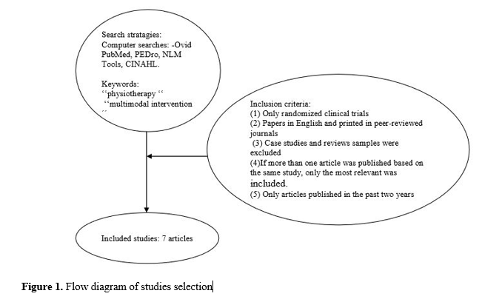
Recent Publications
- Centers for Disease Control and Prevention. Severe headache or migraine, low back pain, and neck pain among adults age 18 and over, by selected characteristics: United States, selected years 1997-2014. website.http://www.cdc.gov/nchs/data/hus/2015/041.pdf. Published 2015. Accessed June 20, 2016.
- Thomas DA, Maslin B, Legler A, Springer E, Asgerally A, Vadivelu N. (2016) Role of Alternative Therapies for Chronic Pain Syndromes. Curr Pain Headache Rep. May; 20(5):29.
- Ris I, Søgaard K, Gram B, Agerbo K, Boyle E, Juul-Kristensen B. (2016) Does a combination of physical training, specific exercises and pain education improve health-related quality of life in patients with chronic neck pain? A randomized control trial with a 4-month follow up. Man Ther. Aug 20;26:132-140.
- Cook AJ, Wellman RD, Cherkin DC, Kahn JR, Sherman KJ.(2015) Randomized clinical trial assessing whether additional massage treatments for chronic neck pain improve 12- and 26-week outcomes. Spine J. Oct 1;15(10):2206-15.
- Beltran-Alacreu H, López-de-Uralde-Villanueva I, Fernández-Carnero J, La Touche R. (2015) Manual Therapy, Therapeutic Patient Education, and Therapeutic Exercise, an Effective Multimodal Treatment of Nonspecific Chronic Neck Pain: A Randomized Controlled Trial. Am J Phys Med Rehabil. Oct;94(10 Suppl1):887-97.

Photograph

Biography
Dr. Enkeleda Sinaj has obtained her PhD in Rehabilitation Sciences in 2016. She has a master degree in Rehabilitation Sciences and Nursing Sciences. She is a lecturer at Faculty of Technical Medical Sciences, University of Medicine, Tirana Albania. She has a lot of experience as academic. Her focus studies are rehabilitation sciences. She is an author of different scientific papers and contributes as editorial board member in different scientific international journals.
Email: enkeleda.sinaj@umed.edu.al

Photograph

Biography
Dr. Vjollca Ndreu has obtained her PhD in 2016. She has a master degree in Nursing Sciences. She is a lecturer at Faculty of Technical Medical Sciences, University of Medicine,Tirana Albania. Her focus studies are rehabilitation and health care. She is an author of different scientific papers and contributes as editorial board member in different scientific international and national journals.
Email: vndreu@hotmail.com

Notes/Comments:

